News Archive 2016

Below is a copy of the news feed for 2016 from Cardiff AACs old website.

A Happy Christmas Thursday 22 December 2016

Cardiff Amateur Athletic Club wishes all our members and friends a very happy Christmas and a successful 2017.
2016 has been a very successful year and 2017 can be even better.
The final club night of 2016 is tonight and normal club nights will resume on Monday, 9th January.
Would you like to help us next year? If so, read on.
As a voluntary organisation, the club depends entirely on many who give up much of their time to help and, without these marvellous people, we could not exist.
There are athletes to coach, teams to organise, the canteen to man (or, perhaps, woman), fixtures to organise, money to be raised and managed, administration to be taken care of, and many other unseen tasks that keep the club ticking over. There are never enough helpers and, with a growing membership, more helpers are needed and will be welcome.
It can be very rewarding to be part of a long established and respected organisation that makes an important contribution to the sporting lives of Cardiff and Wales, not to mention playing a significant role in the lives of young people If you are interested in offering a few hours of your time in a good cause, please do not hesitate to get in touch with the club (any of the officials can be contacted) where you will be assured of a warm welcome.
We especially need help with press and media, volunteers and a minutes secretary for the general committee.
Could it be your New Year's Resolution?

High jumpers on TV Monday 19 December 2016
A group of Cardiff high jumpers will be performing on the TV channel MADE IN CARDIFF on 23rd December at 7.30pm so try to tune in and watch.
Led by Steve Bailey and AJ, Shani Evans, Catrin Jones, Moli Beynon, Emily Steer, Bethan Cushion , Cameron Pamment, Isobel Owen, Gabby Dickinson and Ben Hillman will be acting out the Lords a Leaping verse of "The Twelve Days of Christmas" christmas carol.
Should be fun.
The sequence can be found in the following link https://www.madeincardiff.tv/player/?playercat=94631&v=2.

Golden Mark Gold Friday 16 December 2016

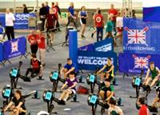
There is more to Mark Gold than meets the eye. On Saturday last, 10th December, he caught the 6am train to London to compete in the British indoor rowing championships, held in the velodrome at the Olympic Park.
So how did he get on? He only won the gold medal in his category, rowing the final, over 1,000m, in 3:25.7, more than 18 seconds ahead of the silver medallist.
More than a thousand rowers competed in the championships in various categories (according to age and other factors) and Mark had to navigate a heat and semi final (each over 1,000m) in order to qualify for the final.
As a former Major in the Army who served in Afghanistan, Mark was rowing for the Help the Heroes charity and is hoping to qualify for next year's Invictus Games.
Many congratulations Mark.

Next stop the world Friday 16 December 2016

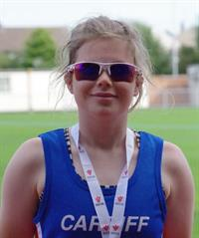
Cardiff's Ceri Jones is still only 17 but has already amassed an impressive array of qualifications and experience.
An all-round athlete, coach, event organiser and official, she has just been selected to officiate at next year's world athletics and para-athletic championships in London.
Ceri will be part of the photo-finish team at the para-championships and will be working in the call room at the IAAF world championships.
Congratulations to Ceri.
Warning!! Wednesday 14 December 2016

Most athletes will be aware that, in 2016, UK Athletics introduced a regulation that, throughout the UK, all athletes have to be registered with their regional associations in order to compete.
In 2017, the rule will be enforced strictly so it is essential that if you want to compete you MUST register.
Registration fees are paid to the athlete's club and they are then paid over by the club to, in our case, Welsh Athletics.
All Cardiff members will receive a request to pay the registration fee and club subscription by email in early January. Payment can be made online so please ensure that you look out for the email and deal with it promptly. The responsibility is yours.
The Welsh Athletics registration fees are as follows and will cover the period from 1st April 2016 to 31st March 2018.
20 years and older on 1st April: £17.50
Less than 20 years on 1st April: £10.00
Club subscriptions are due on 1st January.
If you do not receive an email reminder it will probably be because we do not have your correct email address. In this case please contact membership secretary Bou Ligthart boudewyn_ligthart@hotmail.com who will contact you directly.
Please help us to help you by paying promptly.
Thank you.

Cardiff in the Inter Regional Sunday 11 December 2016

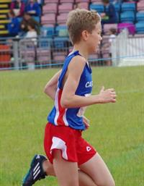
Cardiff athletes, wearing their regional vests, were prominent at the Welsh Athletics inter-regional cross country championships held in Brecon yesterday, helping South Wales to the overall title.
Pride of place goes to the under seventeen women where Cardiff athletes filled six of the first ten positions, including all the medal places.
Outright winners were Jacob Reynolds (under 13 boys), Abi Fisher (under 17 women), Ciaran Lewis (under 20 men) and Bethan Evans (under 20 women).
The best placed Cardiff athletes were:
Under 13 girls: Eden Williams (4th).
Under 13 boys: Jacob Reynolds (1st).
Under 15 girls: Nia Clatworthy (4th).
Under 15 boys: Louis Spencer (5th).
Under 17 women: Abi Fisher (1st); Kiara Frizelle (2nd); Naomi Reid (3rd); Carys Bill (5th); Laura Wright (7th); Jess Wadey (9th).
Under 17 men: James Vincent (4th); Morgan James (5th).
Under 20 women: Bethan Evans (1st); Georgina Cole (2nd).
Under 20 men: Ciaran Lewis (1st); Jac Smith (5th).
Senior women: Liz Davies (19th).
Senior men: Carwyn Jones (2nd);
MM35 men: James Thie (2nd).
The full results can be seen here.

More honour for Jake Thursday 8 December 2016

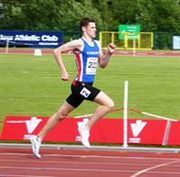
Cardiff's Jake Heyward has enjoyed the best season of his career so far and, for his achievements, he was named the Carwyn James Young Sportsman of the Year at Monday night’s Wales Sport Awards.
The pinnacle of his season was representing Great Britain & Northern Ireland at the European Youth (Under 18) Championships in Tiblisi, Georgia, where he won the 1500 metres gold medal. In addition he retained his Welsh Senior 800m championship title and won the UK Under 20 championship at 1500m.
Congratulations Jake - well deserved.
Jake is ranked sixth Under 20 (1500m) in the UK despite being only 17 and is also ranked tenth in the UK over 800m in the Under 20 category.

Indoor medals Tuesday 6 December 2016

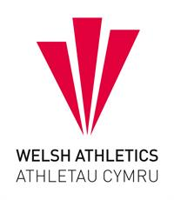
During a busy weekend for the sport, the Welsh Athletics junior grand prix was held at NIAC in Cardiff on Sunday last, 4th December, and numerous Cardiff athletes were amongst the large numbers who entered.
As one of the first indoor events of the winter season, the grand prix incorporated the South Wales and East Wales indoor championships for under 13, under 15 and under 17 athletes and Cardiff athletes were prominent amongst the medal winners, especially in the two older age groups.
Cardiff's medallists were:
Under 15 boys:
South Wales:
Gold: Carter Staples (200m & 300m); Ben Henson (shot put).
Silver: Lloyd Clarke (shot put).
Bronze: Ben Henson (300m); Ben Hillman (shot put).
East Wales:
Bronze: Harry Owen (200m).
Under 15 girls:
South Wales:
Gold: Emmanuella Kone (200m); Gabby Dickinson (high jump); Evie Wong (long jump).
Silver: Ffion Jones (200m); Alana Lea (300m).
Bronze: Gabby Dickinson (long jump).
East Wales:
Bronze: Sadie Graham-Mulvaney (200m).
Under 17 men:
South Wales:
Gold: Jeremiah Azu (200m); Seth Kelly (400m); Luca Contino (shot put).
Silver: Iwan Robinson-Booth (200m); Cameron Pamment (high jump & shot put).
East Wales:
Gold: Harvey Reynolds (400m); Tom Britt (shot put).
Silver: Tom Britt (200m).
Bronze: Harvey Reynolds (shot put),
Under 17 women:
South Wales:
Silver: Issie Tustin (200m); Lana Culliford (300m); Eliza Durnall (triple jump); Angel Onwudiwe (shot put).
Bronze: Lana Culliford (200m); Jessica Hill (300m); Sofia Vella (high jump); Ellie May Stonehewer (triple jump).
The official results can be seen here.

Dan's the man Sunday 4 December 2016

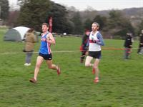
Wearing his Cardiff vest for the first time, Dan Nash took an early lead in the senior men's race at yesterday's third round Gwent Cross Country League and held it to the end, holding off his Bristol rival in what he described as a tough race. Despite winning, Dan could not count in the Cardiff team score as his transfer from East Cornwall will not be through until 1st January.
The first counting senior Cardiff athlete was road and cross country captain Carwyn Jones in fifth place, followed by James Hunt (6th), Ciaran Lewis (8th) and James Thie (18th).
In perfect cross country conditions (cold and dry with only a slight wind), Cardiff's other winner was James Vincent in the under 17 men's race. James' tactics were to track the race leader before moving ahead in the last 600m and gain a convincing win.
In the senior ladies' race Lucy Marland held on to the race leader for most of the race before conceding victory and finishing in second place, with Carys Hughes in third. Emily Brown unfortunately had to pull out of the race after stumbling and twisting her ankle.
The leading Cardiff athletes in the other age groups were:
Under 11 boys: Tommy Bryant (34th)
Under 11 girls: Millie Gold (33rd)
Under 13 boys: Ben Macey (6th)
Under 13 girls: Fiona Bostock (3rd)
Under 15 boys: Iestyn Edwards (17th)
Under 15 girls: Megan Friedli (27th)
Under 17 women: Jessica Wadey
Under 20 men: Jac Smith
Under 20 women: Bethan Evans
The full results will be available on the Gwent League website later in the week.
Cardiff numbers were down at Blaise Castle, many due to illness or injury. However, some athletes informed the team manager Mark Gold of their unavailability very late indeed (one even after names had been registered). Sometimes this is unavoidable but it is not fair to the team manager to leave notification so late so please inform him as soon as possible if you are not able to come. Please also remember that failure to turn up costs the club money as all entry fees for Cardiff athletes are paid for by Cardiff AAC.
Cross country is a great sport and excellent training so it is always better to come and have a go.

Christmas Closure Dates Friday 2 December 2016

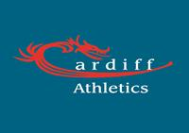
Cardiff International Sports Campus has announced its closure dates over the Christmas period.
The stadium will close at 10pm on Thursday 22nd December and re-open as normal on Tuesday 3nd January 2017.
The club canteen will be closed after clubnight on 22nd December and will re-open on Monday 9th January 2017. The Academy will also re-start on 9th January.

Charlotte clinches GB place Saturday 26 November 2016

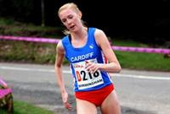
Cardiff's Charlotte Arter produced one of the best performances of her career to take second place in the British Athletics Cross Challenge in Liverpool today after an intriguing tussle with seasoned Great Britain international and three times winner Gemma Steel.
The Liverpool race counts as the official trial for the Great Britain team to take part in the European Cross Country Championship and second place today guarantees Charlotte her place in the team.
The European Cross Country Championships will be held in Chia, Italy on 11th December.
The senior men's race, with 632 finishers, saw Ieuan Thomas in 19th and, making a welcome return to racing in Britain, Mike Ward in 41st.
In the under 17 women's race, Abbi Fisher was 16th, Kiara Frizelle 20th and Naomi Reid 29th, while Jacob Reynolds was 16th in the under 13 boys' race.
Congratulations to all for some excellent performances.

Cardiff athletes win support Thursday 24 November 2016

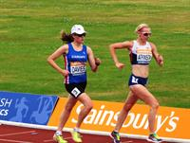
Welsh Athletics has announced its list of athletes to be supported and the list includes ten from Cardiff AAC.
Three athletes have been placed in the Commonwealth Games Podium Support category which means that they are regarded as having the potential to finish in the top six at the next Games. The athletes are Bethan Davies (20k walk), Brett Morse (discus) and Rhys Williams (400m hurdles).
The Commonwealth Games Support category includes Kristian Jones (200m), Tom Marshall (1500m), Jac Palmer (hammer) and Owen Smith (400m).
For younger athletes, the Futures Cymru category includes Jay Morse (discus), Sarah Omoregie (shot put) and Naomi Reid (800m).
All these athletes will receive specialised help with their development including medical assistance, etc.
Following his oustanding performances this year, Jake Heyward has been included in UK Athletics' Futures programme.
Aled Davies and Rhys Williams have been included in the multi-sport athletes' commission that will advise the Commonwelth Games management on matters relating to the athletes.
Congratulations to all.

Magic in the air Sunday 20 November 2016

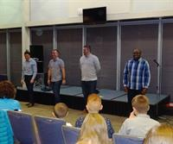
A magician added a sense of fun and amazement to the annual Presentation of Awards evening held on Firiday evening at the Cardiff City Stadium to celebrate another successful year for Cardiff AAC.
Presenting the awards were special guests, Paralympian Steve Morris and club captain and Great Britain Olympian Brett Morse as well as representatives of Run and Become sports shop who support the Athlete of the Month awards.
Numerous standard certificates and medals were presented and these were followed by awards to individual club athletes who had produced notable performances.
Particularly popular are the awards that are voted on by the athletes themselves and these went to:
Under 13 boys: Jacob Reynolds
Under 13 girls: Eilys Finlayson and Elen Williams
Under 15 boys: Ben Hillman
Under 15 girls: Lily Gaskin
Under 17 boys: Richard Lee
Under 17 girls: Laura Wright
Under 20 men: James Vincent
Under 20 women: Rebecca Kennett
The team managers' athletes:
These awards are voted by the team managers and go to the athletes who, in their opinion, have demonstrated the most commitment, enthusiasm and willingness to help the team when asked.
Under 11 boys: Charlie Stiockley-Jones
Under 11 girls: Anais Halliday
Under 13 boys: Ben Hughes
Under 13 girls: Elen James
Under 15 boys: Jonathan Gibson
Under 15 girls: Alana Rowlands
Under 17 boys: Harry Wheeler-Sexton
Under 17 girls: Catrin Lord
Under 20 men: Ciaran Lewis
Under 20 women: Ceri Jones
The Simon Lane Memorial Award went to Megan Bowen for showing determination to continue to train and compete despite tragic personal circumstances. We wish her well in her ambition to study medicine and to continue to train and perform well.
Best Performance awards:
These awards are based on athletes' performances in championships and taking into account Welsh and UK rankings in 2015.
Under 13 boys: Ben Vincent
Under 13 girls: Anna Lee
Under 15 boys: Daniel John
Under 15 girls: Issie Tustin
Under 17 boys: Jay Morse
Under 17 girls: Sarah Omoregie
Under 20 men: Jake Heyward
Under 20 women: Amelia Reynolds
A new award to young athletes who have completed their track and field offciiating courses was presented to Morgan James, Seren Phillips, Annwen Gammon and Ceri Jones.
The presentations were concluded with a line up of the many volunteers without whom the club could not function.
A highlight of the evening was a demonstration of agility and control by the Cardiff AAC acrobatic team; John Bowen, Mark Vincent, John Hillman and Des Reid, who discovered talents unknown to them before.
Our thanks go to Andrew Seary and his team for organising another successful event.

A very good year Thursday 17 November 2016

With the annual presentation evening taking place tomorrow, it is a good time to look back over the track and field season.
2016 was a very good year for Cardiff AAC with many successes for both teams and individuals.
The highlight was Jake Heyward winning the European Under 18 championship 1500m gold medal (hopefully the first of many) but let's not forget Bethan Davies who dominated British women's walking and was unlucky not to have been selected for the Olympic Games in Rio.
Four Cardiff athletes did make it to Rio and we are proud of Aled Davies and Steve Morris (Paralympians) and Kevin Seaward and Charlotte Wingfield who represented Ireland and Malta respectively.
Rhys Williams also should have gone to Rio after a strong season which saw him come fifth in the final of the 400m hurdles at the European Championships and end the season as Britain's number two in his event.
All the club teams competed with distinction, with the senior men's BAL team gaining promotion to Division one of the British League, the UK Youth Development League (upper age group) team reaching the UK national final, the UK womens' league team maintaining its position as one of the best in Britain, the UK YDL (lower age group) team just missing out on a repeat visit to the national final and the Welsh Junior League team retaining its title as the best in Wales.
And as soon as the track season was over, the senior men beat Swansea to win the UK national six stage road relay and the women's team took the four stage bronze medal.
Individually there were also successes and a good test of the club's standing is to see how many of its members appear in the UK top ten as shown by the Power of Ten ranking system.
Standing on top of the mountain in number one positions were Bethan Davies (senior women - 20k walk) and Sarah Omoregie (Under 17 women - shot put). Close behind, in second places, were Rhys Williams (senior men - 400m hurdles), David Omoregie (senior men - 110m hurdles), Brett Morse (senior men - discus), Tom Hanson (Under 17 men - shot put) and Evie Wong (Under 13 girls - 70m hurdles). James Vincent was ranked third in the under 17 men's 1500m and Jay Morse was also third, in the under 17 men's discus.
The full list of top ten UK rankings is:
Senior men: Rhys Williams (400m H - 2nd); Brett Morse (Discus - 2nd); David Omoregie (110m H - 2nd); Elliot Slade (800m - 9th); Tom Marshall (1500m - 10th); 4x100m team (overall 5th/2nd club team).
Senior women: Bethan Davies (20k walk - 1st); Charlotte Arter (half marathon - 9th); 4x400m team (9th club).
Under 20 men: Kristian Jones (200m - 6th & 100m - 7th); Jake Heyward (1500m - 6th & 800m - 10th); Ciaran Lewis (3,000m steeplechase - 6th).
Under 20 women: Melissa Roberts (400m - 7th).
Under 17 men; Tom Hanson (shot put - 2nd); James Vincent (1500m - 3rd); Jay Morse (discus - 3rd); Kieran Grimwade (hammer - 7th).
Under 17 women: Sarah Omoregie (shot put - 1st); Lauren Evans (high jump - 9th); Ffion Palmer (hammer - 10th).
Under 15 boys: 4x300m team (6th).
Under 13 boys: Ben Vincent (long jump - 7th); Jacob Reynolds (1500m - 10th).
Under 13 girls: Evie Wong (70m H - 2nd); 4x100m team (10th).
Paralympics: Aled Davies (F42 shot put - 1st & F42 discus - 1st); Steve Morris (T20 1500m - 1st).
Back home in Wales, Cardiff athletes dominated the rankings and, just considering the senior men and women, the following gives a flavour of the quality of Cardiff athletes.
Senior Men:
Ranked No. 1: 100m - Sam Gordon; 200m - Kristian Jones; 400m - Owen Smith; 800m - Elliot Slade; 1500m - Tom Marshall; 110m hurdles - David Omoregie; 400m hurdles - Rhys Williams; High Jump - Jonathan Bailey; Discus - Brett Morse; Javelin - Jason Copsey; 4x100; 4x400m.
Ranked No. 2: 3,000m & 5,000m - Mike Ward; 3,000m steeplechase - Ieuan Thomas; Marathon - Mike Kallenberg; Pole Vault - Ryan Grimwade; Shot Put - Brett Morse; Hammer - Jac Palmer.
Ranked No. 3: 3,000m steeplechase - Ciaran Lewis; Long Jump - Curtis Mathews; Triple Jump - Gage Francis.
Senior Women:
Ranked No 1: High Jump - Lauren Evans; 20k walk - Bethan Davies; 4x400m.
Ranked No. 2: 1500m - Ffion Price; 2k & 3k steeplechase - Emily Brown; Long Jump - Rebecca Chapman; Shot Put - Lucy Griffiths;
Ranked No. 3: Half Marathon - Gina Paletta; 4x100m.
With all this success, the club was rewarded by being declared the Welsh Athletics club of the year.
If there are any mistakes or omissions, please let us know.

Don't forget Tuesday 15 November 2016

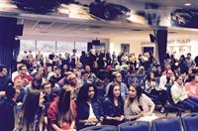
The 2016 Cardiff AAC Annual Presentation of Awards Evening will be held on Friday of this week (18th November) starting at 7.00pm. We shall again be at the Cardiff City Stadium (entrance off Leckwith Road), which was so successful as a venue last year and where there is plenty of parking space.
Cardiff's Olympic and Paralympic athletes will be there to present awards so you can have your photograph taken with Aled Davies, Steve Morris, Kevin Seaward and Charlotte Wingfield.
It is always a great evening so make sure you are there.
All athletes, coaches, volunteers and parents are welcome to attend and celebrate the fantastic talent that we have in Cardiff AAC.
Admission is a nominal £3 per person payable at the entrance to the venue.
This is the club's annual opportunity to recognise the achievements of its younger athletes, both individually and teams, and certificates and other awards will be made. Photographs of all recipients will be available.

A busy weekend (1) Monday 14 November 2016

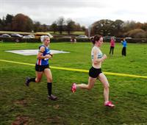
With the second round of the Gwent League in Brecon on Saturday, the Cross Challenge in Milton Keynes the same day and an international in Spain, Cardiff AAC had athletes competing in all three.
Clashes as well as illnesses meant that numbers at the Gwent League were down on the first round but there was still much to celebrate as the South Wales regional championships were incorporated and Cardiff athletes did well, with Jess Wadey, Morgan James, Bethan Evans, Jac Smith, Lucy Marland and Carwyn Jones all winning gold medals.
The under 17 men's regional championships saw Cardiff take the first three places with Morgan James first, Tom Nesham second and Jack McConkey third. Jac Smith and Sam Curwen were first and second respectively in the under 20 men's championship. Jess Wadey was first in the under 17 ladies' age group, Bethan Evans matched her in the under 20 ladies' race and Lucy Marland was the title winner in the senior ladies.
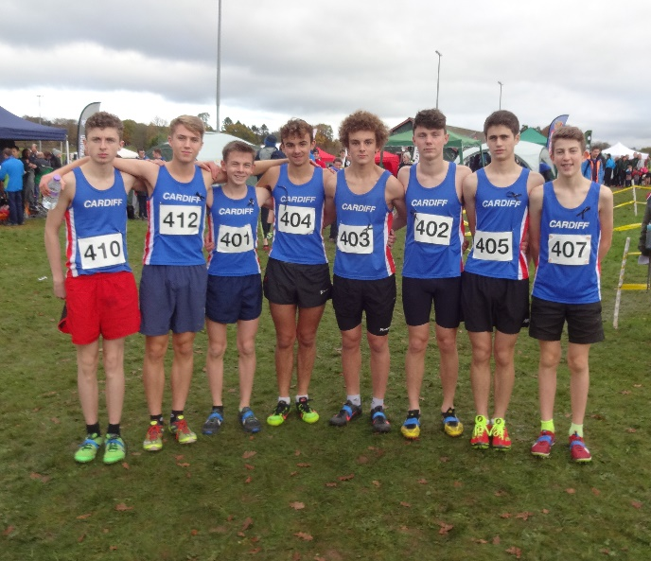 Cardiff's crack squad of under 17 men
The senior men's Gwent League race saw Carwyn Jones and Dan Nash (representing SE Cornwall) take a clear lead and this developed into a fascinating contest until Dan managed to get away from Carwyn on the last lap to take the race by around 50m.
A similar tussle had developed in the senior ladies' race with Lucy Marland in close contention until the final lap; she ultimately finished second but took the regional championship.
Best Cardiff performances in the Gwent League were:
Novice Girls: Millie Gold (36)
Novice Boys: Joseph Joyce (14)
Under 13 Girls: Lili Jones (16)
Under 13 Boys: Ben Macey (8)
Under 15 Girls: Mia Goddard (9)
Under 15 Boys: Kian Murphy (9)
Under 17 Ladies: Jess Wadey ( )
Under 17 Men: Morgan James (4)
Under 20 ladies: Bethan Evans ( )
Under 20 Men: Jac Smith (3)
Senior Women: Lucy Marland (2)
Senior Men: Carwyn Jones (2)
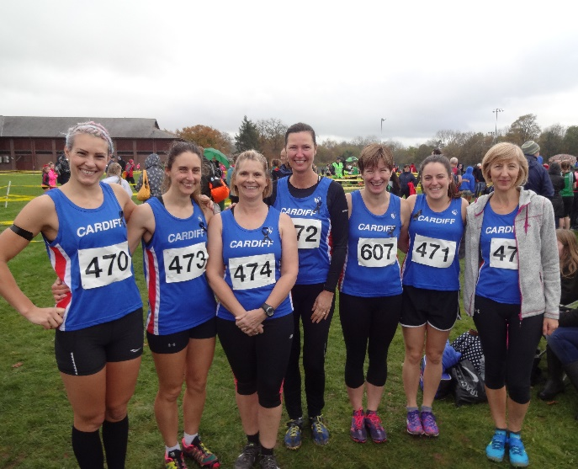 The senior ladies
The conditions in Brecon were perfect for cross country with little or no wind, fairly good underfoot and no rain. Despite absences through clashes and otherwise, Cardiff fielded teams in every age group and every athlete should be proud of giving 110% effort and producing some excellent results.
A nice touch was to see all the Cardiff athletes and team managers wearing black ribbons as a mark of respect and support for the two young Aldershot, Farnham and Distict AC who had tragically lost their lives a few days before.
The results will be available on the Gwent League website within the next few days.

A busy Weekend (2) Monday 14 November 2016

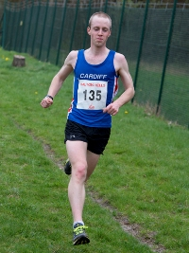
While his team mates were racing over the country Cardiff's Mike Kallenberg was representing Great Britain on Friday in the world 50k road race championships in the heat of Doha, where he finished an excellent sixth, a placing which improved both his position and time from last year’s 50k championships. Following an assured performance, 25-year-old Mike commented: "That was really tough tonight but I'm happy with my run and delighted that we are coming home with a silver medal."
Meanwhile, back on the country, the Cross Challenge took place on Saturday in Milton Keynes. The best performance came from Ryan Edwards in the under 13 boys' race where he finished an excellent second. The under 13 girls' race saw Eden Williams finish in eighth place while Nia Clatworthy was 14th in the under 15 girls' event.
Six Cardiff girls were on the start line of the under 17 girls' race and pride of place went to Abi Fisher (9th), followed by Naomi Reid (13th), Kiara Frizelle (16th), Carys Bill (25th), Megan Bowen (32nd) and Gracie Wheeler (35th).
And, finally, in a high quality international cross country challenge in Burgos, Spain, yesterday, Charlotte Arter, representing England, was 11th, Ieuan Thomas, representing Wales, was 33rd and Ciaran Lewis was 45th in the junior men's race. Liz Davies was one of the team managers.

Multi talents on show Wednesday 9 November 2016

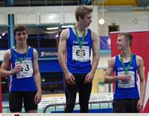
A good turn out at the combined Welsh Athletics and Welsh Schools combined event championships at Cardiff's NIAC last Sunday, 6th November, included numerous Cardiff AAC athletes in the various age groups.
Taking gold medals were Lauren Evans in the under 18 girls' category and Luca Contino in the under 16 boys. Silver medallists were Evie Wong, Daniel John and Harri Wheeler-Sexton with Harvey Reynolds taking a bronze.
The under 16 boys' category saw Cardiff athletes fill the first four places with Iestyn Edwards 7th.
Luca Contino's score of 2,960 earned him the gold medal and he was followed by Daniel John(silver -2,907), Harvey Reynolds (bronze - 2,669) and Ben Hillman (4th - 2,631). Iestyn Edwards scored 2,501.
In the under 18 boys' event, Harri Wheeler-Sexton accumulated 3,091 points for the silver, Tom Britt was fourth with 2,902 and Cameron Pamment 5th with 2,684.
Lauren Evans is an experienced multi-eventer and scored 3,281 for her win. Sarah Omoregie had been leading the competition until an injury forced her to withdraw after three events of the five.
Evie Wong was second in the under 14 girls category with a score for her four events of 1,974. Gabby Dickenson was fourth with 1,919. Georgina Edwards was seventh in the under 13 girs age group. Lily Gregson was 19th in the under 14 group with 747.
The under 16 girls saw Sofia Vella 4th (2,865), Lily Wheeler-Sexton 12th (2,003), Eve Pearson 13th (1,975) and Rhianna Satterley 17th (1,426).
The results can be viewed here.
A selection of photographs can be seen here.

Carwyn wins again Wednesday 9 November 2016

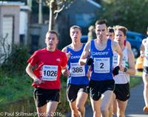
Cardiff's Carwyn Jones is enjoying a run of good form and took first place at the popular Richard Burton 10k road race in Cwmafon on Sunday last, 6th November, with James Hunt in third.
Having won the senior men's race at the first round of the Gwent League, Carwyn will be looking for a repeat performance in the second round in Brecon this weekend.
The senior ladies team (Carys Hughes - 3rd, Lucy Marland - 4th and Laura Wright - 11th) came home in first place.
Meanwhile, at the Leeds Abbey Dash 10k, Kevin Seaward, was 15th, Tom Marshall 16th and Matthew Clowes 22nd.
Another successful weekend for Cariff AAC.

Bernie on the board Sunday 30 October 2016

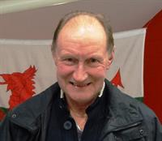
At the AGM of Welsh Athletics, held in Llandrindod Wells yesterday, Cardiff AAC chairman Bernie Plain MBE was elected as one of seven non-executive directors of the board of directors of Welsh Athletics. Alongside Bernie Christian Malcom and Dr Nicky Lewis were also elected.
Bernie said that he is proud to be able to serve Welsh athletics in this way and will regard himself as a voice for all clubs in Wales.
During the meeting a number of awards was announced and these include Meritorious Awards for Arwyn Davies and Bernie Plain and Awards of Honour for Kath Elias and Rhys Williams.
Awards are not handed out lightly and reflect the significant contributions that the recipients have made to athletics. Arwyn is, of course, a highly experienced and respected coach who has produced, and continues to produce many fine athletes. Bernie Plain is well known as a former Great Britain international athlete who went on to team manage Welsh and British teams and is now extremely active in his role as chairman of Cardiff AAC.
Kath Elias, a former athlete, has held numerous positions in the club, including as secretary and membership secretary, and has been a mainstay of Welsh Schools Athletics, also in numerous capacities. The criteria for an athlete to be considered for an Award of Honour are high and only a few Welsh athletes have received this honour. For his oustanding career as an international and medallist at the highest levels, Rhys joins a select band of Welsh athletes that includes Lynn Davies, Colin Jackson and David Greene.
Elsewhere in the meeting, Graham missed out on his bid to be chairman of the General Council, the vote going in favour of Sue Alvey from West Wales.
Cardiff had submitted a proposal that it should be a rule that the board of directors should always include at least two members with experience of running a club but this was not accepted. It was unsettling, however, to see that all the existing board members present at the meeting voted against. At least Bernie Plain is now on the board to represent the views of clubs.

Celebrating Success Thursday 27 October 2016

Cardiff's triumphant six and four stage road relay teams celebrated their successes in Nando's restaurant in Cardiff Bay last Sunday evening.
The celebration meal was organised by James Thie, who coaches several of the team members and who had himself run in the winning team in 1999.
Several of the celebrating athletes had taken part earlier in the day in the Welsh cross country relays in Monmouth, where the senior ladies had won and the men had come second.
The celebration was well deserved and a great time was had by all.

More successes Monday 24 October 2016

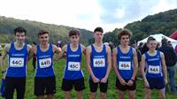
A week after the first round of the Gwent League, Cardiff's cross country runners travelled to Monmouth for the second edition of the Welsh Cross Country relay championships.
Despite late withdrawals from the junior teams, Cardiff had a successful day, returning with three championship titles (under 17 men and women and senior women), two runner up places and one third place.
The day started with the primary school straight races for under 11 boys and girls. In the boys' race, Elis Finlayson finished in second place and led the Cardiff team to the silver medal. Millie Gold was the highest placed in the girls' race, in 25th position.
The under 17 men's and women's relays saw Cardiff's crack squads take both titles as well as the fastest individual legs. Kiara Frizelle got the women off to a good start, handing over to Carys Bill a lead that was never challenged and it was left to Naomi Reid to clock the fastest leg and bring the team home to a comfortable win. Kiara ran the third fastest leg and Carys the fourth.
The under 17 men (Morgan James, Rhys Jones and James Vincent) won a close race, with James taking over in third place but running the fastest leg to bring the team home first; Morgan was the fourth fastest. The B team (Jack McConkey, Callum Russell and Owain Edwards) was fourth.
The senior women fielded two teams with the A squad (Lucy Marland, Carys Hughes and Kath Marshall) taking the title and the B team (Bethan Evans, Ffion Gregson-Lewis and Laura Wright) the bronze. Kath Marshall produced the third fastest leg.
In the senior men's race, Cardiff (Steve Morris, Ciaran Lewis, Tom Marshall anld James Thie) had to take second place on this occasion to Welsh rivals Swansea, with Tom Marshall running the fourth fastest leg.
Elsewhere, the under 13 girls were 7th, the under 15 girls' A team was 5th with the B team 6th and the under 15 boys' team was 4th.
Once again there was excellent team spirit and Cardiff has got the cross country season off to a very good start.
The official results can be seen here.

2016 AGM Wednesday 19 October 2016

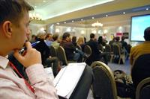
The 2016 Annual General Meeting of the club will be held at 8pm in the club room on Thursday 24th^{th} November.
The canteen will close at 7.45pm.
All paid up members of the club are encouraged to attend the AGM as it is an important occasion and the opportunity to hear about the activities of the club in the past year, to ask questions and to make decisions about the future.
The meeting usually lasts about an hour and includes the election of officers for the year ahead as well as deciding on any changes to the club's constitution
Any paid up member may nominate a person to one of the positions listed below or to propose changes to the club’s constitution or rules. If you wish to do this your proposal(s) (which must be supported by at least one other paid up member) must be sent in writing to the club chairman at least 21 days before the meeting (viz. by 2nd November).
The Who's Who page in the website contains details of the current officers and members of the general committee and the About the Club page includes the constitution.
The current holders of the principal officer positions are as follows:
President: Helen James (the President is traditionally elected for a two year term)
Chairman: Bernie Plain
Secretary: Vacant
Treasurer: Vacant
Membership Secretary: Bou Ligthart
Other positions that are elected at the AGM, and the current holders, are as follows:
Chairman of the track and field committee (Andrew Seary)
Secretary of the track and field committee
Cross Country and Road Coordinator
Coaching Coordinator (Gwyn Jones)
Two members elected at the Annual General Meeting

Good start to Cross Country Monday 17 October 2016

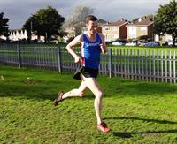
The popular Gwent Cross Country League got its 2016-17 series off to a good start in Bridgend yesterday, being blessed with good weather and good turnouts in all age groups.
Cardiff AAC was well represented and enjoyed a successful day with several winners and other high placings. With the senior men back to winning ways through club captain Carwyn Jones, other winners were Jacob Reynolds (U 13 boys), James Vincent (U17 boys), Ciaran Lewis (U20 men) and, subject to confirmation, Naomi Reid (U17 girls).
t was particularly pleasing to see so many Cardiff vests in the senior men's and women's races. Following Carwyn home in the men's race was Matthew Clowes in third spot with James Hunt not far behind while the senior ladies' race saw a tight finish for second place between Carys Hughes and Lucy Marland, with Carys taking the honours.
Ciaran Lewis was a runaway victor in the under twenty men's race, leading from the gun and never challenged. Jacob Reynolds also had a comfortable win in the under 13 boys' and we are hoping to see older brother Ben back in his racing shoes before long.
The under twenty and under seventeen men's races were held together and James Vincent was well up in the combined race to take the under seventeen honours.
At the time of writing this report, the result of the under 17 girls' race is not available but there was a sprint to the finish between Naomi Reid and Bethan Evans with Naomi edging out Bethan and, it is thought, winning the under 17 title in a joint race with the under twenty women.
Other best places by Cardiff athletes were Elis Finlayson's 6th in the under 11 boys' race, Millie Gold (just turned 9) 36th in the under 11 girls, Eden Williams a very good fifth in the under 13 girls, Rhys Morgan 21st in the under 15 boys and Nia Clatworthy 9th in the under 15 girls.
So a very good start to the cross country season and thanks must go to the mainly new group of team managers who supported the athletes yesterday with a special thanks to Mark Gold for coordinating the entries.
The team spirit amongst the athletes was brilliant as well as many parents experiencing cross country for the first time.
Next week sees the Welsh cross country relays in Monmouth and the next Gwent League round is in Brecon on Saturday 12th November.
The full results will be available on the Gwent League website later in the week.

Presentation - NEW DATE Friday 14 October 2016

PLEASE NOTE THAT THE PRESENTATION EVENING WILL BE ON FRIDAY 18th NOVEMBER AND NOT 22nd OCTOBER.
THIS IS BECAUSE MANY MEMBERS WHO WISHED TO ATTEND WOULD BE AWAY.
ALL OTHER ARRANGEMENTS ARE UNCHANGED.

Cardiff cleans up Thursday 13 October 2016

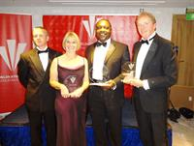
At the Welsh Athletics awards dinner, held at the Hilton Hotel in Cardiff last Saturday, 8th October, the lion’s share of awards went to Cardiff AAC, for both team and individual achievements.
Justifying its claim to be Wales’ premier club, Cardiff AAC was crowned Welsh Athletics’ overall club of the year, junior club of the year and endurance club of the year.
Rhys Williams was Athlete of the year, Jake Heyward junior athlete of the year, Bethan Davies female endurance athlete of the year and Ciaran Lewis junior endurance athlete of the year.
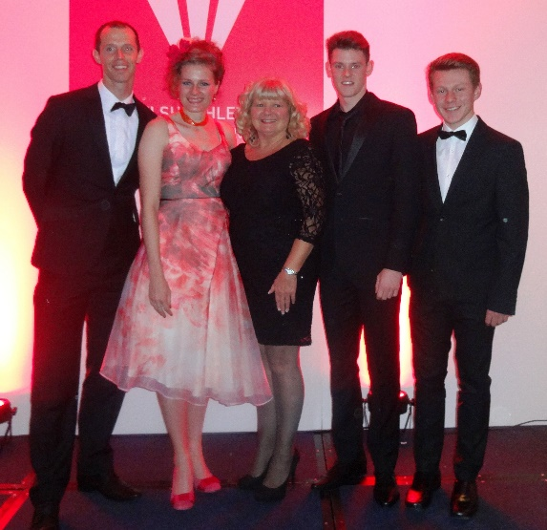
Rhys Williams, Bethan Davies, Helen James (President), Jake Heyward, Ciaran Lewis.
And that was not all. Jen Stone received an award as Newcomer to Officiating and Debbie Bull was justly rewarded for her years of work as Club Volunteer of the Year.
These awards reflect a highly successful year for Cardiff’s athletes and teams. Overall Cardiff retained the Wilkinson Sword trophy for the highest number of championship successes in all age groups while the senior men’s British Athletics League team won its divisional title and secured promotion back to the Division one of the BAL. The senior women’s team retained its place in division one of the UK Women’s League.
Cardiff’s junior UK Youth Development League (upper age group) team secured, for the first time, a place in the national final while the Welsh under 15 League team also retained its national title.
Earlier in the day, Cardiff had won the national six stage road relay, fully justifying its award of endurance club of the year. This followed successes in the Welsh cross country relays and the Welsh road relays as well as individual and team performances in the Welsh cross country championships..
Individually, pride of place goes to Jake Heyward for winning the gold medal in the 1500m at the inaugural European under 18 championships. Rhys Williams was back to near his best form and was fifth (and best British) in the final of the European Championships 400m hurdles in Amsterdam, narrowly missing out (unfairly in many people’s views) on an Olympic place. Ciaran Lewis excelled in numerous mountain running events and was rewarded with selection for Great Britain teams at both the European and World mountain running championships. Bethan Davies was by far the leading British walker, setting new Welsh records and narrowly missing selection for the Olympic Games.
Jen Stone joined Cardiff with her daughter not so many years ago but has quickly made an important mark as team manager, official and creator of Jen’s Joggers. Debbie Bull has carried out many jobs for Cardiff including membership secretary, team manager and home fixtures organiser; as well as filling similar roles for Welsh Athletics and the region.
The evening concluded with the induction of Christian Malcolm into the prestigious Welsh Athletics Hall of Fame, where he joins other Cardiff athletes Lynn Davies, Colin Jackson, Tanni Grey-Thompson, Berwyn Price, Jamie Baulch, Ron Jones, Steve Barry, Venissa Head, Kay Morley-Brown, Tim Benjamin (who made the presentation to Christian) and Angela Tooby-Smith. A galaxy of stars indeed.
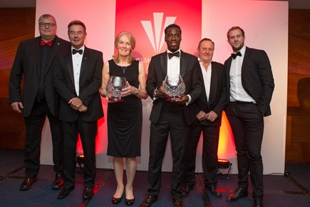
Shaun Pickering, Lynn Davies, Ruth Winthrop (Martin Jones), Christian Malcolm, Steve Barry, Tim Benjamin

Presentation Evening 2016 Tuesday 11 October 2016

The 2016 Cardiff AAC Annual Presentation of Awards Evening will be held on Saturday 22 October starting at 7.00pm. We shall again be the Cardiff City Stadium (entrance off Leckwith Road), which was so successful as a venue last year and where there is plenty of parking space.

Come along to this popular annual event and meet Cardiff's international athletes who will be helping with the presentations.
The Presentation evening is the culmination of the season and we shall, once again, be able to celebrate a very successful year.
All athletes, coaches, volunteers and parents are welcome to attend and celebrate the fantastic talent that we have in Cardiff AAC.
Admission is a nominal £3 per person payable at the entrance to the venue.
This is the club's annual opportunity to recognise the achievements of its younger athletes, both individually and teams, and certificates and other awards will be made. Photographs of all recipients will be available.

There will be a raffle and donations of prizes will be appreciated.
This is always a great evening so be sure not to miss it..

Kings of the road Sunday 9 October 2016

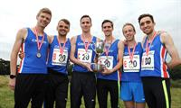
Cardiff's senior men clinched the title "kings of the roads" by winning the national six stage road relay in Birmingham's Sutton Park yesterday. After a ding-dong battle with Swansea over the latter stages, Tom Marshall outran former Cardiff member Jonathan Hopkins to bring the Cardiff team home to a magnificent victory. To underline Cardiff's superiority, the Men's B team was the first B team to finish, in 19th place and, to complete a perfect day for Cardiff, the senior ladies' team was also in the medals, taking the bronze.
The photograph of the winning team was kindly provided by Mark Shearman.
With seventy nine of the strongest men's road running teams in Britain contesting this prestigious championship, to win is a superb achievement.
Rowan Axe got the team off to a strong start, handing over to Matthew Clowes in fifth place. Matthew ran an excellent leg and arrived at the take over point in second. Team captain Carwyn Jones maintained Cardiff's strong position, slipping only one place, and was followed by Ieuan Thomas who recovered to second. On this leg, Swansea's Dewi Thomas, running the second fastest leg of the day, brought his club from fifth to first and this set the scene for a titanic battle between the Welsh rivals over the last two legs. Mike Kallenberg set off in pursuit of Jonathan Tobin, overtaking him to hand over a small lead to Tom Marshall, which he maintained to the end, Cardiff triumphing by three seconds after nearly two hours of racing with an overall time of 1:45.52.
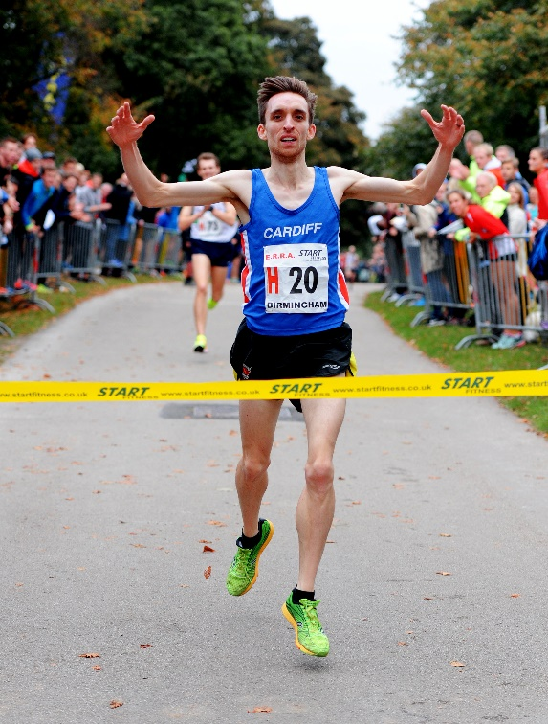 Tom Marshall
Cardiff have won this title once before, in 1999, when the first leg runner was James Thie; who now coaches several of yesterday's team and who, himself, ran in yesterday's B team.
Cardiff's B team (Ciaran Lewis, James Hunt, James Thie, Kevin Seaward, John Cove and Steve Morris) were nineteenth overall with a time of 1:51.34. Swansea's B team was the fifth B team to finish, in 30th place.
With two teams of six finishing in the first twenty, Cardiff has the makings of a powerful twelve stage team for the longer relay.
The ladies' race is run over four stages instead of six and sixty two complete teams finished. To come in the top ten in this company is excellent but to get a medal is outstanding. Cardiff's superb four ladies were led off by Lucy Marland who handed over to Kath Marshall in twenty seventh place. New Zealander 800m specialist Kath pulled the team up to twelfth and Charlotte Arter ran the fastest leg of the quartet to give the baton to Carys Hughes in third. Carys was not going to relinquish a medal position and held third spot through to the finish, holding off Leeds City AC by 12 seconds and less than a minute behind silver medallists Birchfield Harriers.
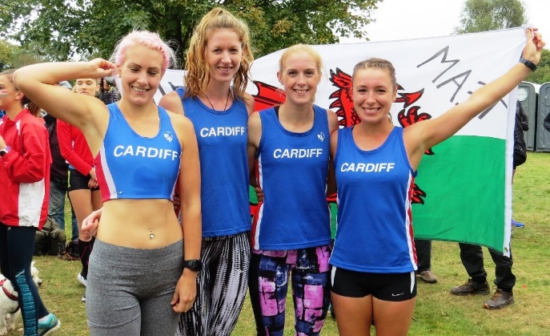 Lucy Marland, Kath Marshall, Charlotte Artur and Carys Hughes
Swansea's ladies finished in ninth so overall it was a fine day for Cardiff, Swansea and Welsh athletics.

Bernie's bid for the board Thursday 6 October 2016

Cardiff AAC chairman Bernie Plain has put his name forward for a position on the board of directors of Welsh Athletics.
The election will take place at Welsh Athletics' AGM in Llandrindod Wells on 29th October and Bernie is seeking the support of all Welsh clubs as he believes that it is important that the board includes members who have practical experience of the challenges of managing clubs on a day to day basis.
As a former distinguished international athlete (he was fourth in the 1974 European marathon championship) who represented Wales and Great Britain on many occasions, Bernie has spent his life in athletics and is well known throughout the sport. He is a former President of his club and is currently chairman, a role that means having to deal with the many practical questions that arise daily. He has also been heavily involved in the organisation of road and cross country events. Outside athletics, Bernie's activities included the governership of one of Cardiff's High Schools so he has plenty of the right kind of experience needed on the board.
In essence, he sees himself as a voice for the clubs.
Also standing for a senior position in the sport is Graham Webb, again a former Welsh and GB international athlete, former chairman of Cardiff AAC and a key figure in Welsh Schools athletics for many years.
Graham is standing for the position as chair of the General Council and hopes that clubs and regional councils will support him.

Easy win for Jacob Sunday 2 October 2016

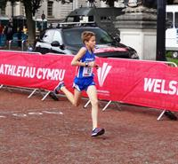
Cardiff's Jacob Reynolds was a comfortable winner of the under 13 boys' Welsh road mile championship held yesterday in Cardiff's Civic Centre. Leading from the gun, Jacob finished some 100m ahead of the field to collect the gold medal.
The senior men's championship was won by Tom Marshall and Kath Marshall made it a family double by winning the senior ladies' race. Cardiff's other gold medal winner was Nia Clatworthy in the under 15 girls' championship.
In the senior men's race, Tom Marshall was followed home by his coach James Thie and Owen Haswell, who took the silver and bronze medals repectively, while Lucy Marland took the bronze medal in the senior ladies' championship.
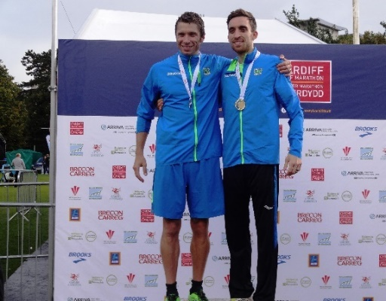 James Thie and Tom Marshall
James Thie also won the masters' title.
In the under 17 women's race, Carys Bill was second, Rhian Jones third and Ffion Gregson-Lewis third.
Eden Williams was third of the under 13 girls and eight year old Millie Gold finished in excellent style as the first girl home in the family fun run.
The annual Welsh road mile championships are held the day before the Cardiff half marathon and attracted a good number of spectators despite the weather which varied between bright sunshine and heavy rain. There is, however, an unanswered question; when the family fun run attracted almost 1000 participants, why were there so few entrants in the championship miles? One race had only four runners, three of whom were from Cardiff AAC.
The highlight of the weekend, however, was the world record set by Carwyn Jones and Mike Kallenberg during the Cardiff half marathon today. Running in Batman (Carwyn) and Robin (Mike) oufits, Mike clocked a very respectable 69:34 for 18th place and Carwyn was only two places behind with 70:45, times that comfortably improved the existing world record for the dynamic duo in a half marathon of around 75 minutes. Carwyn and Mike were running for charity but both found running in costumes very hot and difficult. "It was one of the hardest things I have ever done", said Mike after the race.

James Thie in AW Saturday 24 September 2016

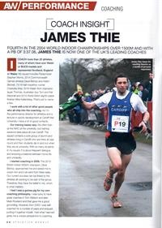
Former Cardiff AAC club captain, and now successful coach, James Thie was featured in this weekend's edition of Athletics Weekly in a two page spread.

A former successful athlete himself (he was fourth in the 2004 world indoor championships over 1500m), James has built an enviable reputation as a coach with a group of talented athletes that include numerous Cardiff AAC members. Steve Morris represented great Britain in the recent Rio Paralympic Games and was sixth in the T20 1500m.
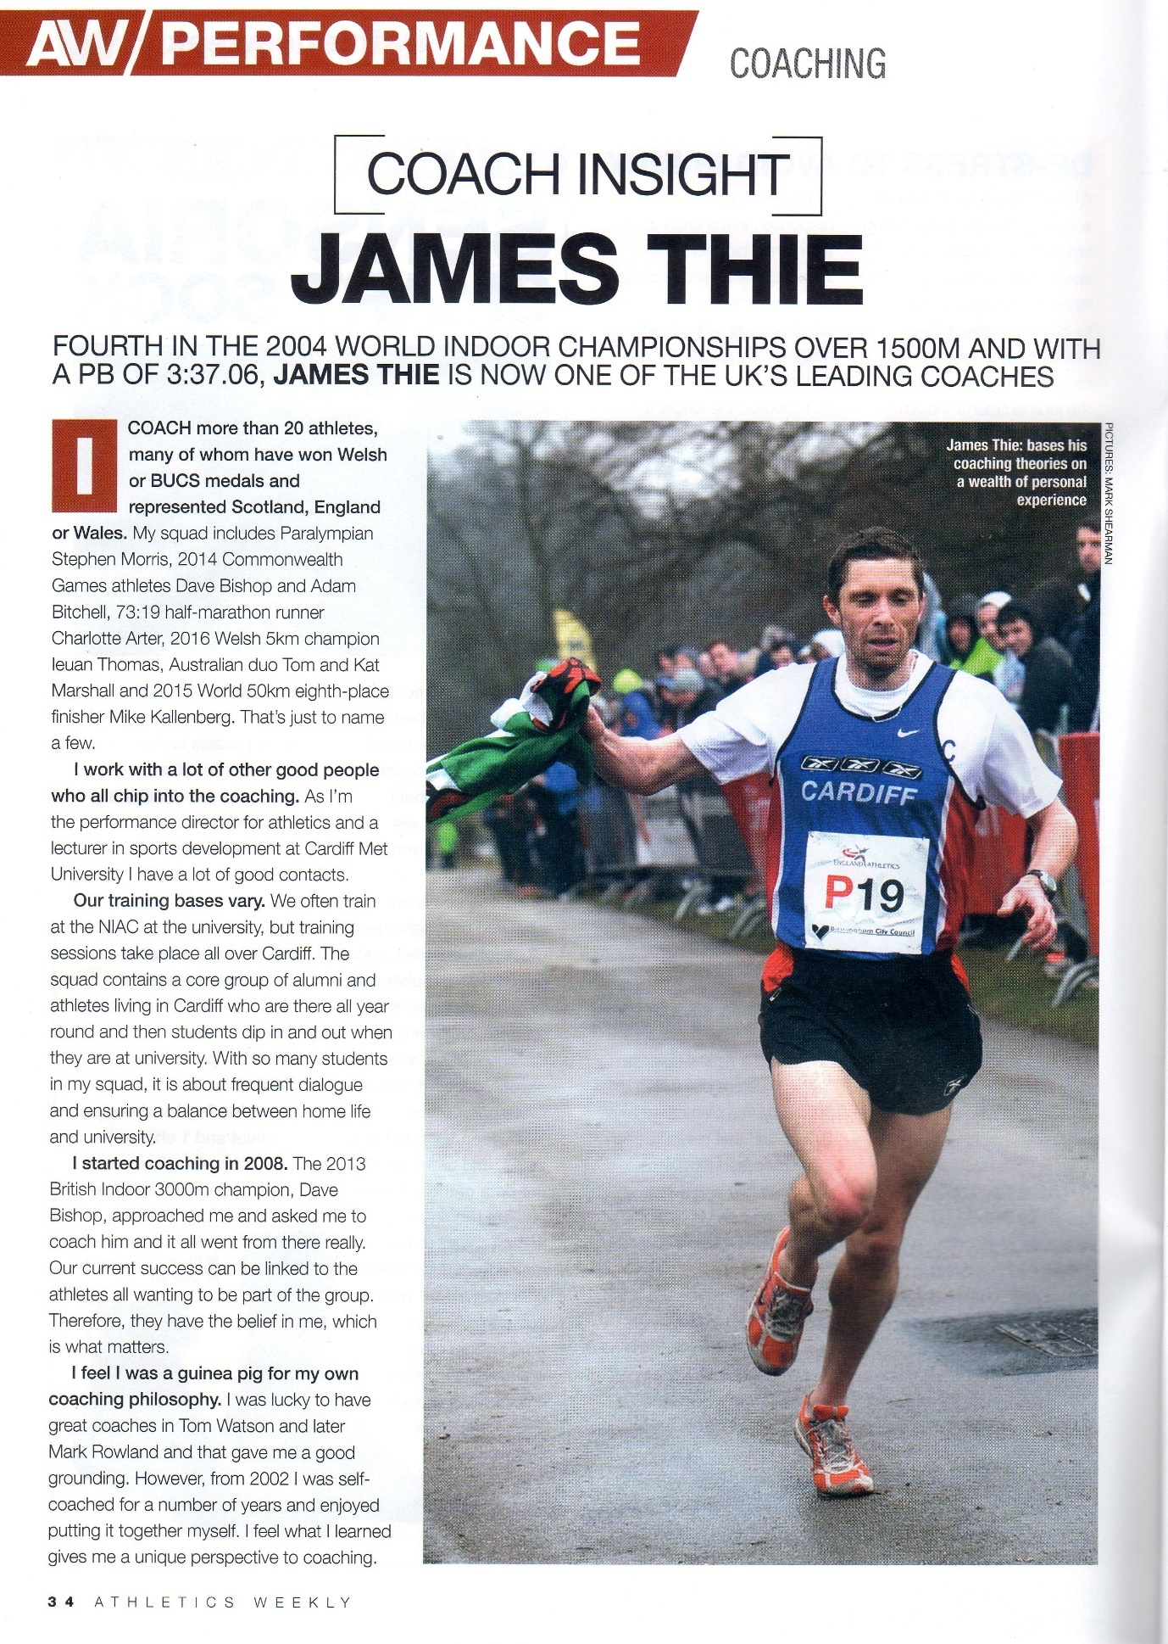

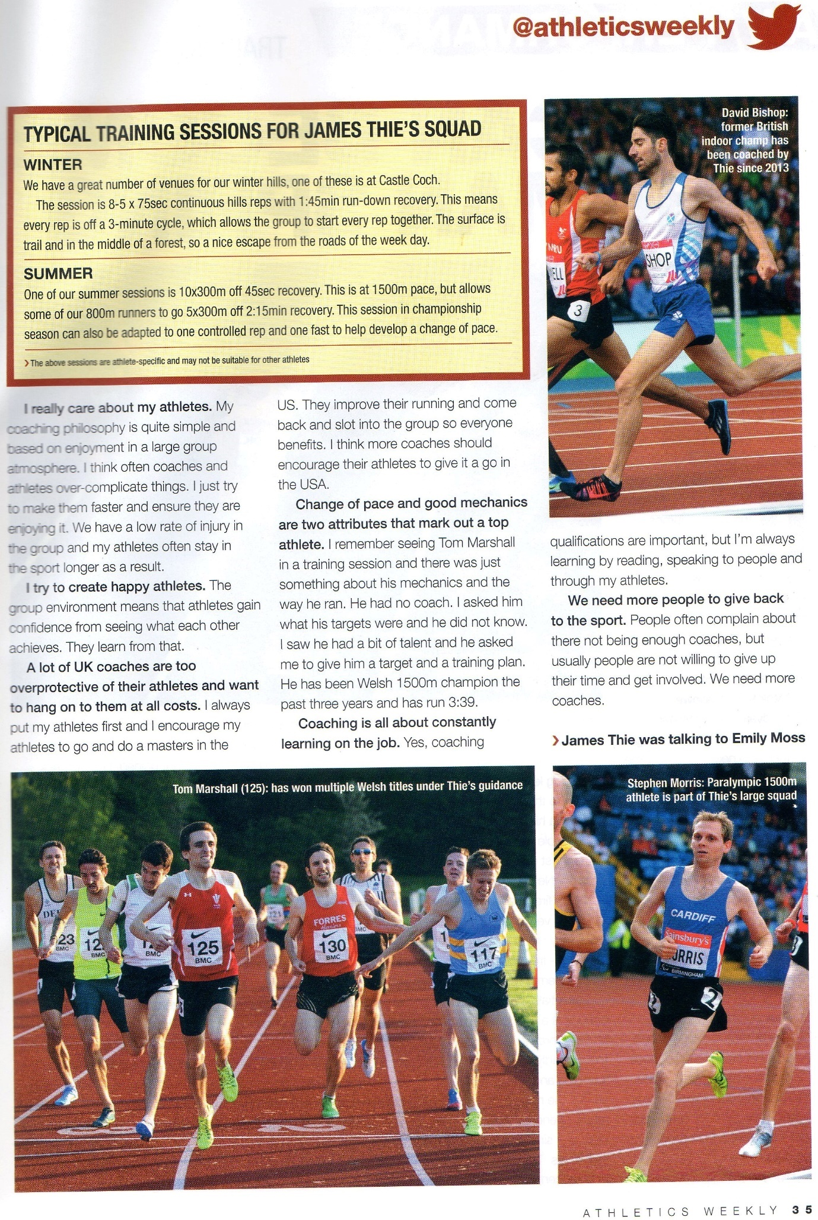

Medals for Ciaran and Jess Thursday 22 September 2016

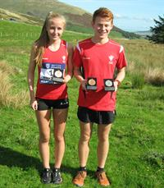
Cardiff's Ciaran Lewis and Jessica Wadey both returned with medals from the British and Irish Mountain Running Championships, held in the Lake District last Saturday, 17th September.
Ciaran is an experienced mountain runner and took the individual silver medal in the under 20 men's race, leading the Welsh team to the bronze medal.
Jessica was making her Welsh mountain running debut and was part of the Wales bronze medal winning under 17 team, finishing in 15th in the individual race.
The previous weekend, Ciaran had been in the Great Britain under 20 team at the World Mountain Running Championships in Bulgaria.

Busy weekend for Rachel Tuesday 20 September 2016

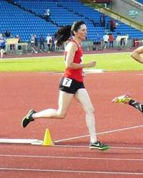
Cardiff's Rachel Matthews returned from the British Masters championships, held at Birmingham's Alexander Stadium on Saturday and Sunday last, with silver and bronze medals as well as a fourth placing.
On Saturday, Rachel took third place in the W40 category 400m and fourth in the 1500m. She returned on Sunday to take 2nd place in the W40 800m in a season's best 2:27.48.
Also competing in a Cardiff vest was Phil Rees who was the bronze medallist in the M75 discus.

Gold again for Aled Tuesday 13 September 2016

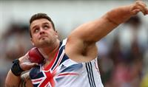
Cardiff's Aled Davies struck gold again by winning the F42 shot put at the Paralympic Games in Rio yesterday; to add to the gold medal in the discus and the bronze in the shot put that he won at the London games four years ago.
Aled's winning distance of 15.97m was a little short of his own world record but was better than every one of his rivals' attempts. The silver went to Iran and the bronze to South Africa.
A delighted Aled said: “I can’t believe I have done it to be honest. It has been a tough four years, and particularly a massive two years. I changed everything in 2014 and moved to coach Ryan Spencer-Jones. He believed in me and he has pushed my aspirations through the roof. Even today, I’m not very happy with the performance because I know I am in 16.5m shape. But it doesn’t matter; I have delivered on the Paralympic stage."
See Aled's winning put and post event interview by following this link.
Aled is now looking forward to the World Championships which will be held in London next year.
Aled was born with an incomplete right leg and has done brilliantly to overcome this disability, particularly in the events in which he specialises.
Congratulations to Aled (and Ryan). Cardiff AAC is proud of you.
In the T20 1500m final today (run in 36 degrees heat), on his 28th birthday, Steve Morris ran a well judged race, holding a leading place until he was overtaken in the final 150m and missing out on a medal in sixth place in 3:58.69.

Golds for the Golds Sunday 11 September 2016

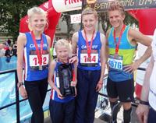
It was a golden day today for the Gold family as James (14) and Bethany (13) won the boys'and girls'family 2k fun run at the Cardiff 10k in Cardiff's city centre today. And to add to the family success, Millie (not yet 9) was officially second behind Bethany in the girls' race.
The siblings are pictured receiving their awards from BBC's Casualty actor George Rainsford.
In the main race (the 10k) Cardiff's Ieuan Thomas was in the leading group before finally finishing fourth and Lucy Marland was also amongst the early finishers. As the first Welsh finisher, Ieuan took the Welsh championship.
Once again, the race was blessed with fine weather and a turnout of over 5000 made it another success for race director Graham Finlayson and for the charity Kidney Wales Foundation.

The Academy is back Thursday 8 September 2016

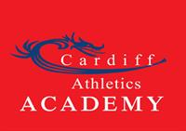
The popular Cardiff Athletics Academy has started back and registration is taking place on Monday and Thursday evenings (6-7 pm) in the Cardiff AAC club room.
As a result of high demand, the number of places for new Academy members is limited and will unfortunately only be available on a first come first served basis.
Existing Academy members will, of course, be given priority.
New enquiries will need to have completed an Academy enquiry form and will be added to the waiting list; we shall endeavour to find places assoon as possible.
To register please follow the below procedure.
1. Sign your child in on the sign-in sheet in the club room.
2. Go to the upper floor of the club room to pay the fees.
3. Head outside to the stand and wait to be called down to the track.
Please try to arrive early to avoid queueing.
Please note that if payment is not received by 19th September, your place will no longer be guaranteed.
Cheques are payable to Cardiff AAC; or cash on the day.
If you are not returning to the Academy, please let us know.
We look forward to welcoming you.
With kind regards,
"The Cardiff Athletics Academy team".

An experience Tuesday 6 September 2016

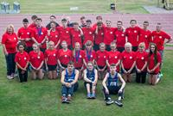
The final of the UKYDL (upper age group) in Bedford on Sunday last, 4th September, provided extremenly tough competition and, although finishing eighth, Cardiff's athletes will have learned from the experience.
Showing great team spirit, Cardiff produced seven individual event winners as well as two club records. In the under 17 men's discus, Jay Morse won with a personal best throw of 52.67m, improving Matthew Field's previous best of 51.12m set five years ago. The under 17 women's 4x300m relay team (Lana Culliford, Jessica Wadey, Jessica Hill & Naomi Reid) set a new record of 2:54.26.
Cardiff's individual event winners were: Ciaran Lewis (U20 2000m s/c A - in a PB of 6:10.96); Iwan Robinson-Booth (U17 100m B - equal PB of 11.11); Jay Morse (U17 Discus A); Bethan Gammon (U17 hammer B); Sarah Omoregie (U17 shot put A); Catrin Lord (U17 long jump B); Lois Hillman (U17 pole vault B).
The official results can be seen here.
A selection of photographs can be seen here.
Team manager Debbie Bull writes:
As I drove up to Bedford on Saturday afternoon, I was feeling really sorry for the athletes at the Lower Age Group Finals that day. The rain was lashing down and the prospect of a nine hour programme in that weather was not good.
Sunday morning arrived, bright and early and at 5.40am the bus pulled out of Sophia Gardens to begin the long journey to Bedford, arriving a little after 9.00am. The weather was to remain dry, if a little too breezy, for most of the day, with wind speeds of +4.9m/s recorded for the U20M B 100m race!
The fact we had made it this far in the League, our first National Final in this format for the Upper Age Group, is testament to the hard work and dedication of our athletes. To be mixing it with the likes of Blackheath & Bromley and Shaftesbury Barnet Harriers was truly an honour. There was a great atmosphere at the event, with team spirit shining through from all the teams. The match itself was very smoothly run, with careful planning very much in evidence. With formal reporting and walk-outs to the events, it prevented people running from event to event, filling gaps. While this is to be applauded on the whole, it did cost us the odd opportunity to cover some of the gaps which appeared in our team in the run up to the match. We were very unlucky to lose some very talented athletes in the last few days before the match. Some of these athletes were down for the more technical events and could not be backfilled with inexperienced volunteers at short notice.
As the day progressed, the long season, time off for holidays, illness and injuries started to take their toll.
It was commented that many of the athletes competing, had finished well in the European Championships this season.
The fact we finished in 8th place should not be taken as a sign we were out-classed. It was more a case of being out-numbered. Just 65 points more would have seen us finish in 6th place. If the match had been held a few weeks earlier, with the team at full strength, I have no doubt we could have finished around 4th or 5th.
We notched up a healthy 7 first places, 12 seconds and 16 thirds; so it was good to see all these athletes rewarded with gold, silver and bronze medals respectively.
I would like to thank everyone who helped out this season, athletes, parents, officials, coaches, volunteers of all descriptions.
You were awesome and proof of what can be achieved when we all work together as a Team!
Let's learn from the experience, get fitter, faster, stronger, re-group and go again next year.
Team Manager Alan Wadey added:
Great memories were created for so many yesterday. I'm sure there will be a few future big names that took part and all wil be able to say 'I competed with them....' with a sense of achievement and pride.

Big win for David Monday 5 September 2016

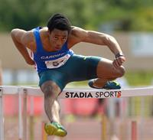
Cardiff's David Omoregie secured the biggest win of his career on Saturday last, 3rd September, at the prestigious ISTAF international in Berlin, clocking a legal personal best time of 13.24 and beating Rio Olympic fourth placer Pascal Martinot-Largarde (also 13.24) in a dip finish. Trailing in sixth place was Wilhem Belocian who had beaten David to the World Junior gold medal two years ago.
This time confirms David at number two in this year's UK rankings for 110m hurdles and sixth on the all-time list.
Elsewhere over the weekend, Emily Brown was the first woman home in the Caernarfon 10k, close to her personal best time for the distance.
In the United States, Rhianwedd Price, Rebecca Evans and Matthew Edwards all got there cross country seasons of to good starts.

Near miss for South Sunday 28 August 2016

With excellent contributions from Cardiff athletes, the South Wales region narrowly missed out on taking the Welsh inter regional championship in Brecon yesterday, placing second behind West Wales.
South Wales topped three of the six age groups with Cardiff AAC athletes winning events in each category.
Individual event winners for Cardiff were:
Senior men: Arron Owen (200m); Gareth Hopkins (400m); James Thie (1500m); Jac Palmer (hammer).
Senior women: Lucy Marland (1500m & 3000m); Ceri Jones (1500m steeplechase).
Under 17 men: Iwan Robinson-Booth (200m); Tom Hanson (shot put); Kieran Grimwade (hammer).
Under 17 women: Lana Culliford (300m hurdles); Grace Leggett (pole vault); Ffion Palmer (hammer).
Under 15 boys: Joseph Coope-Franklin (300m); Henry Gauntlett (javelin).
Under 15 girls: Cassey Grimwade (discus & hammer).
The match result was:
1. West Wales (999.5)
2. South Wales (948.5)
3. North Wales (672)
4. East Wales (585)

Champions again Monday 22 August 2016

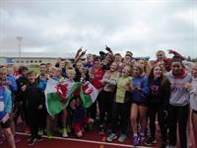
Cardiff AAC once again showed that it is Wales' best junior club by winning the Welsh Under 15 League final in Newport yesterday.
Leading from early in the day, Cardiff's lead grew and grew to an ultimate margin of over 100 points over second placed Cardiff Archers; despite the pole vault being cancelled, in which Cardiff would have done well. In 2015 Cardiff won by 94 points.
Issie Tustin and Daniel John collected the well deserved trophy from Welsh Athletics President Lynette Harries who remarked how good it was to see such enthusiasm.
The final result was:
1. Cardiff AAC (1,178)
2. Cardiff Archers (1,066)
3. Swansea H & AC (980)
4. Pembroke AC (871)
5. Carmarthen H (594)
6. Rhymney Valley AC (579)
7. Newport H (536)
8. Neath H (530)
Cardiff's individual event winners were:
Under 11 boys: Charlie Stockly-Jones (75m A & 150m A); Josh Beecher (75m B & 150m B & long jump A); Ellis Finlayson (800m A & shot put B); Ethan Witchell (shot put A).
Under 11 girls: Anna Halliday (75m B).
Under 13 boys: Ben Vincent (100m B & long jump A); Henry Spencer (800m A); Ben Hughes (800m B); Louis Rochefort-Shugar (75mH A & 200m B); Jacob Reynolds (1500m A); Lloyd Jones (1500m B).
Under 13 girls: Maddy Jones (100m A & 200m A); Holly Medina (100m B & 200m B); Alana Lea (800m A); Fiona Bostock (800m B); Gabby Dickinson (70mH B & long jump B); Eden Williams (1500m A); Jemima Robinson (1500m B); Lily Gregson (Discus B).
Under 15 boys: Joseph Coope-Franklin (300m A & 200m B); Harry Griffiths (300m B); Daniel John (800m A & 200m A); Harry Griffiths (800m B); Lloyd Clarke (Hammer B); Tyler Santos (javelin B).
Under 15 girls: Issie Tustin (100m A); Nia Grundy (100m B & 200m B); Lily Gaskin (300m A); Nia Clatworthy (1500m A); Mia Goddard (1500m B); Emma Fitzherbert (javelin B); Anais Rowlands (discus A); Rhianna Satterly (discus B).
Congratulations to the athletes for a great result and to team managers Huw Phillips, Mark Vincent and Lorraine Price for their massive contributions to this team.
The official results can be seen here.
A delighted team manager Mark Vincent writes:
Under 13 Boys:
The great summer of sport continues, Mr Bale and Wales did us proud in the football. Team GB have inspired and won a pot full of medals at the Olympics. However today was the day for great performances by our U13 Boys. All athletes that have competed this summer should be very proud of a very successful season, with plenty of outstanding performances and PBs along the way in both the WJL and YDL.
The boys competed against the best teams in Wales in the Cup Final, and amassed a total of 200 points. They were determined , focused and fought for every point, they all tried their very best and finished a very respectable 2nd in their age group just 12 points behind the Archers , contributing immensely to the overall team total and ultimately winning the cup in fine style.
A brief view of the day and some of our athletes:
We started the day with the walk, thank you the ever dependable Charlie Russell and one of our throwers Evan Jones for accepting the challenge. Charlie came in 3rd gaining valuable points to start the day. Unfortunately Evan was a little too anxious to do well, and didn’t quite make it home.
Out in the field we started with High Jump. We have struggled all year for U13 boys to jump for the club. I was desperate to fill slots on Thursday night and I had two volunteers, who may I add are such great team players that put their hand up. Lloyd Jones, a middle distance runner, who had never jumped before, was the hero. After literally 5 minutes of training from AJ, Lloyd stepped up with great confidence. He amazed everyone, his dad thought he was seeing things, but hey Lloyd you’re a natural! Lloyd cleared 1.25m, no mean feat for an U13, and he had a grin on his face all day!! Jay Thorne a sprinter was our second jumper also doing very well with 1.20m. Thank you so much boys for the points you scored.
Next on track the 100m and our A runner Louis Shugar was up against the best in a great race, coming in 4th in 13.70. Ben Vincent won the B race with a PB in 13.75.
Middle distance then took over on the track with the 800m. Henry Spencer after smashing his PB at the Welsh Champs the previous week, hit the track with great determination. He led from the start and made it look easy winning in 2.29. Not to be outdone another young star this season Ben Hughes was also pumped up for the B race. He also went onto win in confident style in 2.39.
Back on the field we had Evan Jones and Charlie Russell throwing the discus, both doing very well.
Mention hurdles to a lot of youngsters and they go rather pale! Again I was desperate to fill a slot …..step up relatively new member to the club Jay Thorne who again accepted this challenge at a very late stage. He didn’t look out of place in the B race coming 3rd in a G4 time of 14.67, thank you Jay. Our A hurdler who has shown great potential through this with both sprinting and hurdling was Louis Shugar. He ran and won an amazing race in a G1 time of 13.08, very well done Louis.
Evan Jones was at it again in the field this time, with Ben Hughes doing shot putt. At the same time Javelins were being thrown by Charlie Russell and Jay Thorne. All four boys again contributing well with the points tally and proving to be great team players.
On the track Ben Vincent and Louis Shugar were psyching themselves up for the 200m. Ben ran like the wind in the A race, coming 2nd in 28.57 just behind one of his main rivals of the season. Louis again excelled winning the B race with no problem in 29.14.
Another great positive this season has been having the number 1 middle distance runner in Wales running in the blue vest. Jacob Reynolds and brother Ben seem to have been winning medals and breaking records for years. Amazing to think Jacob is still an U13 with the times he achieves and races he wins. Of course the 1500m was never in doubt, he romped home way ahead of anybody. Still on a “high” from his jumping earlier in the day Lloyd Jones then went onto win the B 1500m. Maximum points for our middle distance runners in both 800 & 1500m, wow this was turning into a great day.
One more field event and after the disappointment of the Welsh Champs, Ben Vincent still 3rd in the UK rankings had something BIG to prove. Ben got in his 3 jumps, they were all huge and he won with a big smile on his face with 4.92m. Our second jumper was Thomas Reid who has been a consistent competitor this season, showing great promise with sprinting and jumping. Thomas our B jumper came 3rd with 4.03m.
Finally it was relay time. We have had to mix the relays frequently this season with boys missing from time to time, however have always done really well. Thomas ran a blistering 1st leg onto Ben who burned up the back straight. Great pass of the baton to Jay who ran a great bend. Louis in the final leg did his utmost to try and gain on the Archers, just missing out and we finished a very respectable 2nd .

Under 15 Boys
The WJL South East Wales U15 Champions were out in force for the final. Bolt had done the triple, Mo Farah the double and guess what our Team was determined to do the double and retain the silverware today on what was to be again a very special day for the club. On final day the U15 Boys’ team showed who the leaders in Wales at this age range are. Congratulations guys the results confirm that by getting a total of 243 points, you are the best in Wales!
Briefly the days report goes like this for this superb team:
Caerwyn Phillips an all round team player for many years and genuinely nice guy (just like his dad!) started things off well in the walk for the U15s coming 2nd close behind the winner. I had a gap to fill for the other walk slot. Step forward Harry Owen, another guy who will give anything a go for his team. Harry was surprised how difficult this event was, even though he did very well. Big respect to our walkers.
Starting things in the morning slot in the field Evan Morgan and Lloyd Clarke our hammer throwers. Both threw well with Evan 3rd in the A event 33.12 and Lloyd winning B with 28.50m.
Unfortunately we missed out on Pole vault points with the event being cancelled due to the safety of the uprights.
With Carter and Harvey away, Luca injured, Ben Hillman ran in a very strong A string 100m sprint. Ben has been progressing amazingly over the last year or so, and I think has grown at least 3ft taller!! This was not his day even though running a gutsy 100m he unfortunately picked up an injury and sadly pulled out of his other events. Louis Thorne was our B runner, another boy with natural talent on the track (it runs in his family …ask his mum!), he did very well 3rd with 12.92.
The man who does anything you ask with great enthusiasm Harry Owen and Lloyd Clarke brought home crucial points in shot. Lloyd coming 4th and Harry giving his all.
We now move onto two double winning stars, Joseph Coope Franklin and Harry Griffiths. Joseph continues to prove that he is one of the strongest sprinters in Wales. He was on fire, looking so strong winning A 300m 39.93 and B 200m 25.09. Harry , a great athlete who it has been great to see progress so well over a few years, won comfortably both the B string 300m 41.14 and 800m B 2.20.
Simeon Santiani was jumping well in high jump, however unfortunately at 1.50m had to head over to jump some hurdles. It was then left up to long serving junior star Jonathan Gibson to fight for the points. Again it’s been a pleasure watching this young man in competition over the years, today he came 3rd jumping 1.60m.
Two of the most established field event athletes Henry Gauntlett and Tyler Santos picked up their javelins. Both have regularly featured high in the UK rankings for this event. Both boys strive for perfection with their throws and did us proud. Henry threw 41.79, 2nd in A string and Tyler won the B string with 33.86.
With Ben injured, Louis Thorne helped the team stepping in less than half an hour before the gun went in the hurdles. Great to see that we have great team players with the Thorne Brothers on board.
A young man who has done it all I think through the years for the team, Daniel John was another of our stars to shine on the big stage. Dan had played the previous day in Bolton for Cardiff City, however nobody would believe it, as those legs certainly were not tired. Dan won both 800m A 2.09 and 200m 24.39 with ease .
Our long jumpers were Jonathan Gibson and Harry Owen . Both were a little bit off their best however the conditions were not the best for our jumpers with the rain starting to fall.
With Ben Reynolds injured, Rhys Morgan was called up for 1500m, thanks Rhys for running in the B race even though just returning from holiday. It has been nice to see Louis Spencer back recently after long term injury, another lovely boy who seems to have run well for the club for years.
Finally in the field Lloyd Clarke and Evan Morgan both did well in the discus with throws over 25m.
The relays always prove to be a highlight and an exciting climax to the day. We demolished the opposition winning in 48.74, more than a second faster than Pembroke. Louis Thorne off to a flying start, to Joseph like a speeding bullet on the back straight. Great change to Simeon , our own Bolt of lightning….onto Dan the Man who was never going to be caught on the last leg….BOOM!!!
It was hard selecting the team for the final as we can only enter 2 athletes per event and we have so much talent to choose from. However everybody selected that performed showed great spirit, gave 110% and you should all be very proud of yourselves.
There are several of our talented U15s that now move up to U17s next season….I’m sure that all of you boys will be welcomed with open arms because you really have the potential to go far, good luck to you all we all will miss you at the WJL fixtures.
Some U13s will move up to U15s, again this is very exciting with the amount of talented youngsters that we have. We also look forward with anticipation to welcoming boys from U11s to U13!!
We as Team Managers are proud to have been a small part of such a successful season. Thank you to all athletes, parents, coaches and club officials for being part of this great team.
Also we have the Club Presentation evening to look forward to probably in October, further details will be confirmed.
Now bring on the mud in the cross country season…….over and out until next season.
Mark Vincent-Your Proud Team Manager

Kings and queens of the road Monday 22 August 2016

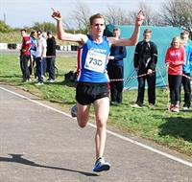
The Welsh 5k Road championships were held at Merthyr Mawr on Saturday 20th August, and, despite the poor conditions, Cardiff AAC scored a double victory, taking the team titles in both men's and women's races.
Ieuan Thomas took the individual senior men's title with Ciaran Lewis third (first under 20 man home) and James Hunt fourth (second under 20).
For the senior women, Camilla Barnes was 4th, Emily Brown 6th and Heddwyn Daniel 7th.
Laura Wright was second in the under 17 women's category and Morgan James was third under 17 man.
Other Cardiff athletes who took part were: Ryan Edwards (6th under 17 men); Ffion Gregson-Lewis (5th under 17 woman); Huw James (6th V45 men).
Elsewhere, Jessica Wadey has been selected to represent Wales in the British and Irish Mountain running championships. She was third in the Welsh Junior Trial Race held in Llanberis on Sunday last 21st August.

Best wishes to Alex and Ava Thursday 18 August 2016

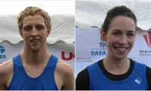
Alex Hains and Ava Hutchinson will be getting married in Ireland on Saturday and Cardiff AAC wishes them every success and happiness in their future life together.
Now living in Leicestershire, Alex joined the club 15 years ago and has been a regular on the middle and long distance running scene. Ava represented her native Ireland in the marathon at the London 2012 Olympic Games as well as in the European Cross Country Championships the same year.
Alex's mother Diane is one of the club's popular and repected middle distance coaches.
We hope that they all have a great day on Saturday.

Medals and PBs Monday 15 August 2016

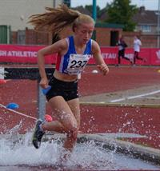
The Welsh under 20 all age groups championships were held in Newport on Saturday and Sunday just passed and Cardiff AAC athletes chalked up numerous medal winning and personal best performances.
Double gold medal winners were: Jacob Reynolds (under 13 boys' 800m & 1500m); Kristian Jones (under 20 men's 100m & 200m); Naomi Reid (Under 17 women's 1500m & under 20 women's 800m).
Other double medal winners were: Lloyd Clarke (under 15 boys' shot put & discus silvers); Issie Tustin (under 15 girls' 100m gold & 200m silver); Cassey Grimwade (under 15 girls' hammer gold & discus silver); Tom Atkinson (under 17 men's triple jump silver & 100m hurdles bronze); Bethan Evans (under 20 women's 1500m gold & 800m silver); Ceri Jones (under 20 women's pole vault gold & triple jump bronze).
The full list of Cardiff AAC medallists is:
Under 13 boys:
Gold: Jacob Reynolds (800m & 1500m).
Under 13 girls:
Silver: Eden Williams (1500m); Alana Lea (200m).
Bronze: Olivia Sugarman (200m); Molly McKerlich (1,000m walk).
Under 15 boys:
Gold: Daniel John (300m); Ben Hillman (long jump); Henry Gauntlett (javelin).
Silver: Joseph Coope-Franklin (300m); Lloyd Clarke (shot put & discus).
Bronze: Jonathan Gibson (high jump).
Under 15 girls:
Gold: Issie Tustin (100m); Anais Rowland (discus); Cassey Grimwade (hammer).
Silver: Issie Tustin (200m); Caitlin Leggett (pole vault); Cassey Grimwade (discus); Bethan Cushion (high jump); Angel Onwudiwe (shot put).
Bronze: Lily Gaskin (300m); Grace Leggett (pole vault).
Under 17 men:
Gold: James Vincent (1500m); Kieran Grimwade (hammer); Tom Britt (pole vault).
Silver: Iwan James (400m hurdles); Tom Atkinson (triple jump); Jay Morse (discus).
Bronze: Seth Kelly (400m hurdles); Iwan Robinson-Booth (200m); Tom Atkinson (100m hurdles); Daniel McKerlich (3,000m walk).
Under 17 women:
Gold: Naomi Reid (1500m); Jessica Wadey (1500m steeplechase).
Silver: Kiara Frizelle (1500m); Megan Hodgson (pole vault); Ffion Palmer (hammer).
Bronze: Lois Hillman (pole vault).
Under 20 men:
Gold: Kristian Jones (100m & 200m); Luke Harry (400m hurdles); Ryan Grimwade (pole vault); Richard Dangerfield (javelin).
Bronze: Iwan Robinson-Booth (100m); Aaron Owen (200m); Tom Trotman (high jump).
Under 20 women:
Gold: Bethan Evans (1500m); Naomi Reid (800m); Isabel Breeden (100m hurdles); Ceri Jones (pole vault); Shani Evans (high jump).
Silver: Bethan Evans (800m).
Bronze: Renee Moore (200m); Ceri Jones (triple jump).
The official results can be seen here.
A selection of photographs by Ceri Jones can be seen HERE and HERE.

Classy Naomi and Jake Wednesday 10 August 2016

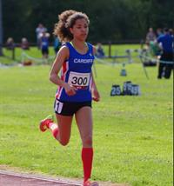
Amongst several excellent performances by Cardiff athletes at last Saturday's Celtic Games in Swansea, two stood out. Running in their Welsh vests, Naomi Reid and Jake Heyward each won their under eighteen 800m races comfortably but it was the manner of their races that caught the eye. Jake is, of course, the European champion at 1500m but both he and Naomi have made big steps up this year in their racing abilities.
Jake set a new Celtic Games rcord of 1:50.61 (just outside his personal best) and Naomi was named the Welsh female athletes' performance of the day.
The Welsh male athletes'performance of the day award went to Jay Morse for his win in the under sixteen discus.
Other Cardiff AAC winners were Sarah Omoregie in the under eighteen shot put, with a Games record of 15.10m and Lauren Evans who won the under eighteen high jump with a season's outdoor best equalling 1.66m. Kiara Frizelle won the under sixteen girls' 800m.

Ladies emulate the men Monday 8 August 2016

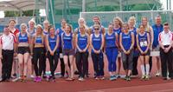
Cardiff's senior ladies UK Women's Athletic League team were not to be oudone by the men and also won their final round match, in Manchester yesterday, narrowly beating Woodford Green & Essex Ladies by two points, with Blackheath and Bromley AC further behind in third.
The ladies thus preserve their position in Division 1 and both men's and women's teams go into next season one division below their respective premierships.
The match result was:
1. Cardiff AAC (208)
2. Woodford Green & Essex Ladies (206.5)
3. Blackheath & Bromley AC (189)
4. Harrow AC (180)
5. Trafford AC (173.5)
6. Bristol & West AC (162)
7. Wigan & District H & AC (156)
8. Crawley AC (121)
The final positions at the end of the series are:
1. Blackheath & Bromley (21.5)
2. Woodford Green & Essex Ladies (20.5)
3. Bristol & West AC (16)
4. Trafford AC (14)
5. Cardiff AAC (13)
6. Harrow AC (11)
7. Crawley AC (6)
8. Wigan & District H & AC (5)
The official results can be seen here.
Although there were only three Cardiff individual event winners (Kath Marshall - 400m A; Amelia Reynolds - 400m B; Lucy Griffiths - Discus B), Cardiff finished on a high note by winning the last event of the day, the 4x400m relay.
A delighted team manager Sharon Heveran said, "The clubs in second and third to us are both going up to Premier League. Shows if we can get a full team out, like today, that we deserve promotion next year. I'm very excited for all the youngsters that are going to join the UKWAL Squad next year.
Well done Ladies. Super proud."
But she added a word of caution.
"I'd love to say that promotion changes anything but it doesn't. Until coaches schedule in BAL & UKWAL as part of the athletes' competition programmes we will always struggle. Responsibility lies with the coach. The athletes will do what they are told."
This is a problem that has bedevilled these two teams for several years and coaches have a responsibility to support the sport through the clubs as well as to the athletes themselves.
A selection of photographs taken by Gwyn Jones can be seen here.

Senior men promoted Saturday 6 August 2016

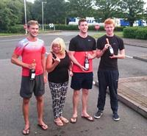
With an all-round team performance, Cardiff's senior men's team clinched promotion to Division 1 of the British Athletics League by winning the fourth and final match of the season at Nottingham today.
Cardiff had started well with Jac Palmer winning the first field event (the hammer) and Paul Bennett and Ryan Cooper taking the A and B races of the first track event (400m hurdles). Maintaining momentum, Cardiff finished well clear and are the Division 2 champions.
The match scores were:
1. Cardiff AAC (367)
2. Nottingham AC (287)
3. Swansea H & AC (274)
4=. Crawley AC (266)
4=. Bristol & west AC (266)
6. Kent AC (258)
7. Kingston Polytechnic H (254)
8. Bedford & County AC (227)
The overall position at the end of the series is:
1. Cardiff AAC (28 points) - Promoted
2. Swansea H & AC (25) - Promoted
3. Kingston Poly H (21)
4. Crawley AC (18.5)
5. Bristol & West AC (15.5)
6. Kent AC (15)
7. Notts AC (11)
8. Bedford & County AC (10)
Athletes of the match were John Cove (800m, 1500m and steeplechase) and Jason Copsey (third javelin win out of four). Athletes of the season are Kristian Jones and Brett Morse for the number of points scored).
In such an important team competition, it is invidious to pick out individuals as every team member is important and every point counts. Nevertheless event winners score big points and Cardiff's individual event winners were: Jac Palmer (Hammer A); Callum Court (Pole Vault B); Paul Bennett (400m Hurdles A); Ryan Cooper (400m Hurdles B); John Cove (800m B); Kristian Jones (100m B); David Omoregie (110m Hurdles A); Jo Reid (400m A); Jason Copsey (Javelin A); Richard Dangerfield (Javelin B); Anax Da Silva (200m B); Matthews Clowes (3000m B).
The match ended on a high note with the Cardiff squad (David Omoregie, James Griffiths, Anax da Silva and Kristian Jones) winning the 4x100m in a time of 40.76 which puts the team at fifth in the UK rankings and the fastest by a British club team. Anax and Kristian, despite being tired, then ran the first two legs of the 4x400m. Despite a solid third leg from Jo Reid, the team looked to finish down the order until an inspired last leg by Paul Bennett brought the team through to second place; narrowly missing a win. Phew!
The full results can be seen here. However, where A and B competitions are held together (mainly in the field events), some of the results are not correctly separated into A and B. However the correct allocation has been made for the points calculations.
A big thank you goes to team manager Andrew Seary who has steered the team this season. Andrew leaves tomorrow for a well deserved holiday in New Zealand, visiting his daughter.
Congratulations also to Swansea's men for gaining promotion in second place.

Treasurer needed Wednesday 3 August 2016

The club urgently needs someone to take over as treasurer from Steve Davies.
Steve has been an excellent treasurer for the past two years but has been forced reluctantly to step down because of pressure in his day job.
If you are interested to help the club in this way (or can suggest someone who is) please contact chairman Bernie Plain (07976 368 543) as soon as possible. You can be assured of plenty of help in what is an important role.

Cardiff second in final Monday 1 August 2016
Cardiff athletes travelled to Swansea yesterday for the final of the Welsh Athletics League and were rewarded with second place behind local rivals Swansea Harriers, scoring 900 points to Swansea's 1189 with Brecon AC third.
Elsewhere over the weekend, David Omeregie won the UK Inter-Counties 110m hurdles title in 13.37, his second best ever time but which, unfortunately, was wind assisted. David had won his heat in a legal 13.53. James Griffiths achieved a big personal best in the 100m with a legal heat time of 10.44; his previous legal best was 10.64.
Cardiff's event winners at the Welsh League final were:
Men: Joshua Brown (100m heat 1); Kris Jones (200m heat 1); Marklan Jackson (200m heat 2); Matthew Collins (200m heat 3); 4x100m; 4x400m.
Women: Rebecca Kennett (200m heat 1); Rachel Donnison (400m); Lucy Marland (3000m); Jessica Wadey (1500m steeplechase); Lois Hillman (pole vault); Catrin Lord (long jump); Eleni Zembashi (discus); Ffion Palmer (hammer); Ellie Stonehewer (triple jump); 4x400m.
The official results can be seen here.
A selection of photograhs taken by Ceri Jones can be seen here.

Aled and Steve go to Rio Saturday 30 July 2016

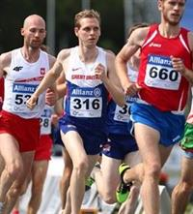
Cardiff AAC will have two representatives at the Paralympic Games in Rio.
Aled Davies will be representing Team GB in the F42 shot put and discus while Steve Morris will be contesting the T20 1500m.
Aled of course will be defending the title that he won four years ago in London.
Good luck to both.

Endurance club record & PBs Thursday 28 July 2016

Following its successful sprints evenings, Welsh Athletics organised an Endurance Open Meeting at Cardiff International Sports Campus yesterday evening and was rewarded with numerous personal best performances and a Cardiff AAC club record.
European Youth Champion at 1500m, Jake Heyward got the evening off to a good start by winning the first heat of the 800m in a personal best time of 1:50.53.
Later in the evening, Jacob Reynolds knocked five seconds off his personal best to improve his own under 13 boys 1500m club record with 4:37.27, taking him to seventh on the UK rankings.
Elsewhere, personal best times were falling thick and fast.
800m: Charlie Walker (1:55.32); Stephen Morris (1:56.06); Brian Dias (2:23.82); Kian Murphy (2:08.39); Charlotte Gaughan (2:11.27); Evan Griffiths (2:12.98); Nia Clatworthy (2:21.25); Mia Goddard (2:34.18); Ffion Gregson-Lewis (2:44.39); Ellie Powell (2:48.28); Caitlin Chapman (3:04.12).
1500m: Ieuan Jones (4:27.29); Jacob Reynolds (4:37.27); Alfie Davies (4:34.92); Lloyd Jones (4:57.78); Eli Scoble (5:01.92); Rachel Matthews (5:08.88); Carwyn Hastings (5:24.54).
The official results can be seen here.

Cardiff athletes in team Thursday 28 July 2016

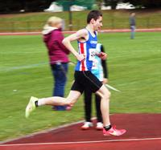
Cardiff AAC is well represented in the under 18 and under 16 teams to represent Wales in the Celtic Games international between Wales, Scotland and Ireland that takes place in Swansea on Saturday 6th August.
Leading the under 18 men's team is Jake Heyward (800m) who is joined by clubmates James Vincent (1500m) Tom Hanson (shot put) and Kieran Grimwade (hammer throw). The under 18 ladies' team includes Naomi Reid (800m), Bethan Evans (1500m), Abi Fisher (3000m), Sarah Omoregie (shot put) and Lauren Evans (high jump), with Catrin Lord (long jump), Megan Hodgson (pole vault) and Ffion Palmer (hammer) included as a development team.
The under 16 team includes Jay Morse (discus), Kiara Frizelle (800m) and Isabel Breeden (80m hurdles), with Issie Tustin (100m) and Luca Contino (high jump) in the development team.

Bedford here we come Sunday 24 July 2016

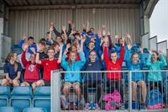
Cardiff's UK YDL (upper age group) team demolished the opposition in the fourth and final round match at Yeovil yesterday, winning by 81.5 points and qualifying outright for the national final in Bedford on 4th September.
Within a fine all-round team performance there were some magificent individual contributions, not least in the women's steeplechase.
Congratulations to the whole team and especially to the team managers and especially to Debbie Bull who has championed this team for so many years.
The famous four who ran in the women's 1500m steeplechase had never attempted the event before but decided to get their feet wet (literally) for the points. Carys Bill (who had already run the individual 3000m and 1500m), Jessica Wadey, Rhian Jones and Ceri Jones were cheered home by their team mates and supporters.
On a generally fine day, with occasional rain, Cardiff's athletes performed magnificently, with individuals too many to mention offering to compete in often unfamiliar events for the sake of the team.
Several athletes took part in three or more events; all-rounder Harry Hillman was in the 110m hurdles, the discus, javelin and long jump before running a leg of the 4x100m relay; Tom Trotman went in the high jump, hammer, shot put and triple jump; Naomi Reid in the 400m, 800m, 1500m plus a leg of the 4x400m; and Ceri Jones in the discus, hammer, javelin and pole vault as well as the steeplechase.
Cardiff's individual event winners were:
Under 20 men: Jac Smith (800m B & 1500m A); Ciaran Lewis (3000m A & 2000m steplechase A & triple jump B); Jack Eggington (3000m B); Harry Hillman (110m hurdles A); Luke Harry (400m hurdles A); Callum Stone (2000m steeplchase B); Richard Dangerfield (javelin A); Ryan Grimwade (pole vault A); Jasper Hawkins (pole vault B).
Under 17 men: Ieuan Jones (400m B); Tom Atkinson (100m hurdles B & triple jump A); Jay Morse (discus A & shot put A); Cameron Taylor (javelin A); Tom Britt (pole vault A).
Under 20 women: Naomi Reid (400m B); Georgia Cole (1500m B & 3000m B).
Under 17 women: Jessica Hill (300m A); Jessica Wadey (800m B); Naomi Reid (1500m A); Ellen Evans (discus B); Katie Roberts (shot put A); Catrin Lord (long jump A); Ellie May Stonehewer (long jump B & high jump B & triple jump B); Lois Hillman (pole vault B).
The match result was:
1. Cardiff AAC (794 points)
2. Team Avon (712.5)
3. Team Devon & Cornwall (681)
4. West Wales (531)
5. Yeovil & Wells City H (377)
6. South East Wales (222.5)
The final overall result of the series was:
1. Cardiff AAC (20 points)
2. Team Avon (19)
3. Team Devon & Cornwall (17)
4. West Wales (16)
5. Yeovil & Wells City H (8)
6. South East Wales (4)
The full results can be seen here.
Thanks to Ian Leek for the photograph of some of the team.
A selection of photographs taken by Ceri and Gwyn Jones can be seen here.
Team Managers Debbie Bull, Alan Wadey and Des Reid have done a great job to support this team and they, as well as the athletes, fully deserve the reward of a place in the national final. The competition in Bedford against the best clubs in Britain will be much harder than yesterday but, with the expected return of some of the club's strongest athletes, Cardiff has the potential to do well.
Congratulations and good luck.

Wins for Elliot and Rhys Saturday 23 July 2016

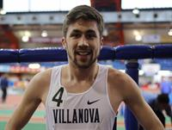
Competing at the Morton Games in Dublin last night, Elliot Slade set a big new personal best for 800m, winning the international race in 1:47.70. His previous best was 1:48.91 indoors. Elliot has been studying in the United States at Villanova University.
Also at the Morton Games, Rhys Williams won the international 400m hurdles in 49.50.

Charlotte picked for Rio Friday 22 July 2016

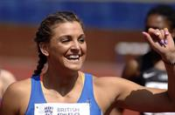
Cardiff AAC member Charlotte Wingfield has been selected to represent her home country Malta in the Rio Olympic Games.
As Maltese champion, she will compete in the 100m and 200m, events where she recently took the bronze medals at the Small States of Europe Athletic Championships. She was also bronze medallist at the Mediterranean under 23 championships and represented Malta at the European Championships in Amsterdam.
Congratulations Charlotte.

Athletics last night Thursday 21 July 2016

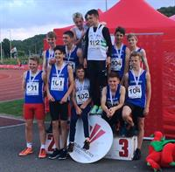
Whilst the Welsh Athletics International was going on at the Cardiff International Sports Campus, the third round of this year's SSAFA 5k road races was taking place and Cardiff athletes were prominent in both events.
In the SSAFA race, Cardiff filled second, third, fourth, seventh and eighth places through Carwyn Jones, Mike Kallenberg, Ciaran Lewis, James Hunt and Stephen Morris, whilst at Leckwith James Vincent set a personal best in the One Mile and Carys Bill won the Welsh under 17 women's 3000m championship gold medal.
Other winners at Leckwith were Paul Bennett (400m hurdles), Brett Morse (discus) and Aled Davies (shot put).
The under 15 boys' 4x100m A relay team (Ben Hillman, Joseph Franklin, Harvey Reynolds and Carter Staples) just lost out to Swansea in a very tight finish and the B team (Evan Griffiths, Matthew Register, Jack Jones and Louis Thorne) took third place to ensure silver and bronze. The under 15 girls' team (Lily Gaskin, Nia Grundy, Emanualla Kone and Issie Tustin) was also second.
The Welsh Athletics International results can be seen here.
The SSAFA results can be seen here.

Great team spirit Monday 18 July 2016

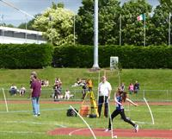
Cardiff's UK Youth Development League (lower age group) team travelled to Cheltenham on Saturday last, 16th July, for the fourth and final round of this year's campaign.
Team Managers Jen Stone and Annie Hillman thought that the team, weakened through absences, would struggle but a great team spirit throughout the day saw the squad come through to finish an excellent second behind league leaders Swansea, who go on to the national final. Cardiff has an outside chance of joining them, depending on a paper comparison of all the runners up.
After leaving the grey of Cardiff, Cheltenham enjoyed a day of sunshine (albeit with some wind) and the team finished on a high note with the 4x300m under 15 boys' team of Joseph Coope-Franklin, Harvey Reynolds, Harry Griffiths and Daniel John storming to victory by 150m in a time of 2:37.9, a club record, which places them in third place on the UK rankings, just behind second place Blackheath & Bromley's 2:37.3 and not far behind Windsor Slough Eton & Hounslow's leading tme of 2:36.7.
The match result was:
1. Swansea H & AC (660)
2. Cardiff AAC (548)
3. Cardiff Archers (506)
4. Cheltenham & County AC (476)
5. South Wales (234)
6. North Somerset AC (233)
The overall result for the season is:
1. Swansea H & AC (23)
2. Cardiff AAC (20)
3. Cardiff Archers (17)
4. Cheltenham & County AC (12)
5. South Wales (8)
6. North Somerset AC (4)
Cardiff's individual event winners were:
Under 15 boys: Daniel John (200m A & 300m A); Joseph Coope-Franklin (200m B); Harvey Reynolds (300m B); Ben Reynolds (1500m A); Louis Spencer (1500m B); Ben Hillman (Long Jump A & 80m hurdles B); Evan Morgan (Discus A); Tyler Santos (Javelin A); Jonathan Gibson (High Jump A & Long Jump B); Adam Mohsin (High Jump B).
Under 15 Girls: Nia Grundy (100m A); Cassey Grimwade (Discus A); Emma Fitzherbert (Javelin B); Grace Leggett (Pole Vault B).
Under 13 Girls: Elen James (800m B); Eden Williams (1200m A); Lily Gregson (Javelin B); Holly Medina (High Jump A).
The official results can be seen here:
A selection of photographs can be seen here.
The team managers reports:
Girls - Jen Stone:
The preparation for this match was difficult with many athletes unavailable for selection, especially in the U13 age group. However, those that did compete gave their all, with many filling in slots that they had never done before… but more of that later!
AJ could not be in attendance and only had six boys in the U13 age group, whereas I was ‘lucky’ with nine U13 girls. Annie Hillman and I spent the bus journey from rainy Cardiff to sunny, but windy, Cheltenham cajoling our Fab Fifteen into filling the gaps. There was no hesitation –“I’m no good at it but I’ll have a go” – it was going to be a team effort, that’s for sure.
The athletes did not disappoint. They all ran/threw/jumped their hearts out, the pride of wearing the Cardiff AAC vest spurring them on. The atmosphere was one of fun and enjoyment – just what athletics at this age is meant to be.
There were two highlights of the day for me. Emmanuella Kone provided the comedy moment of the season in the 75m Hurdles and how she managed to clear the last hurdle from a standing start showed the determination that was shown throughout the day. The other was Charlie Russell. He was asked to do the long jump or the 1500m – he opted for the 1500m, which is no mean feat for anyone let alone a thrower! He finished the race – his position was not important – and he gained valuable points for the team.
Thank you to all who competed, supported and officiated.
I was very proud of everyone and hope that the Mr Freezes enjoyed on the bus ride home helped cool everyone off!
This league is very important to the club as it is an opportunity for our young athletes to compete in a national league with top clubs; with all competing through the season for the cherished places in the National League Final. Winners of each division automatically progress to the final. We won the Midlands Premier SW League last year and enjoyed our day in the Final managing fifth place – that’s fifth place in the whole of the UK!
This year we are not so lucky as our second place today ensured that we have finished runners up to Swansea AC. Our only chance to be in the final is to be the winner of a paper match – which in effect is the winner of all second placed clubs in all of the YDL league tables nationally. We have a nervous wait until the end of July when the final league matches have been played out to see who we are up against.
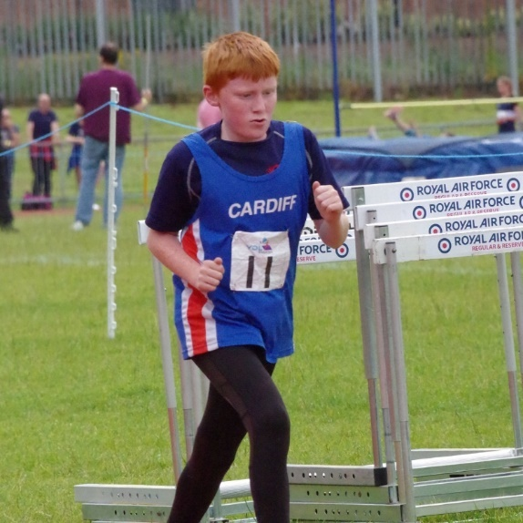
Boys - Annie Hillman / AJ
Some matches are easy. Some matches are stress-free. For some matches, everyone's available, and the team practically picks itself.
This match was none of those....
As the selection emails went out, the replies came back very quickly... "Sorry AJ, holiday, holiday, injured, holiday, SIAB, injured, holiday..."
Oh boy... here we go again...
This is the side of team managing that most people don't see. As TMs, we could say, "oh well, let's leave it at that". But, we don't. We keep trying to fill those gaps, to the last second. And we do it for one reason; we do it because those who will put on the vest deserve the effort.
No matter who is not available, we still have lots of heroes and champions who will be available...
Under 13 Boys
As with the under 15 boys, our two highest point scorers were missing; Luca enjoying a well earn break in NYC! and Ben Vincent cheering on big brother James who was flying the Welsh flag at SIAB.
We could not have asked for better heroes than the six under 13 boys that did compete in Cheltenham. "I'm not very good at it, but I'll give it ago", is what every team manager dreams of. Ben Hughes - Shot, Long Jump? No problem. Louis - High Jump? No problem. Jacob - Long Jump? No problem. Jay - High Jump? No problem. Lloyd – Javelin? No problem. The biggest hero of the day? Charlie - 1500m; no problem.
I have never seen that before. NONE of those are the events that they were selected for. And most were trying these out for the first time. Today wasn't about PB or personal performances for the Under 13 boys; this one was for Cardiff AAC.
If we do get to the Final again this year, these six boys will be the unsung heroes that we all need to thank for making sure we got there.
Under 15 Boys
Just like the under 13 boys, our two biggest point scorers were missing; Luca injured and the ever present Lloyd Clarke missing for the first time that I can recall.
But, even without Luca and Lloyd, the under 15 boys are still a very strong team. With Welsh champions and club record holders aplenty.
Speaking of club records, there was a very special one! A time of 2:37.9 in the 4x300m, gives Joseph Coope-Franklin, Harvey Reynolds, Harry Griffiths and Daniel John a slice of Cardiff AAC history. The previous record was held by Jake Heyward and Jordan Fender amongst others. Well done to the 2016 Fab Four!
Elsewhere, there were some excellent individual performances; PBs for Joseph and Harvey and Carter in the 100m. Daniel John ran the 200m for the first time this season, with a brilliant time of 23.9. Joseph was also a whisker outside his PB in the B race. Daniel and Harvey won both the A and B races in the 300m.
In the 800m, Harry Griffiths, who has been there for every match this year, got the points in the A race. Whilst Kian Murphy had a fantastic PB in the B race. In the 80m Hurdles, Matthew Register and Ben Hillman took more than half a second off their PBs.
The 1500m was very special - Ben Reynolds was back to his best, the serious injury now a distant memory. And Louis Spencer made a five second PB look like a stroll in the park, the boys winning the A and B races.
In the field events (without any bias), the High Jumpers stole the show, taking maximum points. Jonathan Gibson finally got the 1.60m that he's been chasing all year and Adam Mohsin, the forgotten man of the under 15 boys’ team, reminded himself how much he enjoys High Jump. A 1.60m PB was 20cm more than his season's best. In HJ, that's a lot!
The Long Jumpers were not to be outdone. Here too were maximum points with the latest member of the five metre club, Ben Hillman, winning the competition. The talented year eight has another year to build on his 5.09m PB. The Welsh LJ Champion, Jonathan Gibson, took the B points. In Pole Vault, Iestyn Edwards was the new name in the team, with a very good YDL debut of 2.00m. Adam too, achieved a PB of 2.00m.
There were mixed fortunes in the throws. Tyler Santos, as in every match this season, wore the Cardiff vest with pride with another solid throw in the Javelin and Louis Thorne stepped in to get the B points. With Luca absent, it was Ben Hillman and Louis Thorne (again!) filling in in the Shot to get valuable team points.
Evan Morgan had a Hammer competition to forget, but, a brilliant 25+ metres won the Discus A competition. Caerwyn Phillips got a late call to come into the team and picked up the points in the B event.
As for the Relays, we know what the 4x300m boys did. A new quartet also won the U15 4x100m, to make it eight wins out of eight in the YDL and WJL this year. The 4x300m team was unbeaten this year too.
And now, it's all over except for the paper playoffs! We will now be compared to the other runners-up in the YDL Premier Leagues. If we win the playoff, we will be in the YDL National Final for the second consecutive year. And that is exactly what this amazing class of 2016 deserves. Fingers crossed; there may be one more YDL match to come this year!!
Congratulations to everyone but especially to team managers Jen and Annie, who did a great job, as well as the club's officials who ensured that we filled our quota and made the day a success.

Honours for Sarah and Tom Monday 18 July 2016

With numerous Cardiff AAC athletes in the Welsh schools team that competed in the annual SIAB schools international between Wales, Scotland, England and Ireland on Saturday last, it was Sarah Omorehgie and Tom Hanson who came away with the honours.
Sarah was one of only two Welsh event winners, taking the girls shot put, while Tom's second place in the shot put with a personal best 16.20m earned for him the Most Meritorious Performance by a Welsh boy.
Other notable performances by Cardiff athletes included Jay Morse (silver in the discus), James Vincent (bronze in the 1500m), Ffion Palmer (bronze in the hammer) and Naomi Reid (fourth in the 800m). Fifth places came from Kieran Grimwade (hammer), Kiara Frizelle (1500m), Lauren Evans (80m hurdles, where she set a new personal best and club record of 11.77) and Megan Hodgson (pole vault).
The official results can be seen here.

Euro gold for Jake Sunday 17 July 2016

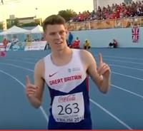
Athlete of the month in June, Jake Heyward has staked his claim for the award again in July by taking the gold medal at the European under 18 championships in Tbilisi, Georgia yesterday, 16th July.
After winning his heat, despite being tripped, Jake went into the final as the fastest European on display and the clear favourite. Despite slight illness in the days leading up to the final, Jake won a relatively slow, tactical race in 4:00.64 and is European champion.
Commenting after the race, Jake said, "I’m ecstatic - it’s so nice to see the hard work paying off. I got injured in the winter, so it’s been a bit of a slog getting back. I’m just so happy to pull it off on the day.
“I knew that as long as I was in contention, no one was going to match me in the last 100m. My roommate Jake Norris and I have been a bit under the weather, but when I saw that he got silver, I had no excuse not to come out and deliver.”
Many congratulations to Jake and to his coach Paul Darney.
You can watch Jake's race on Youtube by clicking here.

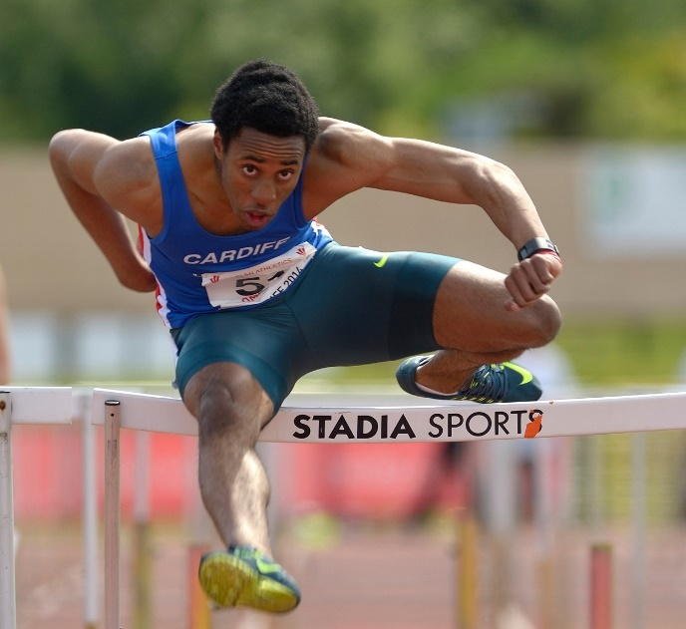
Meanwhile, in the Loghborough open meeting, also on Saturday, David Omoregie raced (literally) to the top of the UK rankings with a brilliant personal best of 13.25 for the 110m hurdles. David ran 13.46 in his heat and both times are inside UK Athletics standard for the Olympic Games. Will David be added to the team at the last minute?

No Rio for Rhys Saturday 16 July 2016

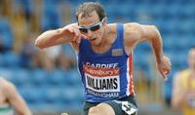
Cardiff's Rhys Williams has had his appeal against non-selection for the Olympic Games turned down by UK Athletics.
Automatic qualification required that an athlete come in the first two at the UK trials and have at least two qualifying times. A third place was available at the discretion of the selectors. Rhys came third at the trials and achieved his second qualifying time at the European Championships last week where he came fifth in the final and was the best British performer in his event, the 400m hurdles. He was omitted from the Olympic team and appealed. His appeal was supported by Welsh Athletics.
Rhys has a unique record of medal winning at the European Championships and is ranked number two in the UK, above one of the athletes who has been selected.
UK Athletics' philosophy on selection for major championships is hard to understand and, without taking away anything from the athletes who have been given discretionary places in the Olympic team, it is difficult to discern a consistency, which makes Rhys's omission all the harder to understand. It is particularly hard to defend a decision to inform Rhys a few days before the European Championships that the goal posts had been moved and, if he was to be considered for Rio, he would have to run even faster in Amsterdam. This is extremely unfair on any athlete and UK Athletics should re-consider its stance.
Rhys is entitled to think that he has been treated badly.

Ladies first Thursday 14 July 2016

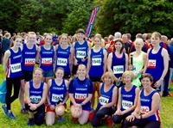
Cardiff AAC were represented by no fewer than five ladies' teams at the popular Cosmeston Relays, held in Cosmeston Park, Penarth last night.
The A team of Ffion and Rhianwedd Price and Emily Brown were not only the winners of the senior ladies category but were first home of the entire race, including all the men's teams.
The senior ladies B team (Rachael Newport, Zoe McParlin and Hannah Pretty) were 8th in their category while the C team (Rachel Matthews, Cery Ash and Helen John) were 4th master ladies (35-44) and the D team (Karen Seary, Emma Smith and Jen Stone) were 6th master ladies (45-54). JensJoggers (Beth Jones, Annie Hillman and Ruth Wright) were 15th allcomers women.
What a great turnout by the Cardiff ladies, some of whom had not even run 5k twelve months ago.
Congratulations also to Jen Stone for organising the teams.
The results can be seen here.

Juniors off to final Monday 11 July 2016

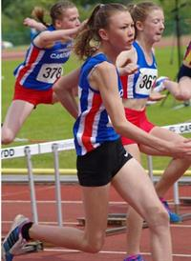
With the advantage of a home match, Cardiff's Welsh Under 15 League team were clear winners of the fourth round match at Cardiff International Sports Campus on Saturday last 9th July.

Cardiff, along with Cardiff Archers, Rhymney Valley AC and Newport Harriers are qualified from the South East division to the national final and Cardiff will be looking to retain the title that they won last year.

The Welsh final will be held in Newport on Sunday 20th August.
Cardiff's individual event winners were:
Under 11 girls: Anna Halliday (75m heat 5 & 150m heat 5); Molly Type (150m heat 4); Maddie Lea (800m heat 3).
Under 11 boys: Gethin Dobbs-Evans (75m heat 4); Charlie Stockly-Jones (75m heat 5 & 150m heat 6); Josh Beecher (150m heat 4 & long jump).
Under 13 girls: Holly Medina (100m heat 1 & 200m heat 1); Anne Miles (100m heat 3); Alana Lea (200m heat 5 & 800m heat 1); Eden Williams (1500m heat 1); Molly McKerlich (1000m walk); Evie Wong (70m hurdles heat 1); Gabbie Dickinson (long jump).
Under 13 boys: Louis Rochefort-Shuga (100m heat 1); Thomas Reid (100m heat 2); Jacob Reynolds (800m heat 1); Ryan Edwards (1500m heat 1); Ben Vincent (long jump).
Under 15 girls: Issie Tustin (100m heat 1 & 200m heat 1); Lily Gasdkin (200m heat 2 & 300m heat 1); Catrin Jones (1000m walk); Caitlin Leggett (pole vault); Cassey Grimwade (hammer).
Under 15 boys: Carter Staples (100m heat 2); Joseph Coope-Franklin (200m heat 3); Daniel John (800m heat 1); Evan Griffiths (800m heat 2); Caerwyn Phillips (1000m walk); Matthew Register (80m hurdles heat 1); Evan Morgan (discus & hammer); Henry Gauntlett (javelin).
The match score was:
1. Cardiff AAC (1536 points)
2. Cardiff Archers (1487)
3. Rhymney Valley AC (882)
4. Blaenau Gwent AC (774)
5. Newport Harriers (769)
6. Cwmbran Harriers (542)
7. Hereford & County AC (493)
8. Rhondda AC (256)
9. Aberdare Valley AC (131)
The final results can be seen here.
A selection of photographs can be seen here.

Senior women slip Tuesday 5 July 2016

After finishing a creditable fifth in the first round match of this year's UK Women's Athletics League, Cardiff's senior ladies slipped to seventh place last Sunday, 3rd July, at the Lee Valley stadium in London.
Cardiff finished the day on a good note by winning the final event, the 4x400m relay but now need an improved performance in the third and final round on 7th August in Manchester in order to retain its place in this division.
Once again, team captain Rhiannon Linington-Payne led by example, taking part in three individual events and both relays.
The match result was:
1. Blackheath & Bromley AC (220.5)
2. Bristol & West AC (213)
3. Woodford Green & Essex Ladies (191)
4. Crawley AC (183.5)
5. Trafford AC (167.5)
6. Harrow AC (149.5)
7. Cardiff AAC (138)
8. Wigan & District H (133)
The league position after two rounds is:
1. Blackheath & Bromley AC (15)
2. Woodford Green & Essex Ladies (14)
3. Bristol & West AC (13)
4. Trafford AC (9)
5. Harrow AC (6) (315 match points)
6. Crawley AC (6) (298.5 match points)
7. Cardiff AAC (6) (292 match points)
8. Wigan & Districy AC (3)
With three clubs each having 6 points, the tussle in the final match to avoid relegation will be close.
The official results can be seen here.

Senior men still lead - just Monday 4 July 2016
With a team depleted by clashes with other events, Cardiff's British Athletics League team slipped to fourth place in the third round match held in Kingston on Saturday last, 2nd July, but still lead the division overall by one point.
With Brett Morse and Curtis Mathews competing in seven events between them, the team finished on a high note by winning both the 4x100m and 4x400m relays.
With one match to go, a strong team is needed for the final round to assure promotion to Division one.
Individual event winners for Cardiff were: James Griffiths (100m A); Gareth Warburton (800m A); Carl Hill (800m B); Paul Bennett (400m hurdles A); Brett Morse (Discus A); Curtis Mathews (Discus B).
The match result was:
1. Kingston & Polytechnic H (347)
2. Crawley AC (343)
3. Swansea H & AC (314.5)
4. Cardiff AAC (297)
5. Kent AC (290.5)
6. Bedford AC (210)
7. Notts AC (208)
8. Bristol & West AC (138).
The league position after three rounds is:
1. Cardiff AAC (20)
2. Swansea H & AC (19)
3. Kingston & Poly AC (19)
4. Crawley AC (14)
5. Kent AC (12)
6. Bristol & West AC (11)
7. Bedford AC (9)
8. Notts AC (4)
The official results can be seen here.

Schools champions Sunday 3 July 2016

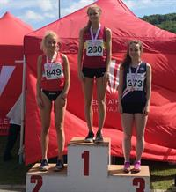
With plenty of Cardiff athletes representing their schools, the Welsh Schools championships were held in Cardiff yesterday; on a day that was warm and sunny (but a little windy) after early rain.
Championship best performances were achieved by Kristian Jones (senior boys' 200m in 21.82), Sarah Omoregie (middle girls' shot put with 14.23m) and Ffion Palmer, who also set new Welsh and club records in the middle girls' hammer with 55.53m.
Double gold medals were achieved by Kristian Jones (100m & 200m) and Lauren Evans (middle girls' high jump and 80m hurdles).
Cardiff athletes who are now also Welsh Schools champions are:
Senior Boys: Kristian Jones (100m & 200m); Jasper Hawkins (pole vault); Richard Dangerfield (javelin).
Senior Girls: Rebecca Kennett (100m); Bethan Evans (1500m); Georgia Cole (3000m); Tasia Stephens (javelin).
Middle Boys: James Vincent (1500m); Thomas Hanson (shot put); Kieran Grimwade (hammer).
Middle Girls: Naomi Reid (800m); Kiara Frizelle (1500m); Abi Fisher (3000m); Lauren Evans (high jump & 80m hurdles); Sarah Omoregie (shot put); Ffion Palmer (hammer).
Junior Boys: Daniel John (300m).
Junior Girls: Issie Tustin (100m).
The official results can be seen here.

Sprinters galore Thursday 30 June 2016

With Cardiff AAC sprinters turning out in force, the second Welsh Athletics sprints open meeting went ahead last night in Cardiff and, despite the damp, dreary and chilly conditions, a favourable wind that, for most races was within the legal limit, helped to produce numerous personal best performances.
Seventy two athletes (including thirty five from Cardiff) contested ten heats of the 100m, with Cardiff athletes winning seven of them.
It was a pity that the weather was poor, but this is a good initiative by Welsh Athletics and should continue.
The results of both 100m and 200m races can be seen here.

GB vest for Jake Wednesday 29 June 2016

Cardiff's Jake Heyward (17), who joined the club when he was only ten, has been selected to represent Great Britain in the 1500m at the first ever European youth championships, to be held in Tbilisi, Georgia from 14th to 17th July.
The youth championships are for athletes aged 16 or 17 on 31 December 2016.
Jake is the current UK under 20 champion at 1500m as well as Welsh senior champion over 800m and has improved his 1500m time by over 10 seconds this year.
His personal best time of 3:46.50 places him second on the latest European rankings, behind Jakob Ingebritsen of Norway, who is not yet 16 but has a best time of 3:42.44. Jake is coached by senior Cardiff coach and long-time member Paul Darney.
It should be a great race between Jake and Jakob and we say congratulations and good luck to Jake.

Rhys in Euro team Tuesday 28 June 2016

Cardiff's Rhys Williams, former European champion at 400m hurdles, has been included in the Great Britain team for the European Athletics championships which take place in Amsterdam next week.
Ranked number two in the UK with 49.22, Rhys clinched his place after coming third in the British Championships last weekend. He now has a good opportunity to secure his second Olympic qualifying time and persuade the selectors to add him to the team for Rio.
In a distinguished career, Rhys has the unique distinction of having won individual European Gold medals over 400m hurdles at Junior, Under 23 and senior level, as well as silver and bronze at senior level. He also has 4x400m relay silver medals at European Junior and Under 23 levels, not to mention a Commonwelth Games bronze medal.
His full list of medals is:
Gold: European Junior 2003; European Under 23 2005; European 2012.
Silver: European 2010; European 4x400m 2006; European 4x400 Under 23 2005.
Bronze: European 2006; Commonwealth Games 2010.
Good luck to Rhys in Amsterdam.

The final beckons Monday 27 June 2016

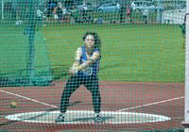
Cardiff's UK Youth Development League (U20/U17) team finished an excellent second in the third round match in Carmarthen yesterday, 26th June.
After finishing third in the first round in Plymouth and then winning in Newport, Cardiff and Team Avon both have 14 league points although Team Avon has more match points, which technically places them as the leaders. If Cardiff can win the final round in Yeovil on 24th July, the team will qualify for the national final in Bedford on 4th September, thus emulating last year's achievement by the U15/U13 team.
In wet and windy conditions (what a surprise!), team spirit was evident with athletes taking on multiple events for the points. The competition between Cardiff and three composite teams at the top of the division was quite close with West Wales coming out on top, but only 23 points ahead of Cardiff, with Teams Avon and Devon & Cornwall only a further 20 points behind.
Cardiff's individual event winners were:
Under 20 men: Aaron Owen (100m A); Richard Lee (100m B); Harry Hillman (110m Hurdles A); Richard Dangerfield (Javelin A); Jordan Fender (Long Jump A); Ryan Grimwade (Pole Vault A); Jasper Hawkins (Pole Vault B).
Under 17 men: Iwan James (400m B); Harry Wheeler-Sexton (100m Hurdles A); Tom Atkinson (100m Hurdles B & Triple Jump A); Kieran Grimwade (Hammer A); Jay Morse (Hammer B); Tom Hanson (Shot Put A).
Under 20 women: Rebecca Kennett (100m A); Eleanor Stephenson-Wilding (400m B); Georgia Cole (1500m B); Bethan Evans (3000m A); Isabel Breeden (100m Hurdles A); Ceri Jones (Discus A & Pole Vault A).
Under 17 women: Eliza Hill (100m B); Ffion Gregson-Lewis (3000m B); Ffion Palmer (Hammer A); Bethan Gammon (Hammer B); Shani Evans (High Jump A).
The match result (based on the provisional results) was:
1. West Wales (671 points)
2. Cardiff AAC (648)
3. Team Avon (628)
4. Team Devon & Cornwall (626)
5. Yeovil & Wells City H (304)
6. South East Wales (242)
The league position after three rouns is:
1. Team Avon (14 league points)
2. Cardiff AAC (14)
3. Team Devon & Cornwall (13)
4. Team West Wales (13)
5. Yeovil & Wells City H (6)
6. South East Wales (3)
The provisional results can be seen here.

Another gold for Bethan Sunday 26 June 2016

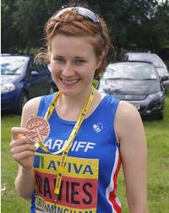
Just as Aled Davies is unbeatable in his events, Bethan Davies is by far the best British race walker of the moment and, today, proved this once again by winning the 5000k walk by over a minute at the British Athletics championships and Olympic trials in Birmingham.
Bethan's time of 22:03.82 improved her own personal best time by three seconds. The day before, she had been in Poland in an unsuccessful attempt to achieve the qualifying standard for the 20k walk.
Also at the trials, Aled yet again improved his own personal best (and, naturally, his own world record) in the F42 shot put with a throw of 16.38m
Elsewhere at the trials there were mixed fortunes for Cardiff athletes.
David Omoregie showed a return to good form to run a season's best 13.58 in his heat of the 110m hurdles and, in the final against a stiff wind, was fourth in 13.67. Rhys Williams, having qualified comfortably for the final of the 400m hurdles was pushed into third place in 49.90. And Brett Morse could manage only 58.75m for second place in the discus.
Ffion Price and Tom Marshall made it through to the finals of their respective 1500m races, with Ffion finishing 10th and Tom ninth. Charlotte Arter, meanwhile, ran a controlled 5000m to finish in an excellent fifth place in a time of 16:00.79, a mere 33 seconds off her personal best.
Other Cardiff AAC performances were: Gareth Hopkins (6th in heat 2 of the 100m in 10.97); Anax da Silva (3rd in heat 4 of the 100m in 10.67); Josh Brown (4th in heat 9 of the 100m in 10.82); Kristian Jones (8th in heat 3 of the 200m in 22.04); Owen Smith (2nd in heat 2 of the 400m in 47.48 and 4th in the semi final in 47.67); Paul Bennett (4th in heat 2 of the 400m hurdles in 53.35); Gareth Warburton (4th in heat 1 of the 800m in 1:50.81); Jason Copsey (8th in the javelin with 64.78m); Lucy Griffiths (9th in the shot put with 12.90m).

Three bronze medals Sunday 26 June 2016

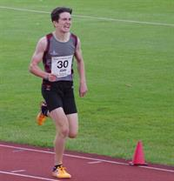
At the Welsh Schools and Welsh Athletics combined events championships held in Swansea yesterday, three Cardiff athletes won individual medals and each was a bronze.
Sofia Vella was third in the under 15 girls' age group, Daniel John was third in the under 15 boys' age group and Alana Lea was third in the under 13 girls.
The individual peformances were:
Sofia Vella: 2694 points (LJ - 4.66m; 75mH - 12.76; SP - 6.89m; HJ - 1.47m; 800m - 2:28.11).
Daniel John: 2263 points (80mH - 12.83; SP - 7.82m; HJ - 1.44m; LJ - 4.77m; 800m - 2:09.79).
Alana Lea : 1665 points (SP - 6.06m; 70mH - 12.30; LJ - 3.63m; 800m - 2:35.66).
The full results can be seen here.
A selection of photographs can be seen here.

Aled goes to Rio Thursday 23 June 2016

Aled Davies is amongst the first group of athletes selected by the British Paralympic Association to represent Great Britain at the Rio Olympic Games. He will contest the F42 discus and shot put competitions and is the current world record holder in both events so will start as one of the favourites.
Aled recently set new a world mark in winning the IPC European discus title.
He will be defending the Paralympic discus title that he won in London.
Aled, also winner of the men’s F42 discus throw and shot put at the 2015 IPC Athletics World Championships, said:
“London 2012 was the start of my journey in the sport and to have won two medals at the Games was a dream come true. The Paralympic Games is the pinnacle of the sport, so to be selected once again is a huge achievement for me.
“Since London, I’ve managed to secure successive world and European titles along with world records, but I do not have the Paralympic shot put title. To win that medal will be the missing piece in the jigsaw and I will be leaving no stone unturned to ensure I’m in the best possible shape come September.”

Carwyn wins in Stuttgart Wednesday 22 June 2016
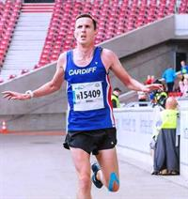
Stuttgart in Germany is one of Cardiff's twin cities and three Cardiff AAC athletes (Carwyn Jones, Mike Kershaw and Carys Hughes) were invited to the annual half marathon and 7k races last Sunday 20th June.
With over 15000 in the half marathon, Carwyn flew the flag for Cardiff by winning in a time of 69.01 while Mike was second home in the 7k race and Carys was 9th in the women's half marathon.
Ultra distance runner Mike Kallenberg has again been selected to represent Great Britain in the IAU 50km World Championships on Friday 11 November in Doha. Mike represented GB in the same event last year finishing in an excellent eighth place.

Harry the hero Monday 20 June 2016

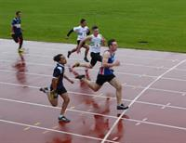
With continuous rain, frequently heavy, throughout the day, the conditions faced by the teams in Swansea yesterday for the third round of the UK Youth Development League (lower age groups) did not dampen their enthusiasm in an enthralling competition.
With rivals Cardiff AAC and Swansea H & AC swapping the lead throughout, Cardiff finally came out on top, winning the final track event, the under 15 boys' 4x300m relay, in great style and heading Swansea by a mere one and a half points, with Cardiff Archers a further 120 points behind in third place.
With one round to go, Swansea lead the division by two league points from Cardiff.
In a team competition, every point counts and, on Sunday, none more so than those gained by Harry Owen. Harry (13) had come to Swansea to take part in the non-scoring 100m but, when Ben Reynolds was forced to withdraw from the under 15 boys' 1500m B race, Harry volunteered to do it for the points. (Apparently team manager Jen Stone promised him a Welshcake if he would and that he should not worry if he came last.) Harry was cheered to the finish, did come last but counted as third in the B race and, without these points, Cardiff would have finshed second and not first. Of course, every other member of the team was just as important to the final result but well done to Harry. That's team spirit.
Despite the awful conditions, there were excellent performances from Cardiff and plenty of event winners in each age group. The individual event winners were.
Under 15 boys: Luca Contino (100m A, discus A & shot put A); Joseph Coope-Franklin (200m A & 300m A); Harvey Reynolds (200m B & 300m B); Daniel John (800m A); Harry Griffiths (800m B); Lloyd Clarke (discus B & hammer B); Evan Morgan (hammer A); Simeon Santima (high jump A).
Under 13 boys: Ben Hughes (800m B); Jacob Reynolds (1500m A); Ryan Edwards (1500m B); Louis Shugar-Rocherfort (75m hurdles A); Fin Hall (javelin A); Luca Logue-Fonseca (long jump B).
Under 15 girls: Issie Tustin (100m A & 200m A); Nia Grundy (100m B & 200m B); Saffie Maurice (75m hurdles A); Brooke Annandale (75m hurdles B); Anais Rowlands (discus A); Cassey Grimwade (discus B & hammer A); Scarlet Russell (javelin B); Isobel Owen (long jump B); Rhianna Satterly (pole vault B).
Under 13 girls: Maddy Jones (75m B & 150m B); Alana Lea (800m A); Jemima Robinson (800m B); Eden Williams (1200m A).
The under 15 boys and girls both won their 4x100m relays and the under 15 boys won the 4x300m relay.
The match result was:
1. Cardiff AAC (643.5 points)
2. Swansea H & AC (642)
3. Cardiff Archers (521.5)
4. Cheltenham H & AC (373)
5. South Wales (300)
6. North Somerset AC (184)
The league position after three rounds is:
1. Swansea H & AC (17 points)
2. Cardiff AAC (15)
3. Cardiff Archers (13)
4. Cheltenham H & AC (9)
5. South Wales (6)
6. North Somerset AC (3)
The full results can be seen here.
Congratulations to the team on a great result; can we repeat it in the next round?
A special mention and thanks need to go to team managers Jen Stone and Gail Gaskin who worked tirelessly all day; parents should remember that the team managers are volunteers who do a difficult job and that without them there would be no teams and no competitions for their children. Fortunately, most parents appreciate this and are very supportive and cooperative.
Thanks also to all the officials who worked out in the rain throughout the day and must have dearly wished to be somewhere else. Without officials there can be no sport. Cardiff thanks especially Seren Phillips who volunteered as a timekeeper to ensure that we provided our full complement of officials and did not risk any penalty points.
The Team managers write:
Girls:
Happy Father’s Day! Thank you to all of the father’s who brought their children to compete and missed out on family lunches; and to the officials who did the same.
Travelling along the M4 on the team bus, I felt dismay at the grey clouds and drizzly rain. It was like ground hog day! The same conditions as Match 2 - or was it worse? It was more like a swimming gala at times but as usual our talented young athletes went PB crazy!
U15G U13G
Lily Gaskin 300m Holly Medina 75m & 150m
Nia Clatworthy 1500m Maddy Jones 75m & 150m
Brooke Annandale 75m Hu Eden Williams 1200m
Anais Rowlands DT Jemima Robinson 800m & HJ
Emily Steer = HJ Gabby Dickinson LJ
Isobel Owen = HJ Katie Gould SP
The YDL league is about winning points for the team and with the result see sawing back and forth between us and Swansea every gap needed to be filled. Well done to Emily and Nia for running in the 4 x 300m relay with only half an hour’s rest after their 1500m. And whilst I know that this is the girls’ team report, a special thank you to Harry ‘Hero’ Owen who ran the 1500m – not a bad effort for a sprinter!
Thank you to our officials and parents who got soaked running our allocated events. A special thank you to Seren Phillips who, at 15, had never tried timekeeping but gave it a go so that we wouldn’t miss out on any points.
I have to remind all athletes and parents that the club does have a code of conduct. It can be found on the club web site http://www.cardiffaac.org/codeofconduct.htm
Please remember that team managers are volunteers and give up a lot of time and energy to do what they do.
Despite the horrible weather, the team won by 1.5 points – a win is a win!
Jen Stone
Boys:
Boys Team
Despite not being there myself, I could sense the exciting back in Cardiff. But, little did I know that this match would go down as our best YDL performance ever. A grand total of 643.5 points, beating Swansea by a mere 1.5 points, and surpassing our previous best of 619!
Under 13 Boys
Heroes and Champions!!
We moved things around. Jacob Reynolds and Ryan Edwards running the 1500m made a huge difference, winning both A and B races; plus with the return of Luca, Charlie and Louis, confidence was high.
The performance of the day has to go to Louis Shugar-Rocherfort. A great win in the 75m Hurdles A race was followed by another win in the 200m B race. He wasn’t done yet with a PB in the 100m and leading the 4x100m team to an excellent second place.
In the 800m, team regulars Ben Hughes and Lloyd Jones were at their usual awesome best, with a PB for Ben winning the B race.
In the field Fin and Charlie stole the show with a first in the Javelin A and second in the B. In the Shot, Evan Jones made his first YDL appearance for Cardiff AAC - great debut Evan.
In the Long jump, who else; Ben Vincent and Luca were back together to get the points.
We should all be very proud of the under 13 boys. This was a great TEAM effort. Well done boys J
Under 15 Boys
Heroes and Champions – part 2!!
Our Sprinters are awesome! FACT! In the 100m, 200m, 300m, 800m, 4x100 and 4x300m, the U15 boys scored 88 out of a possible 90 points! That is awesome!
If athletics had an MVP award, it would have Luca Contino written all over it. Luca became the first Cardiff AAC athlete ever to achieve the maximum, 36 points! 100m A, Discus A, Shot Put A, 4x100m anchor leg; win, win, win, win, MAXIMUM points.
Joseph and Harvey owned the 200m and 300m, winning the A and B races in both events.
Daniel John and Harry Griffiths won the A and B races, in the 800m and, in the 100m, Carter Staples made a welcome return from injury to the YDL. Carter would later team up with Simeon, Ben Hillman and Luca for a brilliant win in the 4x100m.
In the 80m Hurdles, Matthew Register was also back from injury with a great PB. In the B race Ben Hillman did extremely well in his first Hurdles race and Samuel Griffin did very well in tough conditions in the 1500m.
We have fantastic throwers too. We know all about Luca, but Evan Morgan kicked off the whole match with an incredible 6 metre PB to win the Hammer competition. Lloyd Clarke is still scoring points for fun, taking first place in the Hammer B and Discus B, along with a second in the Shot Put B.
The extremely popular and ever present Tyler Santos gave another brilliant performance in tough conditions. A great example of a team player! Well done to Tyler, Lloyd and Evan for a great points haul.
As for jumps, it was another brilliant display from Simeon and Jonathan Gibson in the High Jump, with a PB for Simeon. Jon and Adam kept the points coming in the PV with Ben Hillman and Jonathan getting the points in the LJ.
BUT, more than anything, this Swansea match will forever be remembered for one thing. The 100m sprinter who ran the 1500m, to win the match. I could almost hear the cheers in Cardiff.
Harry Owen, take a bow sir!!
Harry got 4 points for filling in the 1500m. We won the match by 1.5 points. The maths are simple…
The Under 15 Boys were incredible. It’s hard to believe there is a better team anywhere in the UK right now!! Well done boys.
AJ
The final round of this season will be in Cheltenham on 16th July.

The best of British Sunday 19 June 2016

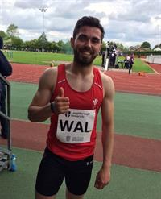
The England Athletics Under 23 and Under 20 championships, held in Bedford yesterday and today, are effectively the British championships and it was excellent to see so many Cardiff athletes taking on the best in the UK and not only taking them on but returning with medals.
Jake Heyward (17) continued his run of form to win a tactical under 20 men's 1500m in 3:55.63 while Owen Smith (47.22 - pictured) and Joe Reid (48.06 after 47.91 in his heat) took first and third places in the under 23 men's 400m. In the Under 23 men's 100m, Sam Gordon won the silver medal and David Omoregie ran a season's best 13.65 to take the silver medal in the 110m hurdles.
Other Cardiff peformances were:
Under 23: John Cove (1500m - 12th after 3:51.03 in his heat); Mark Prentice (100m - 7th in heat 2 in 11.10); Lizzie Harris (400m - 6th in heat 1 in a personal best 57.82); Jonathon Bailey (high jump - 5th with 2.03m); Jake Dawkins (200m - 4th in heat 1 in 22.33); Anax da Silva (200m 5th in semi final in 21.94); Simeon Clarence (long jump - 9th with 6.68m); Jac Palmer (hammer - 6th with 59.66m); Lucy Griffiths (shot put - 5th with 13.24m); Tasia Stephens (javelin - 5th with 40.27m).
Under 20: Kristian Jones (100m - 8th in final with 10.83 after 10.58w in s/f & 200m - 7th in final with 22.16 after 21.58 in s/f); Amelia Reynolds (400m 4th in heat 1 in 56.97); Melissa Roberts (400m - 7th in final with 55.84 after 55.78 in heat 3).
Hidden away amongst the results was an outstanding performance by Sarah Omoregie. Competing in an under 18 competition, Sarah improved her personal best and club record for the under 17 shot put by more than a metre to record 15.83m; which places her at No.1 on the latest UK rankings with a lead of almost a metre over the No.2 ranked.
The full results from day one can be seen here.
The full results from day two can be seen here.

Rhianwedd best in Caerphilly Sunday 19 June 2016

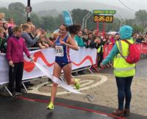
Rhianwedd Price (pictured), back home from university in the USA, where she has been clocking up personal best times, was 14th overall finisher today in the Caerphilly 10k road race and first in the women's open race.
Megan Bowen was the first home of the junior women and Rachel Matthews was the best of the F40 ladies.
Elsiddig Ibrahim was 8th overall finisher and first M40 male.
Elsewhere, Gareth Warburton improved his season's best for 800m to 1:49.31 at the Flanders Cup Nivelles, Belgium on Saturday 18th June.

Welsh League round 2 Saturday 18 June 2016

The second round of the Welsh Athletic League was held in Brecon today and it was good to see a number of Cardiff athletes winning their events.
A personal best height was cleared in the pole vault by 16 year old Lois Hillman, who won the competition with a clearance of 3.21m.
Cardiff's other individual event winners were:
Men: Carl Hill (200m heat 1); Jac Smith (1500m Heat 2); Richard Dangerfield (javelin).
Women: Rhiannon Linington-Payne (200m heat 3); Camilla Barnes (1500m & 3000m); Lana Culliford (U17 300m hurdles); Catrin Lord (long jump).
The full results can be seen here.
A selection of photographs from yesterday can be seen here.
The third round will be held in Carmarthen on 17th July.

Another PB for Jake Friday 17 June 2016

Cardiff's Jake Heyward continued to eat away at his 1500m best last night at the BMC Gold Standard races in Watford with a time of 3:46.5 which took him to fourth place on the UK under 20 rankings (Jake is only 17).
Other near best performances came from Tom amd Kath Marshall, with Tom running 3:40.2 for 1500m and Kath running 2:03.56 for 800m.
Kath is ranked second over 800m in her native New Zealand.

Is Aled unbeatable? Wednesday 15 June 2016

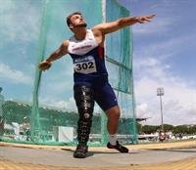
With two gold medals at the IPC European Championships in Grosseto, Italy, including a World, European and Championship record in the discus, Aled Davies is on course to complete the double at the Rio Olympic Games.
Aled's winning throw of 54.14m yesterday in the F42 discus was a huge 4.55m further than his own World and European records of 49.59m. Aled had earlier won the F42 shot put with 16.11m, only two centimetres behind his own World and European records.
After his discus success, Aled (who is coached by Ryan Spencer Jones) said: “I am absolutely delighted with that result. To throw a personal best on the main stage is something every athlete wants to do. For me, I was even more shocked because I haven’t been doing too much discus this year as I have been focusing on the shot put for Rio, but I know there is a lot more in the tank. I’m so happy with that – I don’t really throw PBs on the big stage all that often so it was nice to do it today.
“I managed to hold things together after the first round but as soon as that big throw came my body shut down, it was hard to go even further. I was shocked more than anything when the distance came up on the screen. I know I can throw a long way but the fact that I am surprised in myself is very exciting. I’m ecstatic to perform like that on the European stage against some top guys in the world.”
He added: “I’m a Paralympic bronze medallist in the shot put and I want to upgrade that. Hopefully my Iranian rival (Sajad Mohammadian) is watching but he can get some big throws out there so I know it is going to be tough.”
Congratulations Aled.
On the track, Steve Morris (coached by James Thie) narrowly missed out on the medals in the middle distance events, finishing fofth in the T20 1500m in a time of 4:00.46, and finishing an agonising fourth in the 800m despite leading for much of the last lap – his time of 1:58.09 was a season's best.
Elsewhere, in cold and damp conditions in Lucerne, David Omeregie showed good form to win his 110m hurdles race in a season's best time of 13.66, into a slight wind.

We are the champions Sunday 12 June 2016

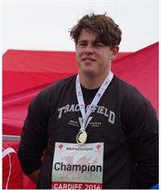
On a day in Cardiff that started off rather grey and cold but ended in warm sunshine, Cardiff athletes took home a sackful of medals from the Welsh Championships yesterday.
The senior men's 100m saw Cardiff take the first three places in both the A and B finals, with club athletes occuping six of the eight qualifiers to the A final. There was a clean sweep also in the senior men's javelin and under 17 women's high jump.
Senior club records are of a very high standard and are rarely broken nowadays but Jac Palmer (still only 20) erased Matthew Richards hammer record (64.17m) with a throw of 64.81m.
Sarah Omoregie improved the under 17 women's shot put record to 13.95m although she has thrown further indoors. And Jake Heyward, only 17, oozed class to comfortably win the senior men's 800m, retaining the title he won last year when only 16 (in an almost identical time).
Other personal bests were recorded by Anax da Silva (10.59 to take the 100m gold medal) and Ffion Palmer who set yet another club record for the under 17 hammer with a throw of 53.28m.
The championships incorporated under 17 championships for certain events and Naomi Reid won the 800m with a fine run, with Kiara Frizelle second. Lauren Evans won the under 17 women's high jump with Shani Evans second and Eliza Durnall third.
In the club relay championships, with improved baton passing, Cardiff squads won the under 13 girls and under 15 boys races and were second in the under 13 boys, under 15 girls as well as in the under 15 boys and girls B races. The under 13 boys and girls teams both set new club records.
Cardiff's Welsh Championship medallists were:
Senior Men:
Gold: Anax da Silva (100m A); Chris Parry (100m B); Kristian Jones (200m); Jake Heyward (800m); Tom Marshall (1500m); Paul Bennett (400m hurdles); Jonathan Bailey (high jump); Ryan Grimwade (pole vault); Curtis Mathews (long jump); Brett Morse (discus); Jac Palmer (hammer); Jason Copsey (javelin).
Silver: Kristian Jones (100m A); Gareth Hopkins (100m B & 200m) Emyr Jones (pole vault); Simeon Clarence (long jump); Curtis Mathews (discus); Richard Dangerfield (javelin).
Bronze: James Griffiths (100m A); Jake Dawkins (100m B); Adrian Lawrence (triple jump); Aaron Thomas (javelin).
Senior Women:
Gold: Bethan Davies (3,000m walk); Amelia Reynolds (400m); Emily Brown (3,000m steeplechase); Tasia Stephens (javelin).
Silver: Charlotte Gaughan (800m); Bethan Evans (1500m); Lucy Griffiths (shot put) Sarah Omoregie (long jump).
Bronze: Lizzie Harris (400m); Georgia Morgan (800m); Isabel Breeden (100m hurdles); Catrin Lord (long jump).
Under 17 Men:
Gold: Thomas Hanson (shot put).
Silver: James Vincent (800m).
Bronze: Richard Lee (100m).
Under 17 women:
Gold: Naomi Reid (800m); Lauren Evans (high jump); Sarah Omoregie (shot put).
Silver: Kiara Frizelle (800m); Shani Evans (high jump).
Bronze: Eliza Durnall (high jump).
As the championships were open to athletes without Welsh qualifications, other Cardiff AAC athletes were prominent but did not qualify for medals. Callum Court was actually third in the pole vault and Kath Marshall won the senior ladies' 400m.
The official results can be seen here.
A selection of photographs taken at the championships can be seen here.
Without taking anything away from the athletes who competed and won medals yesterday, especially the young ones, it was noticeable that many of the events had very few competitors, with straight finals containing as few as two or three athletes (in one case only one). There were numerous absentees and one wonders if it should be made a condition of representing Welsh Athletics on any occasion, and certainly if they are in receipt of financial or medical assistance, that athletes shall have competed in the previous year's Welsh Championships. The championships should be the flagship event of the Welsh summer season and need to be supported.

Steady start for senior ladies Wednesday 8 June 2016

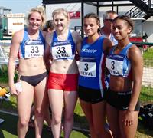
After a slow start, Cardiff's UK Women's Athletic League team finished with a flourish to win the final event of the day, the 4x400m relay, at the first round match in Bristol on Sunday last, 5th June.
On a day of hot sunshine, Cardiff's ladies showed great team spirit to fill unaccustomed events and none more so than captain Rhiannon Linington-Payne who competed in the long jump and 400m B race (which she won) before taking the first leg in both the 4x100m and 4x400m relays.
Cardiff finished in a creditable fifth of eight teams and although producing only two winners, kept the scorecard moving with numerous second places.
Charlotte Arter stepped down in distance to take on the 3,000m, coming second in the A race while Lucy Marland also took second place, in the B race. Lucy Griffiths was second in the shot put A as well as the discus B while Emily Brown was second in the 2000m steeplechase after placing fourth in the opening track event, the 400m hurdles A. Jessica Abrahams was second in the pole vault A and Elena Zembashi was second in the discus A.
Melissa Roberts produced a big personal best to come third in the 400m A race with a time of 55.38.
The team scores were:
1. Woodford Green & Essex Ladies (216 points)
2. Blackheath & Bromley (216)
3. Bristol & West (210.5)
4. Trafford AC (199)
5. Cardiff AAC (154)
6. Harrow AC (146.5)
7. Wigan & District H (127)
8. Crawley AC (115)
The full results can be seen here.
The next round will be held in Lee Valley, London on 3rd July.
Thanks go to all the athletes as well as the officials; Graham Webb, John Penny, Garry Jones, Morgan James and Annwen Gammon.

Senior men still lead Wednesday 8 June 2016

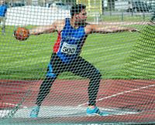
With several (too many) absentees, Cardiff's senior men's British Athletics League team had to be content with second place behind Bristol & West at Bedford on Saturday last, 4th June, but still lead the division overall after two rounds, with two to go.
Pride of place goes to captain Brett Morse who contested two events, winning his speciality discus and taking second in the shot put, even though he was scheduled to compete the following day in the Diamond League in Birmingham. Olympian Rhys Williams took maximum points in the 400m hurdles after completing a busy period of competition including achieving the Olympic qualifying time for his event.
Maximum points came from the javelin through Jason Copsey (very close to his season's best with 66.26m in the A event) and Richard Dangerfield in the B; with Jac Palmer winning the A hammer and Callum Court winning the B pole vault. Consistent Paul Bennett won the B 400m hurdles.
The day ended on as high note with Cardiff winning both the 4x100m and 4x400m relays.
Athletes of the match were Gage Francis and Nick Lia.
The match score was:
1. Bristol & West AC (328)
2. Cardiff AAC (285)
3. Swansea H (280)
4. Kingston AC & Polytechnic H (272)
5. Kent AC (268)
6. Bedford & County AC (249)
7. Crawley AC (246)
8. Notts AC (244)
After two rounds the positions are:
1. Cardiff AAC (15 league points)
2. Swansea H (13)
3. Kingston AC & Polytechnic H (11)
4. Bristol & West AC (10)
5. Kent AC (8)
6. Crawley AC (7)
7. Bedford & County AC (6)
8. Notts AC (2)
The full results can be seen here.
The next round will be in Kingston on 2nd July.

So near for Bethan Tuesday 7 June 2016

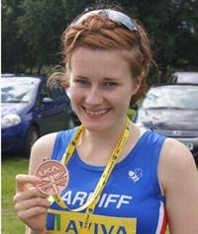
Cardiff's Bethan Davies set new Welsh and club records and established herself as the second best ever UK walker over 20k when she won the British Olympic Trials race in Leeds on Sunday, 5th June. Her winning time of 93.48 was, however, an agonising 48 seconds outside the Olympic qualifying time of 93 minutes. For much of the race, Bethan was right on target to qualify but slipped slightly behind the pace in the later stages.
After the race, Bethan commented that, "I am disappointed to have come so close but this is a massive performance after the disappointment of Rome. I did my first ever 20km in training in this park four years ago and I am now half an hour quicker. This shows how far I have come and I will use this as a stepping stone to qualify for London 2017”.
Kevin Seaward, on the other hand, has been confirmed as one of the three athletes selected to represent Ireland in the marathon at Rio. The announcement had been delayed pending an appeal against the selection of one of the other athletes although Kevin's place was not in doubt as he had the fastest time, having run 2:14.52 in the Berlin Marathon last year.
Kevin had represented Ireland in the World Half Marathon championships in Cardiff last month, finishing in 42nd place. Congratulations to Kevin.
Middle distance specialist Tom Marshall travelled to Belgium for a competition on Saturday and was rewarded with a big personal best of 3:39.41 for 1500m, not far off coach James Thie's club record of 3:37.06.

Juniors win by one point Monday 6 June 2016

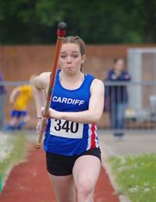
Despite lacking several of its points scorers, Cardiff's Welsh Under 15 League team took first place at the third round match at Newport yesterday, 5th June.
In glorious sunny weather, Cardiff scored 1,482 points against Cardiff Archers' 1,481, placing Cardiff in second place in the league with 26 points behind Cardiff Archers' 26.
With one round to go everything is set for an exciting final in Newport on 21st August when Cardiff will be hoping to defend its Welsh League title.
The final match score was as follows:
1. Cardiff AAC (1482 points)
2. Cardiff Archers (1481)
3. Newport Harriers (820)
4. Rhymney Valley AC (811)
5. Blaenau Gwent AC (663)
6. Cwmbran Harriers (598)
7. Hereford & County AC (536)
8. Rhondda AC (274)
9. Aberdare Valley AC (181)
After three rounds the league position is as follows:
1. Cardiff Archers (26 league points - 4472 match points)
2. Cardiff AAC (25 league points - 4272 match points)
3. Newport Harriers (21)
4. Rhymney Valley AC (17)
5. Blaenau Gwent AC (15)
6. Cwmbran Harriers (13)
7. Hereford & County AC (9)
8. Rhondda AC (5)
9. Aberdare Valley AC (4)
Cardiff's individual event winners were:
Under 15 boys: Luca Contino (100m Ht 1 & high jump); Simeon Santini (200m Ht 2); Kian Murphy (300m Ht 2 & 800m Ht 2); Caerwyn Phillips (1,000m walk); Lloyd Clarke (discus); Henry Gauntlett (javelin).
Under 15 girls: Saffron Maurice (100m Ht 3); Erin Murray (100m Ht 4); Lily Gaskin (300m Ht 3); Nia Clatworthy (800m Ht 1); Catrin Jones (1,000m walk); Rhianna Satterly (pole vault).
Under 13 boys: Tom Reid (100m Ht 4); Jacob Reynolds (1500m); Ben Vincent (long jump); Fin Hill (discus).
Under 13 girls: Holly Medina (100m Ht 1 & 200m Ht 1); Olivia Sugarman (100m Ht 2); Fiona Bostock (200m Ht 2); Alana Lea (200m Ht 3 & 800m Ht 1); Sarah John (800m Ht 2); Eden Williams (1500m).
Under 11 boys: Charlie Stockly Jones (75m Ht 1 & 150m Ht 1); Ben Griffin (800m Ht 2).
Under 11 girls: Rhiannan Harris (75m Ht 4); Maddie Lea 800m Ht 2).
Jacob Reynolds established a new under 13 boys' club record for 1500m with a time of 4:42.15, improving Jake Heyward's time of 4:43.32 set five years ago.
The full results can be seen here.
A selection of photographs can be seen here.
The next round will be held in Cardiff on Saturday 9th July.

The fast men and women Thursday 2 June 2016
The second Welsh Athletics Sprints Evening was held last night, 1st June, at the Cardiff International Sports Campus with no fewer than 51 Cardiff AAC sprinters racing over 100m and 200m. All ages from under 13 upwards, men and women, were included
With 15 heats of the 100m and 14 for the 200m, the event was a great success and marred only by the strong following wing that was well over the permitted limit for the majority of the races.
Nevertheless, the athletes enjoyed the opportunity to produce a large number of wind assisted personal bests.
The official results of the 100m races can be seen here.
The official results of the 200m races can be seen here.

Close second in WJL Wednesday 1 June 2016

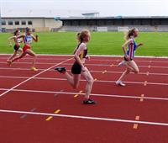
Despite numerous absentees because of half term holidays, etc. Cardiff's Welsh Under 15 League team finished a close second in the second round of this year's series, held in Newport on Saturday last, 28th May.
Outstanding performances came from Ben Vincent, who improved his personal best long jump by an astonishing 39cm to set a new under 13 club record of 5.12m and go to second on the UK rankings, and Josh Beecher who scored triple wins in the 75m, 150m and long jump.
The full match result was:
1. Cardiff Archers (1147)
2. Cardiff AAC (1069)
3. Newport Harriers (623)
4. Blaenau Gwent AC (529)
5. Cwmbran Harriers (507)
6. Rymney Valley AC (433)
7. Hereford & County AC (366)
8. Aberdare Valley AC (264)
9. Rhondda AC (171)
The full offcial results can be seen here.
Cardiff's individual event winners were:
Under 11 Girls: Rhiannan Harris (150m Ht 2).
Under 11 Boys: Josh Beecher (75m Ht 1, 150m Ht 1 & Long Jump); Elis Finlayson (800m Ht 1); Joe Joyce (800m Ht 2).
Under 13 Girls: Elen James (100m Ht 4); Fiona Bostock (200m Ht 2); Eden Williams (200m Ht 4); Alana Lea (800m Ht 1); Evie Wong (70m Hurdles Ht 3); Lily Gregson (Discus).
Under 13 Boys: Ben Hughes (100m Ht 3); Ben Vincent (Long Jump).
Under 15 Girls: Issie Tustin (100m Ht 1 & 200m Ht 1); Nia Grundy (100m Ht 2); Emmanuella Kone (200m Ht 2); Catrin Jones (1k walk); Sofia Vella (75m Hurdles Ht 2); Caitlin Leggett (Pole Vault); Cassey Grimwade (Discus & Hammer); Scarlett Russell (Javelin).
Under 15 Boys: Simeon Santini (200m Ht 3); Daniel John (300m Ht 1); Louis Thorne (300m Ht 3).
A selection of photographs can be seen here.
The next round is on Sunday next, 5th June, again in Newport.

Silver for Ciaran Tuesday 31 May 2016

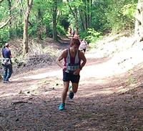
Cardiff's Ciaran Lewis took the silver medal at the European Mountain Running Trials held in Whinlatter Forest, Lake District, on Saturday last, 28th May over a 8.25km course.
The trial counted as the England Athletics official championship and, by coming in the first two, Ciaran should have clinched his place in the British team for the European championship in Arco, Italy, on 2nd July.
Meanwhile, in Belgium, Rhys Williams won an international 400m hurdles race in 49.22, his best time this year and within the Olympic qualifying time of 49.40.
At the same event, Owen Smith achieved a big personal best with 46.23 for 400m; Joe Reid clocked 48.28; Anax Da Silva ran 10.81 and 21.76 for 100m and 200m respectively; Tasia Stephens threw the javelin 38.65m; Ryan Cooper ran 55.45 for 400m hurdles and Paul Bennett was close to his best in the same event with 51.76.

Clear win for juniors Monday 30 May 2016

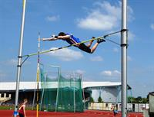
On a glorious sunny day that was marred only by a gusting wind that was over the limit for some events, Cardiff's UK YDL (U17/U20 age groups) scored a convincing win in the second round match in Newport yesterday, 29th May.
After coming fourth in the first round match in Plymouth, Cardiff AAC has improved to second place overall, only one point behind the league leaders.
Showing great team spirit, three of the team (Naomi Reid, Kiara Frizelle and James Vincent) had competed at the BMC Grand Prix in Watford the previous evening and, despite arriving home late, turned out again for their club yesterday. And both Naomi and Kiara produced personal best peformances (Naomi and 400m and Kiara over 800m).
Also supporting his team, GB Sprint squad member Kristian Jones was a class apart in the 100m and 200m, recording impressive times (10.52 and 21.39) although the wind was unfortunately over the permitted limit in both events.
Encouraging for the future was the fact that several of the team had been competing last year in the the under 15 age group and, despite stepping up to a higher category, were able to more than hold their own with older athletes.
The match result was:
1. Cardiff AAC (665 points)
2. Team Devon & Cornwall (624)
3. Team Avon (617)
4. West Wales (513)
5. Yeovil & Wells City H (288)
6. South East Wales (232)
After two rounds, the league position is:
1. Team Avon (10)
2. Team DC (10)
3. Cardiff AAC (9)
4. West Wales (7)
5. Yeovil & Wells City H (4)
6. SE Wales (2)
Cardiff's individual event winners yesterday were:
Under 20 men: Kristian Jones (100m A & 200m A); Aaron Owen (100m B & 200m B); Harry Hillman (110m Hurdles A); Richard Dangerfield (Javelin A); Ryan Grimwade (Pole Vault A); Jasper Hawkins (Pole Vault B).
Under 17 men: Callum Stone (1500m B); Rhys Jones (3000m A); Kieran Grimwade (Hammer A); Tom Hanson (Shot Put A); Jay Morse (Shot Put B).
Under 20 women: Amelia Reynolds (100m A); Rebecca Kennett (100m B); Naomi Reid (400m A); Bethan Register 400m B); Bethan Evans (800m B & 1500m A); Georgia Cole (1500m B); Megan Bowen (3000m A); Ellie Powell (3000m B); Isabel Breeden (100m Hurdles A).
Under 17 women: Isabel Breeden (200m B); Jessica Wadey (800m B); Gracie Wheeler (1500m B); Ffion Gregson-Lewis (3000m B); Elen Evans (Discus B); Ffion Palmer (Hammer A); Bethan Gammon (Hammer B); Lauren Evans (High Jump A & Javelin B); Sarah Omoregie (Shot Put A); Katie Roberts (Shot Put B); Eliza Durnell (High Jump B).
The full results can be seen here.
The next round is on 26th June, in Carmarthen, and this team is well capable of securing a guaranteed place in the national final on 4th September.
Well done to everyone including team managers Debbie Bull and Alan Wadey. This was the first time that Cardiff has won a round in this league since it was inaugurated in 2013 and is a fitting reward for Debbie Bull who has been team manager throughout and has been a staunch supporter of the team.

PBs at BMC GP Sunday 29 May 2016

It was well worth the trip to Watford last night to take part in the British Milers'Club Grand Prix meeting as six Cardiff athletes returned home after producing personal best times.
Leading the charge was Katherine Marshall who is hoping to represent her native New Zealand at the Rio Olympic Games. Katherine edged closer to the two minute barrier with 2:03.90 for the 800m.
The others who secured PBs were: Naomi Reid (2:10.79 for 800m); Kiara Frizelle (4:37.42 for 1500m); James Vincent (3:56.25 for 1500m); Rowan Axe (3:44.99 for 1500m); Stephen Morris (3:58.19 for 1500m).
Dani Cocking clocked 2:12.64 for 800m, Matthew Edwards 3:58.24 for 1500m, Charlotte Gaughan 4:38.31 for 1500m and Abi Fisher 4:53.96 for 1500m.

Big PB for Jonathon Monday 23 May 2016

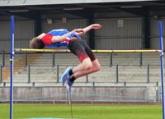
Cardiff's Jonathon Bailey improved his high jump best by a massive 6cms when he cleared the bar at 2.09m during yesterday's Loughborough International.
A strong wind made it tricky for all competitors except the 100m sprinters so Jonathon's performance was particularly good.
Personal bests were also recorded by 400m runner Owen Smith who was timed at 46.81 for the one lap race and Sam Gordon with a legal 10.43 for the 100m.
Elsewhere, Brett Morse contested the discus (60.77m) and shot put (15.25m) and Jason Copsey threw the javelin 66.02m.
On the track, the 100m saw Anax da Silva clock 10.70, James Griffiths 10.77, Jake Dawkins 10.87 and newcomer Josh Brown 10.77. In the 400m, Seb Blanch was timed at 50.23 while higher claim member Joe Reid stopped the clock at 48.85.
Kristian Jones could not quite repeat his sizzling form of a couple of weeks ago but still ran a very respectable 21.54 for 200m. Daniel Dell recorded 22.41 and consistent Paul Bennett ran 52.67 for 400m hurdles.
Gareth Warburton ducked under the 2 minute barrier with 1:49.55 for 800m but Ieuan Thomas had the misfortune to fall while leading the 3,000m steeplechase. Ieuan's fall impeded Ciaran Lewis who finished with a time of 9:36.73.
The day's events concluded with four Cardiff sprinters (Anax, Jake, James and Sam) running as the Welsh 4x100m relay squad and clocking 41.01.

Summer in Swansea Monday 23 May 2016

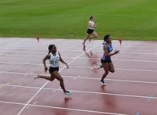
The forecast had promised early rain but sunshine later. No such luck - there was heavy rain for most of the day along with cold and wind. These were the conditions for the second round of this season's UK YDL (lower age group) at Swansea last Saturday 21st May. Luckily, the high jump and pole vault competitions could be held indoors.
After finishing third in the first round on 24th April, Cardiff took second place behind Swansea on Saturday, pushing Cardiff Archers into third spot. After two rounds, Cardiff AAC and Cardiff Archers both have 9 league points, with Archers narrowly ahead on match points.
he match result was:
1. Swansea Harriers (602 points)
2. Cardiff AAC (534)
3. Cardiff Archers (528)
4. Cheltenham & County AC (390)
5. South Wales (323)
6. North Somerset AC (315)
The positions after two rounds are:
1. Swansea Harriers (12 League points)
2. Cardiff Archers (9 - 1084)
3. Cardiff AAC (9 - 1073)
4. Cheltenham & County AC (6)
5. South Wales (4)
6. North Somerset AC (2)
Despite the awful conditions, there were numerous personal best performances.
Cardiff's individual event winners were:
Under 15 boys: Harvey Reynolds (100m B & 200m B); Daniel John (300m A); Joseph Coope-Franklin (300m B); Luca Contino (Discus A & Shot Put A); Lloyd Clark (Discus B & Hammer B); Simion Santima (High Jump A); Jonathan Gibson (High Jump B).
Under 15 girls: Issie Tustin (100m A & 200m A); Nia Grundy (100m B & 200m B); Lily Gaskin (300m B); Brooke Annandale (75m Hurdles B); Cassey Grimwade (Discus A & Hammer A); Anais Rowlands (Discus B).
Under 13 boys: Jacob Reynolds (800m A).
Under 13 girls: Fiona Bostock (800m A); Alana Lea (800m B); Lili James (1200m B).
It was noticeable that there were numerous events where Cardiff did not have a competitor (7 under 13 boys and 1 under 15 boys) which is extremely surprising considering how many of that age age members of the Academy. We need complete teams to succeed in these league competitions.
Well done to everyone that competed on Saturday and a special thank you to team managers Jen Stone and AJ and supporters, But the biggest thank you should go to all the officials who worked in the pouring rain to make sure this event went ahead and was completed on time.
The next round is again in Swansea, on 19th June. Let's hope for some sunshine.
The official results can be seen here.
A selection of photographs can be seen here.
The team managers report:
Under 15/13 Girls - Jen Stone
Friday night as a team manager is never a good place to be. Keep checking the phone and e-mails for late withdrawals. To keep me occupied, I checked the weather forecast – heavy rain but clearing around 11am – perfect. Well, the BBC got it horribly wrong! It poured down for most of the day. There was no way that anyone was going to PB in the grey, miserable, wet conditions but, as usual, our talented young athletes proved me wrong.
Under 15 Girls
Nia Grundy: 200m
Elin Williams: 1500m
Brooke Annandale: 75m Hurdles
Cassey Grimwade: Hammer Throw
Anais Rowlands: Hammer Throw
Lily Gaskin: Long Jump
Emily Steer: High Jump
Caitlin Leggett: Pole Vault
Under 13 Girls
Holly Medina: 75m & 150m
Fiona Bostock: 800m
Alana Lea: 800m
Eden Williams: 1200m
Lili Jones: 1200m
Elen James: 70m Hurdles & 800m
Trinity Coles: 75m Hurdles
Lily Gregson: Javelin Throw
Megan Hastings: High Jump
The YDL league is about winning points for the team, as well as individual performances. Illness hit team selection this match leaving a few gaps so thank you to all the athletes who filled those gaps at very short notice. A last minute dash down the motorway by Eve Pearson added valuable points to our team efforts. Every point counts.
Thank you to our officials and parents who got soaked running our allocated events. We need more people to volunteer their time to help us run these matches smoothly. Are you aware that we get bonus points for providing all of our officials? This time we missed out on 25 points as we couldn’t do this as there just aren’t enough officials to go around. Please give up your evening and attend a course and get that officials course under your belt.
Under 13/15 Boys - "AJ"
This was tough. This was hard earned.
After finishing thirrd in the first match, we knew that only a first or second place finish in Swansea would keep our hopes of getting to the final alive. All looked good 24 hours before the match; first place was on.
Then… One, two, three four athletes from the boys’ team get struck by the Norovirus; then a couple more in the girls’ team.
Surely, that's it. Surely, we can forget first or second; too many gaps; too many of our best athletes out. If this was any other team, there was no chance.
But, this is Cardiff AAC and this is the YDL!!! And it isn't over till it's over....
Under 13 Boys:
When you get a message at 1:15am to say one of your main athletes has been up all night with sickness, you don't get a good night sleep. Having known that we were missing two hurdlers and two high Jumpers, we started the day with nine gaps, including the relay.
On days like these, you need heroes. Up stepped Ben Hughes! Firstly, he agreed to fill in the Shot Put; and the relay. Ben also gave us the closest finish of the day with a fantastic third place in the 800m B race with less than half a second separating the top three. A brilliant team player!
As well as heroes, you need champions and I give you two Welsh Champions!
- Ben Vincent got virtually no rest, starting the day as the A athlete for the 100m, 200m and long jump, plus the fourth leg in the relay. A proper Captain's innings!
- Jacob Reynolds, the 800m and 1500m Welsh Champion, was making his YDL debut for Cardiff AAC. In pouring rain, Jacob took almost two seconds off his PB in the 800m with an incredible 2:18.02.
In the Javelin, Fin Hill came away with an excellent second place and seven very important points.
In the 1500m A race, Lloyd Jones was a whisker outside his PB to take a very good fourth place. In the 1500m B race, Rhys Blow took second place; another good day for Rhys in a Cardiff vest.
Orson James did very well in the 100m B race, and joined Ben Hughes, Ben Vincent and Jacob Reynolds to make sure that the team came home with some points in the 4x100m.
These seven athletes proved that it's quality not quantity that matters! Well done boys!
Under 15 Boys:
In contrast, there were no gaps in under 15 boys’ team as the first event got under way. A very late withdrawal from the 800m, however, was the only minor setback to an incredible performance by these boys.
And it was the new boys that made names for themselves.
Harvey Reynolds made a sensational debut in a Cardiff vest, winning both the 100m and 200m B races. He also ran the third leg in the 4x100m relay, keeping that team unbeaten this year.
Welcome to Cardiff AAC,Harvey!
The sprinters were immense. In the 100m, 200m, 300m and 4x100m they scored 53 out of a maximum 57 points, including maximum points by Daniel John and Joseph Coope-Franklin in the 300m; both with PBs.
The endurance runners also added valuable points. The ever dependable Harry Griffiths picked up another impressive second place in the 800m while the 1500m saw two YDL debutants. Samuel Griffin ran the race of his life, taking a huge chunk off his PB and it was great to see Ben Reynolds in a Cardiff vest again. Only a few weeks ago Ben was on crutches, so it was great to see him in spikes again.
There were valuable points too in the 80m hurdles with Iwan Prys Jones, also a first timer to the YDL, getting an impressive third and Simeon Santima a huge PB and second place in the B race.
In the field, Evan Morgan and Lloyd Clarke got the match started with 14 points, taking second in the A and first in the B Hammer. Luca and Lloyd got maximum points in the Discus, winning the A and B competitions. The same pair would get another 14 points in the Shot. The ever dependable Tyler Santos was joined by Carter Staples in the Javelin to bring the points total up to 53 points in the throwing events.
In the Long Jump, another Ben, Hillman, continued his excellent recent form, in very tough conditions. Daniel John stepped in at the last minute, to get the team very valuable points. In the High Jump, maximum points came from fantastic efforts by Simeon and Jonathan Gibson.
In the Pole Vault were two names known more for High Jump and Long Jump. Adam Mohsin did very well to clear the required height to finish third in the B competition but Jonathan Gibson jumped beyond his own expectations to clear two metres in the A competition.
Whilst this was a brilliant team effort, it’s hard to ignore the incredible points haul already amassed by Luca Contino in these opening matches. In Swansea, he won the Discus A, Shot Put A and anchored the 4x100m boys to another win so that they remain unbeaten this year. In the 100m, he was within 0.01 of winning the A race, getting a total of 34 out a maximum 36 points - as he did in Newport.
But, the last word has to go to the last race of the day, the 4x300m! - Harry Griffiths, Ben Hillman, Philip Grundy (the birthday boy) and Daniel John. At the start of the race, it was announced that Cardiff AAC was one point behind Archers. The news got to the four boys and they were a team possessed! The same four boys ran six seconds quicker in Swansea than they did in the first match. We needed a win, and the Fab 4 did not disappoint. They never do!

Season's best for Rhys Friday 20 May 2016

Cardiff's Rhys Williams showed that he is returning to good form with a season's best time of 49.85 for 400m hurdles, for fifth place in the international event at the Ostrava Golden Spike meeting (Czech Republic) today, 20th May. This time takes him to the top of the latest UK rankings.
At the same meeting, David Omoregie could manage only eighth place in the 110m hurdles with 13.93.

GB call-up for Kristian Thursday 19 May 2016

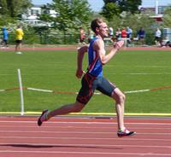
Cardiff's Kristian Jones has been rewarded for his fine early season form with a call-up to the Great Britain junior 4x100m squad for the Loughborough Intenational on Sunday next. This follows his personal best times at 100m (10.53) and 200m (21.23) in the opening British Athletics League match in Cardiff on 7th May.
Kristian will also contest the individual 200m in the Welsh team, along with a host of club-mates.
The Welsh men's team reads like a Cardiff BAL team sheet with Sam Gordon (100m), Kristian Jones (200m), Owen Smith (400m), Gareth Warburton (800m), Paul Bennett (400m hurdles), Ieuan Thomas (3,000m steeplechase), Jonathan Bailey (high jump), Brett Morse (discus & shot put), Jason Copsey (javelin), Jake Dawkins (4x100m), Anax da Silva (4x100m), James Griffiths (4x100m), Daniel Dell (4x400m).

Treasurer needed Thursday 19 May 2016

The club is looking for someone to take over as treasurer from Steve Davies.
Steve has been an excellent treasurer for the past two years but has been forced reluctantly to step down because of pressure in his day job.
If you are interested to help the club in this way (or can suggest someone who is) please contact chairman Bernie Plain (07976 368 543) as soon as possible. You can be assured of plenty of help in what is an important role.

Regional championships Sunday 15 May 2016

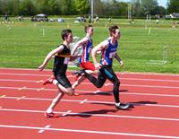
On a sunny day but with a cold wind early on, the South and East Wales regional championships were held in Brecon yesterday, 14th May. Cardiff athletes usually do well in these championships and yesterday was no exception with Cardiff vests to the fore in most of the events.
Triple gold medal winners were Luca Contino (under 15 boys' 100m, high jump and shot put) and Harri Wheeler-Sexton (100m hurdles, pole vault and long jump) while siblings Ffion and Jac Palmer each took gold in their respective hammer competitions; Ffion once again breaking her own club record with 52.93m and Jac setting his best throw of the year, very close to his own personal best.
Cardiff's individual medallists were:
All are South Wales medallists unless indicated.
Under 13 boys:
Gold: Jacob Reynolds (800m); Ryan Edwards (1500m); Ben Vincent (long jump); Finlay Hill (javelin).
Silver: Ben Vincent (200m); Lloyd Jones (800m & 1500m).
Bronze: Ben Vincent (100m); Charlie Russell (discus & javelin).
Under 13 girls:
Gold: Holly Medina (200m); Eden Williams (800m); Gabby Dickinson (high jump).
Silver: Olivia Sugerman (200m); Lili Jones (1500m); Holly Medina (high jump); Gabby Dickinson (long jump); Katie Gould (shot put); Lily Gregson discus); Georgina Edwards (javelin).
Bronze: Evie Wong (70m hurdles & long jump); Lily Gregson (shot put & javelin).
Under 15 boys:
Gold: Luca Contino (100m & high jump & shot put); Caerwyn Phillips (discus); Tyler Santos (javelin); Henry Gauntlett (East - javelin); Harvey Reynolds (East - 300m).
Silver: Iestyn Edwards (200m); Ben Hillman (300m & long jump); Kian Murphy (800m); Joseph Coope-Franklin (East - 300m).
Bronze: Ben Hillman (100m); Samuel Griffin (1500m); Iwan Jones (80m hurdles).
Under 15 girls:
Gold: Issie Tustin (100m & 200m); Nia Clatworthy (1500m); Catrin Jones (high jump); Caitlin Leggett (pole vault); Cassey Grimwade (discus & hammer); Scarlett Russell (javelin).
Silver: Sofia Vella (800m); Emily Chirighin (3000m); Saffron Maurice (75m hurdles); Rhianna Satterley (pole vault); Brooke Annandale (long jump); Emma Fitzherbert (javelin).
Bronze: Saffron Maurice (200m); Sofia Vella (300m); Brooke Annandale (75m hurdles); Grace Leggett (pole vault); Cassey Grimwade (shot put); Anais Rowlands (discus); Caitlin Chapman (hammer); Sadie Graham- Mulvaney (East - javelin).
Under 17 men:
Gold: James Vincent (800m); Morgan James (1500m); Harri Wheeler-Sexton (100m hurdles & pole vault & long jump); Jay Morse (shot put & discus); Kieran Grimwade (hammer); Tom Britt (East - 400m hurdles & pole vault).
Silver: Richard Lee (200m); Seth Kelly (400m); Thomas Atkinson (100m hurdles); Cameron Pamment (pole vault); Tom Britt (East - javelin).
Bronze: Cameron Pamment (100m & 200m).
Under 17 women:
Gold: Naomi Reid (800m); Carys Bill (3000m); Kiara Frizelle (1500m); Clara Nuthall (80m hurdles); Eliza Durnall (high jump); Lois Hillman (pole vault); Sarah Omoregie (shot put); Bethan Gammon (discus); Ffion Palmer (hammer); Thea Willis (javelin); Isabel Breeden (East - 80m hurdles); Katie Roberts (East - shot put & hammer).
Silver: Lana Culliford (200m & 300m); Carys Bill (800m); Grace Wheeler (1500m); Laura Wright (3000m); Ellie-May Stonehewer (high jump); Megan Hodgson (pole vault); Sarah Omoregie (long jump); Thea Willis (shot put); Eliza Hill (discus); Bethan Gammon (hammer).
Bronze: Eliza Hill (100m); Seren Wenham (200m); Jessica Hill (300m); Jeri-Lynne Grabham (800m & 1500m).
Under 20 men:
Gold: Arron Owen (100m & 200m); Iestyn Jones (400m); Nicholas Jones (800m); Geraint Lloyd Pugh (shot put); Richard Dangerfield (javelin).
Bronze: Matthew Verran (800m).
Under 20 women:
Gold: Ellie Stephenson Wilding (400m); Bethan Evans (800m & 1500m); Ceri Jones (pole vault & discus).
Silver: Rebecca Kennett (100m & 200m); Felicity Williamson-Sarll (800m); Georgia Cole (1500m); Sofia Ali (hammer).
Senior men:
Gold: Daniel Dell (100m); Garry Jones (200m); Rhys Williams (400m); Jonathan Bailey (high jump); Jac Palmer (hammer); Jason Copsey (javelin); Jake Dawkins (East - 100m & 200m).
Silver: Brian Dias (1500m & 3000m); Aaron Thomas (javelin).
Bronze: Garry Jones (100m).
Senior women:
Gold: Rhiannon Linington-Payne (200m); Lizzie Harris (400m); Georgia Morgan (800m); Tasia Stephens (javelin).
Silver: Rhiannon Linington-Payne (100m).
The full results can be seen here.
A selection of photographs taken at the event can be seen here.

Lucky Friday 13th Sunday 15 May 2016

Friday the 13th is said to be an unlucky date, but not for Cardiff's Aled Davies who, last Friday broke his own category F42 shot put world record with a new personal best throw of 16.13m at the IPC grand prix in Arizona.
Aled, who is coached by Ryan Spencer Jones, is aiming to improve on the bronze medal he won at the Paralympics in London 2012 and could not have wished for a better start to the year.
Aled commented on his performance,
“The event went well, I came to Arizona for warm weather training and the competition fitted nicely at the end,”
“It was my first outdoor meet of the year so it was nice to pb even though I was shaking out the cobwebs.
“I’m excited to build on that performance and see what I can produce this year. I don’t compete much as I’m injury prone – the plan is to get to Rio in one piece.”
Aled is the defending Paralympic champion in the discus.

Off to a flying start Saturday 7 May 2016

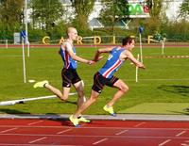
After the disappointment of relegation last season, Cardiff's senior men's team got this year's campaign off to a flying start with a resounding win at today's first round match in Cardiff.
On a generally fine day (interrupted by one rain-shower) but with a gusting wind, Cardiff led throughout the day and finished 46 points ahead of second placed Swansea. An excellent all-round team performance included several outstanding individual personal bests including those from Kristian Jones, Anax Da Silva, Jake Heyward, Simeon Clarence and Ciaran Lewis.
Kristian Jones (18 in a few days time) produced a huge personal best to place second in the 200m in the fine time of 21.23, having earlier clocked 10.53 in the guest 100m but with the wind just over the limit at 2.1 m/sec. The club's other sprinters were equally impressive with Sam Gordon taking second place in the A 100m with a windy 10.38 and Anax da Silva setting a legal personal best of 10.64 to win the B race. Daniel Dell was second in the B 200m and near his personal best with 21.92.
Ciaran Lewis (19) ran a very mature 3000m steeplechase to win comfortably in 9:22.26, a massive 46 seconds off his best. Also on the track Tom Marshall stepped in to take injured Carl Hill's place in the B 800m, and win it, and came back later to make it a double win in the 1500m, just managing to hold off fast finishing Jake Heyward (17 two weeks ago). Jake is aiming for the European Youth Championships and his time of 3:49.75 is again inside the qualifying time.
It was great to see Curtis Mathews back in athletic action and winning the B shot put after substituting for injured Brett Morse in the A discus and placing fourth. And let's not forget 62 year old (yes, 62) Nic Lia who stepped in to throw the hammer and placed 4th in the B competition; and then placed 7th in the B discus. Nic was a club stalwart back in the 1970s and has kept himself fit ever since. What an example!
Cardiff's individual event winners were: Jac Palmer (Hammer A); Jason Copsey (Javelin A); Richard Dangerfield (Javelin B); Simeon Clarence (Long Jump A); Curtis Mathews (Shot Put B); Paul Bennett (400m hurdles B); Anax Da Silva (100m B); Gareth Warburton (800m A); Tom Marshall (800m B & 1500m A); Jake Heyward (1500m B); Ciaran Lewis (3000m s/chase A); Callum Court (pole Vault A); Ryan Grimwade (Pole Vault B).
The day ended with Cardiff teams winning both the 4x100m and 4x400m relays, the latter being anchored by former European 400m hurdles champion Rhys Williams who, running in the unfavourable lane 1, had earlier been just pushed into second place in the 400m hurdles by fellow Olympian Jack Green.
Athletes of the match were Tom Marshall (track, for two good wins) and Simeon Clarence (field, for his 7.01m long jump win).
The team scores were:
1. Cardiff AAC (378 points)
2. Swansea H & AC (332)
3. Kingston Polytechnic AC (292)
4. Crawley AC (284)
5. Kent AC (231)
6. Bedford & County AC (226)
7. Bristol & West AC (223)
8. Notts AC (213).
The provisional full results can be viewed here.
The next round is on 4th June in Bedford and Cardiff will need again to field a strong team to put it on the path to promotion to its rightful place in a higher division. And, looking at the results from the higher division at Watford yesterday, Cardiff's team would easily have held its own and would be challenging for promotion to the Premiership division. Our athletes are far too good to be in Division 2.
Congratulations to every athlete who competed today for Cardiff and thanks to Andrew Seary for acting as team manager. Thanks also to Debbie Bull and all the officials for making the day a success.

Code of Conduct Tuesday 3 May 2016

The general committee of the club has issued a Code of Conduct that applies to all members as well as to parents of members.
The club has traditionally been a harmonious organisation with all those involved respecting and supporting each other and contributing to the furtherance of the high standing and quality of Cardiff AAC and its athletes. This is the ethos of a voluntary organisation and the vast majority of members and friends understand and demonstrate this spirit.
The Code of Conduct has been issued in response to a number of unfortunate incidents recently and we hope that by adhering to the Code the spirit of cooperation and goodwill will be fully restored.
The Code is published in full on the website and can be read by selecting Code of Conduct on the menu or by clicking HERE.
Thank you.

Pipped at the post Tuesday 3 May 2016

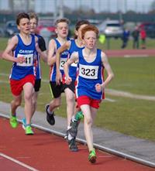
Although thankfully the rain stayed away for most of the day, it was cold with a sharp wind for the first round of the Welsh Under 15 League in Cardiff last Saturday, 30th April.
With the lead changing during the day, Cardiff eventually settled for second place a mere 34 points behind Cardiff Archers; the same result as in the first round last year before Cardiff went on to win the overall title.
The official results show the team results as follows:
1. Cardiff Archers (1368 points)
2. Cardiff AAC (1334)
3. Blaenau Gwent AC (631)
4. Newport Harriers AC (611)
5. Rhymney Valley AC (560)
6. Cwmbran Harriers AC (466)
7. Hereford & County AC (358)
8. Rhondda AC (296)
9. Aberdare Valley AC (223)
The official results can be viewed here.
Cardiff's individual event winners were:
Under 11 girls: Molly Type (75mH heat 4); Rhiannon Harris (150m heat 4).
Under 13 girls: Fiona Bostock (100m heat 3 & 800m heat 1); Olivia Sugarman (200m heat 2); Alana Lea (800m heat 2); Eden Williams (1500m heat 1); Molly McKerlick (1000m walk).
Under 15 girls: Issie Tustin (100m heat 1 & 200m heat 1); Saffie Maurice (100m heat 2); Eve Pearson (100m heat 4); Nia Clatworthy (1500m); Isobel Owen (high jump); Caitlin Leggett (pole vault); Cassie Grimwade (discus & hammer); Emma Fitzherbert (javelin).
Under 11 boys: Charlie Stockly-Jones (75m heat 3 & 150m heat 3); Joshua Beecher (75m heat 5 & 150m heat 4 & long jump); Ellis Finlayson (800m heat 2).
Under 13 boys: Ben Vincent (200m heat 1 & long jump); Jacob Reynolds (200m heat 4 & 800m heat 1); Ryan Edwards (1500m).
Under 15 boys: Daniel John (300m heat 1 & 800m heat 1); Lewis Tyrell (300m heat 2); Iestyn Edwards (800m heat 2); Simeon Santani (80mH heat 2); Luca Contino (high jump & discus); Lloyd Clarke (hammer); Tyler Santos (javelin).
With lots of excellent performances, one that stood out was nine year old Joshua Beecher's triple wins in the 75m, 150m and long jump, plus the final leg of the winning boys' 4x100m relay. Watch out for Josh.
A selection of photograhs taken at the event can be seen here.
Cardiff at BUCS Tuesday 3 May 2016
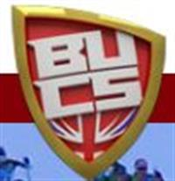
Numerous Cardiff AAC athletes were representing their universities at the BUCS championships in Bedford from 30 April to 3 May.
Getting his outdoor season off to a good start, with two clockings under 14 seconds, David Omoregie took the gold medal in the final of the 110m hurdles in 13.74.
Bronze medallist in the hammer throw, Jac Palmer was close to his personal best with 62.66m and will surely take Matthew Richards' club record of 64.17m this year.
Other significant performances came from Owen Smith (400m silver medal), with higher claim member Joe Reid third, and Charlotte Wingfield (100m silver medal).
Other Cardiff performances were; Lucy Marland (10,000m - 7th); Emily Brown (2000m steeplechase - 6th); Rebecca Chapman (long jump - 4th); Lucy Griffiths (shot put - 4th); Eleni Zembashi (discus - 10th); James Griffiths (100m - 8th); Gareth Hopkins (200m - 6th); Paul Bennett (400m hurdles - 4th); Ryan Cooper (400m hurdles - 7th); Jonathan Bailey (high jump - 5th); Gage Francis (triple jump - 10th); Jonathan Edwards (hammer throw - 9th).
The full results can be viewed here.

Solid start for YDL campaign Monday 2 May 2016

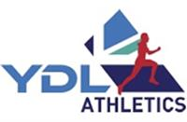
Cardiff's upper age group UK Youth Development League team set off at 6am yesterday for the long trip to Plymouth and produced a steady opening performance, finishing in fourth place behind three composite teams.
The early matches in this league are traditionally beset with availability problems and this year was no exception. Revision for exams and injuries are typical issues but this match also suffered from a clash with the BUCS championships in Bedford and a BMC meeting being held in Millfield on Monday.
That said, the team that did make the early morning trip to Plymouth were amazing! Many athletes were rewarded with PB's despite the cold, wet, generally wintry conditions.
Particularly noteworthy was Ffion Palmer's hammer win with a throw of 52.13m, a personal best and her second club record of the year - and the season has only just started.
Several team members stepped up an age group from last year's lower age group league and immediately made important contributions.
Individual event winners were:
Under 20 men: Aaron Owen (100m A); Ciaran Lewis (1500m A); Luke Harry (400m hurdles A); Richard Dangerfield (javelin A).
Under 20 women: Melissa Roberts (400m A); Bethan Evans (1500m A).
Under 17 men: Morgan James (3000m A); Kieran Grimwade (hammer A).
Under 17 women: Naomi Reid (800m A); Ffion Palmer (hammer A); Bethan Gammon (hammer B); Sarah Omoregie (shot put A); Katie Roberts (shot put B); Catrin Lord (long jump A); Ellie May Stonehewer (triple jump A); Lauren Evans (high jump A).
The under 17 women also won the 4x100m and 4x300m relays.
The match result was:
1. Team Avon (670 points)
2. Team DC (669)
3. West Wales (525)
4. Cardiff AAC (451)
5. Yeovil & Wells City AC (275)
6. S East Wales (139)
We finished in 4th place overall, giving us a firm foundation to build on.
Team Manager Debbie Bull would also like to thank the officials and parents who came to help us out and ensured the match ran smoothly.
As Team Managers, we could not have asked for more from the athletes. They gave their best, encouraged their teammates and performed extremely well. It is very encouraging to see them gelling as a team so early in the season, something we struggled with last year. This bodes well for the forthcoming matches, when we expect the team to grow in size as exams are completed and injuries are hopefully cast aside.
The next match is in Newport on Sunday 29th May and we look forward to seeing as many athletes and officials there as we can.

Close second for Jake Sunday 24 April 2016

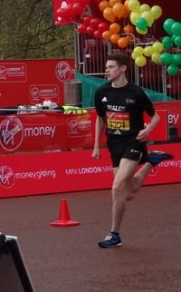
As they entered the Mall approaching the finish, Cardiff's Jake Heyward and Stroud's Tom Mortimer were shoulder to shoulder and it appeared that Jake would have the edge until a sprint over the final 20m pushed him into second place by the smallest of margins, but well ahead of the third placed.
The mini marathon, held over the final three miles of the London Marathon course, is of high quality and a second placing is an excellent performance from Jake. Unfortunately he just missed out on a meeting with Prince Harry who was presenting the awards to the winners.
The races counted as the British Championships and, in the under 15 girls' race, Kiara Frizelle was an outstanding third, followed closely by Abi Fisher in sixth and Carys Bill in 20th.
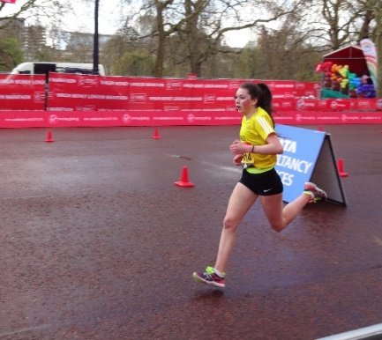
In the under 17 girls' race, Bethan Evans was 22nd, Naomi Reid 27th and Megan Bowen 32nd.
Nia Clatworthy was 10th in the under 13 girls'race and Jacob Reynolds was 57th in the under 13 boys'race.
Merely to take part is a great experience for these young athletes and to do so well is an extra bonus.
In the marathon itself, Mike Kallenberg ran a new personal best of 2:21.38 to take the silver medal in the Welsh Championship.
Alan Wadey, running for the Ron Pickering Memorial Fund, finished in a very respectable 3:27:25. Jen Stone finished in 4:44:12 with Huw Phillips three minutes later in 4:47:03.
Well done to all.

The challenge is on Sunday 24 April 2016

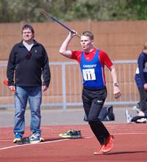
Having just pipped Swansea for the divisional title last year, Cardiff's UK Young Athletes League (U15/U13) had to settle for third place in the season's opening round at Newport on Saturday 23rd April.
Missing some of its more experienced athletes who have moved up an age group and with points machine Carter Staples injured (but filling in to throw the javelin and put the shot - that's team spirit), Cardiff nevertheless scored numerous wins and, with three more rounds to come and not many points separating the top three teams, should move up the table.
The final team scores were:
1. Swansea H & AC (598.5 points)
2. Cardiff Archers (556)
3. Cardiff AAC (539.5)
4. Cheltenham & County AC (416.5)
5. South Wales (333)
6. North Somerset AC (255.5)
Cardiff's individual event winners were:
Under 15 Boys: Daniel John (300m A); Joseph Coope-Franklin (300m B); Evan Griffiths (800m B); Luca Contino (Discus A & Shot Put A); Lloyd Clarke (Discus B); Simeon Santima (High Jump B).
Under 13 Boys: Luca Logue-Fonseca (200m B); Lloyd Jones (800m A); Rhys Blow (800m B).
Under 15 Girls: Issie Tustin (100m A & 200m A); Lily Gaskin (300m B); Cassie Grimwade (Discus A); Anais Rowlands (Discus B); Emma Fitzherbert (Javelin B); Isobel Owen (High Jump A).
Under 13 Girls: Fiona Bostock (800m A).
Cardiff teams won the 4x100 (Under 13 girls and boys) relays and the under 15 boys 4x300m.
The results can be found here.
A selection photographs can be seen here.
THe next round is in Swansea on 21st May.

Entry deadline Wednesday 20 April 2016

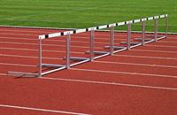
The summer season is already underway and the South Wales Regional Championships will be held in Brecon on 14th May.
The closing date for entries is 28th April (a week tomorrow) so get your entries in now to avoid a last minute rush.
Please also remember that your club subscription and Welsh Athletics registration fee needs to be paid up to date or your entry may be refused.
The championships are open to athletes aged from under 13 to seniors and are are an important part of the early season.
Full details including online entry can be found here.
Don't delay. Do it now.

Off to London Tuesday 19 April 2016

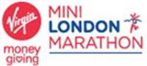
Cardiff AAC will be well represented in next Sunday's London Marathon and Mini Marathon.
Running in the main event, and raising money for their chosen charities, will be Alan Wadey, Jen Stone and Huw Phillips, while ten Cardiff athletes have been selected to represent Welsh Schools.
The Under 13, 15 and 17 teams, each comprising six athletes, have been chosen from performances over a series of cross country events held over recent months. They will travel to Royal Holloway College on Saturday and, following an overnight stay, continue into London early on Sunday morning with races taking place shortly after 9am.
The mini marathon is run over a three mile course, finishing in The Mall in the same place as the main London Marathon.
The Cardiff athletes are:
Under 13 girls: Nia Clatworthy.
Under 13 boys: Jacob Reynolds.
Under 15 girls: Abi Fisher, Carys Bill and Kiara Frizelle.
Under 15 boys: Morgan James.
Under 17 girls: Bethan Evans, Naomi Reid and Megan Bowen.
Under 17 boys: Jake Heyward.
This is a great experience for these athletes and we wish them all good luck.

Excellent Road Relay results Sunday 17 April 2016

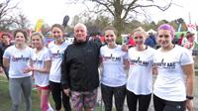
Cardiff's senior men's and women's road relay teams produced excellent performances in the National 12 and 6 stage championships in Birmingham yesterday, finishing 11th (out of 67 teams) and 12th (out of 50 teams) respectively.
Oustanding individual performances included Charlotte Arter's third fastest long leg and Kath Marshall's sixth fastest short leg.
And a special mention for veteran Nat Lane who celebrated his 40th birthday a week ago and brought the men's team home on the final leg.
The men's team was led off by Irish international Kevin Seward (who had represented Ireland in the world half marathon championships in Cardiff a fortnight ago) who handed over in 7th place. The second leg produced one of the team's best runs to take the squad into first place. It was not going to be possible to maintain a medal position however and the team finished in a really excellent 11th place, never having been lower than 12th.
The ladies team (the only Welsh team taking part) had suffered an unavoidable late withdrawal but, with Charlotte Arter running the third fastest long leg of the day, Jessica Hegarty brought the team home in 12th place.
These relays attract the cream of the UK's road runners and Cardiff has traditionally done well, the men's team having taken the silver medal in 2013. Four of the silver medal winning team (Kevin Seaward, Mike Kallenberg, Matt Edwards and Nat Lane) ran yesterday and to come 11th and 12th is excellent.
Video highlights of the men's race can be seen HERE and of the women's race HERE.
The declared teams were as follows, with positions after each leg in brackets:
Ladies:
1. Lucy Marland (17)
2. Katherine Marshall (9)
3. Liz Davies (13)
4. Charlotte Arter (6)
5. Georgia Morgan (7)
6. Jessica Hegarty (12)
Men:
1. Kevin Seward (7)
2. Alex Coomber (1)
3. John Cove (2)
4. Stephen Morris (5)
5. Mike Kallenberg (7)
6. Matthew Edwards (7)
7. Mike Kershaw (10)
8. Jack Eggington (12)
9. James Hunt (12)
10. Ieuan Thomas (10)
11. Ciaran lewis (10)
12. Nat Lane (11)
Congratulations.

Bethan in GB team for Rome Wednesday 13 April 2016

Cardiff's Bethan Davies has been selected for the British team that will take part in the biennial IAAF World Race Walking Championships in Rome on 7-8 May.
Bethan, who holds the Welsh record and is third best on the UK all-time list, will contest the 20k senior women's race.
Bethan's Welsh record for the 20k distance is 1:36.07 and the UK all-time best is 1:30.41.
Good luck Bethan.

Back to winter Monday 11 April 2016

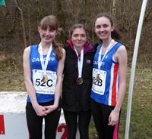
After the spring-like weather in Cardiff on Saturday, winter returned for the Welsh Road Relay championships held in Bargoed's Parc Cwm Darran yesterday, 10th April.
Despite a bitterly cold, strong and gusting wind that faced the runners for half the lap and made running into it very challenging, Cardiff teams ended the day with two sets of team gold medals, one of silver and one of bronze.
The under 15 girls' team was particularly strong, with Jessica Wadey, Kiara Frizelle, Abi Fisher and Carys Bill finishing a long way ahead of the second placers. Kiara also took the medal for the fastest lap of the race.
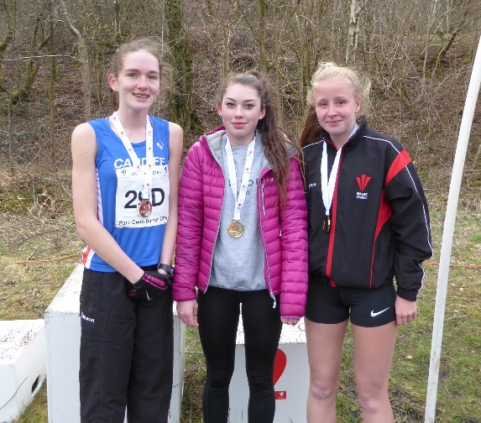
Carys Bill, Kiara Frizelle & Jessica Wadey (Abi Fisher missing)
The under 15s were matched by the under 17 girls' team that also scored a convincing victory, with lead-off runner Megan Bowen running the fastest leg and setting the race up nicely for Rhian Jones and Laura Wright.
The James family was out in force with father Huw and mother Mary both running in the senior race after son Morgan had led off the under 17 boys' team, with Seth Kelly and Daniel John, to the bronze medal.
The first race of the day had seen Jemima Robinson win the under 11 girls' one lap race.
The final race of the day saw a strong Swansea senior men's team, anchored by GB international Dewi Griffiths, take the title from defending champions Cardiff. A solid first leg from dependable Ciaran Lewis brought Cardiff to the first change-over in second place and within striking distance of Swansea. The gap proved too much to make up, however, but good legs from Matthew Edwards and Caerwyn Jones enabled James Thie to cross the line in second place and take the silver medals.
A big thank you must go to Tracey Gammon, Jen Stone and Huw James for organising and looking after the Cardiff teams. Cardiff had several teams in the younger age groups and could have finished more but for some last minute withdrawals.
This was a new venue for the annual championships and it has to be said that it was not an improvement on previous venues such as Pontypridd, or even Landow. On the whole, as an advertisement foe Welsh Athletics, it should have been better.
The official results can be seen here.

Better late than never Monday 11 April 2016

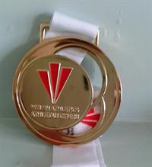
Although Cardiff AAC has a very talented group of young athletes, the older ones can win medals too.
After a delay in compiling the results, the Cardiff Master Women 45 ladies' team has been awarded the gold medals at the Welsh Cross Country Championships, held in Swansea on 27th February.
Congratulations to Helen John, Cerys Ash and Jen Stone.

Run Jump Throw a success Sunday 10 April 2016

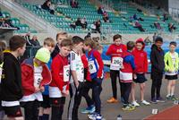
The weather was kind, with sunshine and a light wind, the athletes enjoyed it and the organisation was good.
The first edition of the Run Jump Throw competition for under 15 athletes was held yesterday at the Cardiff International Sports Stadium and was a welcome first of the season event.
With athletes competing in three events each, early season form could be judged and there were awards for the best all-round performances.
The winners in each of the age groups were:
Under 11 boys: Joshua Beecher (Cardiff AAC)
Under 11 girls: Callie Jones (Cwmbran H)
Under 13 boys: Zac Wall (Cardiff Archers)
Under 13 girls: Holly Medina (Cardiff AAC)
Under 15 boys: Luca Contino (Cardiff AAC)
Under 15 girls: Grace Powell (Neath H)
The results can be seen here: Under 11 boys: Under 11 girls: Under 13 boys: Under 13 girls: Under 15 boys: Under 15 girls:
A selection of photographs taken yesterday can be seen here.
Congratulations to Ceri, Garry and Gwyn Jones as well as the sponsors and every one else who contributed to a successful day.

Time to pay Thursday 7 April 2016

The bad news is that Welsh Athletics registration fees were due on 1st April and, unless they are paid, athletes will not be able to compete. UKA Athletics has made it a condition that all athletes in the UK must be registered in order to compete so, with the summer season upon us, this needs to be done straight away.
Payment is to be made to the club and we pass it on to Welsh Athletics.
The good news is that we have made it easier to pay, including online.
All Cardiff AAC members for whom we have an email address have already received two reminders by email and the messages included a link to the online payment system.
If you have not received an email it is because we do not have your current email address. Please contact membership secretary Bou Ligthart at boudewyn_ligthart@hotmail.com and he will advise you.
Alternatively, call into the club office and you can pay there.
A majority of members have already paid but, if you are one of those who have not, please deal with it straight away.
Thank you.

Coaches in the USA Wednesday 6 April 2016

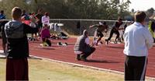
Steve Bailey and Derrick Stephenson, two of Cardiff's coaches, are currently enjoying the chance to mix with the best at the ALTIS centre in Arizona.
Along with Steve Boyles and former Cardiff AAC decathlete Fran Baker, they have been funded by Welsh Athletics and are there to make the most of this great opportunity.
Steve Bailey has been sending a daily Blog back to Welsh Athletics and has offered to talk to other coaches about the experience when he returns.
Having to put up with blue skies and 32 degrees must be the downside of the trip but Steve has sent the following report on his first day.
"Monday, Monday, so good to me’ as the song says.
Great first day at Altis, 32 degrees, clear blue skies and around 60 elite athletes training. There is a great buzz at the Paradise Valley track.
After introductions we were out meeting coaches and athletes. I watched the warm up drills for two sprint groups. My first learning point, movement quality, the good posture, precision and the accuracy of the drills. Definitely something to bring back and reinforce with my development age athletes. No more Mr Nice Guy there, get it right and develop correct movement patterns.
The Combined Events and Jumps group were equally awesome – quality is key, in the drills in the runs and at the weights Gym... where we went next.
EXOS is a phenomenal facility, just google it. Another learning point was the cross group support and interaction. Everyone helps and encourages each other even though at the meet here in Phoenix this Saturday they will be rivals!
No rocket science today not even in Stu McMillen’s presentation on acceleration running mechanics, but a real reminder about coaching quality from the earliest age and expecting it from yourself and your athletes.
I’m excited about the jumps group technical session on Tuesday...some elite combined eventers involved ."
Information about ALTIS can be found here.
The course is called Altis 2016 but, if you try to google this,you will discover that it is a model of a Toyota car.

Stadium News Friday 1 April 2016
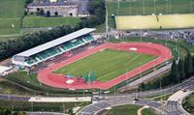
At long last, the responsibility for Cardiff International Sports Stadium has today been transferred from Cardiff City Council to Cardiff and Vale College.
The College has overall responsibility for the site but has sub-contracted the external sports areas (track, artificial pitch, rugby pitches, etc.) to House of Sport, which is based off Sloper Road and is connected with Cardiff City Football Club.
These negotiations between the College and the Council have taken a long time and we must congratulate the College for bringing them finally to a conclusion.
Cardiff AAC has agreed the principal conditions of a new lease of its club room and hopefully the final version will be signed off in the not too distant future.
Users of the stadium (it is likely that there will be a change of name to Cardiff International Sports Campus) should not notice much difference but we are awaiting confirmation of admission and other charges that will take effect.
The club will be part of a user group that will be consulted on the day to day use of the stadium.
If anyone needs further information, please speak to Bernie Plain or John Lister.

Paula meets Jen's Joggers Thursday 31 March 2016

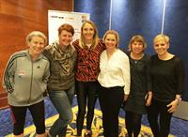
A week ago, in the build-up to the world half marathon championships, world record holder and marathon legend Paula Radcliffe was due to join Jen's Joggers, amongst others, for a three mile run around Cardiff.
Unfortunately, traffic on the M4 prevented Paula from joining the runners (perhaps she was secretly worried about the likely pace) but she made it to the Hilton Hotel in time for a general discussion about running and her own career.
In Jen's words, " Paula was delightful. She came across as very unassuming and down to earth. She answered everyone's questions and then we joined the scrum for selfies! She even signed my race programme. A very inspirational lady."
Well done to Jen's Joggers as well as those who actually took part in the half marathon or who lined the streets to watch and support the runners.
Cardiff looked very good on the television coverage; just a pity the weather wasn't better.

Cardiff at the top Thursday 24 March 2016

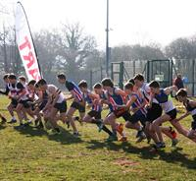
The Gwent Cross Country League has confirmed that Cardiff AAC was a clear winner of the overall junior club trophy, with Westbury Harriers second and Carmarthen Harriers third.
Cardiff won medals in no fewer than eight of the ten categories (under 11 to under 20) that count for the junior trophy and finished multiple teams in most; there were six Cardiff teams classified in the under 13 girls' category and four in the under 15 boys'..
Congratulations to all the athletes and team managers for such a magnificent result.
The finishing positions of the junior teams were as follows:
Under 11 boys: A team - 2nd; B - 19th; C - 44th.
Under 11 girls: A team - 8th; B - 30th.
Under 13 boys: A team - 1st; B - 15th.
Under 13 girls: A team - 6th; B - 15th; C - 21st; D - 27th; E - 32nd; F - 36th.
Under 15 boys: A team - 2nd; B - 11th; C - 16th; D - 24th.
Under 15 girls: A team - 1st; B - 7th; C - 23rd.
Under 17 boys: A team - 1st; B - 11th.
Under 17 girls: A team - 2nd; B - 10th; C - 18th.
Under 20 men: A team - 1st; B - 8th.
Under 20 women: A team - 2nd.
In addition to the juniors, it was encouraging that Cardiff finished teams in most other age groups:
Under 23 Men: A team - 3rd.
Under 23 Women: A team - 14th.
Senior men: A team - 16th; B - 44th.
Senior women: A team - 10th; B - 40th.
Masters 35 men: A team - 26th; B - 78th.
Masters 35 women: A team - 23rd.
Masters 45 men: A team - 28th.
Masters 45 women: A team - 25th.
Masters 55 men: A team - 40th.
The complete results are now available here.

Cardiff athletes shine Tuesday 22 March 2016

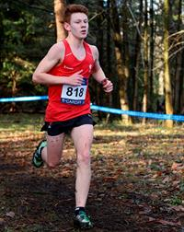
After a long journey by coach on Friday last, the Welsh teams were greeted with sunshine and good conditions for the annual SIAB/Welsh Athletics cross country international in Falkirk on Saturday last, 19th March.
With numerous Cardiff athletes in the teams, it was a final opportunity to test themselves against the best.
The best result of the day came from consistent Ciaran Lewis with a fine fifth place in the under 20 home countries international. Jake Heyward, representing Welsh Schools, was eleventh in the same race.
In the senior women's race, Lucy Marland, recovered from her injury the previous week, was the first Welsh athlete to finish, in 13th place.
Other Cardiff performances were:
Intermediate girls: Carys Bill (19th); Naomi Reid (22nd); Kiara Frizelle (24th); Abi Fisher (25th); Megan Bowen (28th).
Intermediate boys: Morgan James (27th).
Junior boys: Daniel John (18th).
Under 20 women: Bethan Evans (27th); Emma Ligthart (37th).
Under 20 men: James Hunt (24th).

Ready for the summer? Friday 18 March 2016

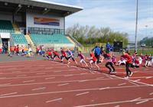
With the cross country season coming to an end, the first track and field events are only a few weeks away.
The Run Jump Throw in Cardiff on 9th April is specially designed for athletes under 15 and will provide a good guide to team selections for the first league matches. All Cardiff athletes under 15 are expected to enter this competition and entry forms are available in the club room or can be downloaded (see under).
League competitions proper start in April with the UK YDL (under 13 & 15) on 23rd April, the Welsh Senior and Under 20 league on the 24th and the Welsh Junior League on 30th.
It is important to let team managers know which competitions athletes will be available for and, if you have not done so already, please complete the online availability survey HERE. Please do this straight away.
Details of Run Jump Throw and the entry form can be found here.

Huge PB for Sarah Monday 14 March 2016

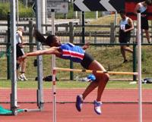
Sarah Omoregie was selected as February's Athlete of the Month for her Welsh shot put record of 13.83m.
She is also an accomplished multi-eventer and was an excellent third place at the England under 17 championships in Sheffield over last weekend, with a pentathlon score of 3,605 which puts her in third spot on the latest UK rankings.
On the way to her pentathlon score, Sarah produced a massive 1.03m improvement on her shot put best with a throw of 14.86m which takes her to a clear No.1 spot in the UK.
She also achieved a long jump best of 5.39m, equalled her high jump best of 1.60m and ran a personal best 800m in 2:44.61. She just missed out on a five event pb grand slam with "only" 9.40 for the 60m hurdles (her best is 9.36).
After such an impressive indoor season, what will Sarah do outdoors?
Meanwhile, at the Trafford 10k Inter Area match, Ieuan Thomas was the first of the Welsh men's team to finish, in 20th place, in a personal best time of 29:44, closely followed, in 22nd, by Mike Kallenberg, who was representing the Combined Services team. In the women's race, Gina Paletta finished in an excellent 6th place, also in a personal best time of 34:43.

Inter Counties Cross Country Saturday 12 March 2016

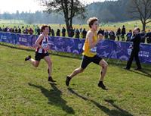
Several Cardiff athletes challenged the best in Britain today at the UK Inter Counties championships in Birmingham.
On a fine day with little wind and on a course that was a mixture of dry surfaces and mud, and included a testing uphill stretch, to come in the first hundred was pretty good, to come in the first fifty very good and in the first twenty excellent.
Ciaran Lewis set the standard in the first race of the day, finishing tenth in the under 20 men's race; and Carys Bill matched that in the under 13 girls' race, both producing outstanding runs.
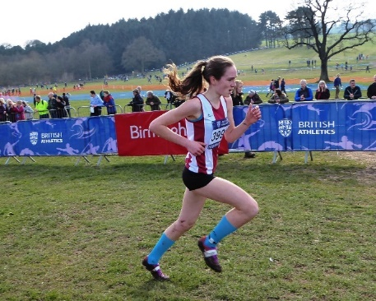
In the under 13 boys' race, after Ben Reynolds was forced to withdraw through illness, brother Jacob kept the family flag flying with a very good 25th place. In the under 17 men's race, the start having been delayed because of a medical emergency on the course, James Vincent ran a very steady race to finish in 18th place while Morgan James was 48th in the under 15 boys' race and Megan Bowen was 54th in the under 17 women's race.
Abi Fisher, running for East Wales was a few places behind Carys Bill in the under 13 girls' race in 13th.
This championship is a big step up from the Welsh championships and Gwent Leagues, in both the qualities and sizes of the fields, but it is important experience especially for the younger athletes to test themselves against the best.
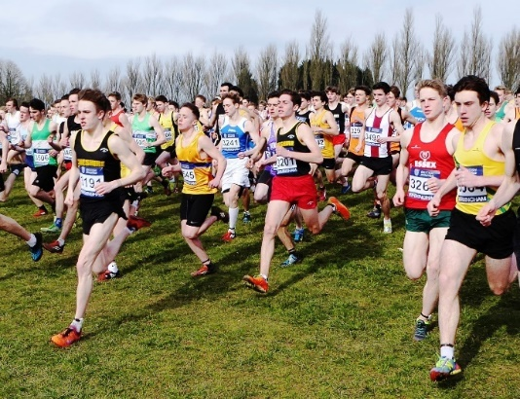

Congratulations Tim Friday 11 March 2016

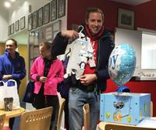
There was a new addition to the Fry family last Friday when Tim's wife Hannah gave birth to their first child Elliot.
To welcome the birth, Tim's coaching group last night presented him with some gifts for Elliot.
Tim and Hannah can look forward to some sleepless nights but everything is fine.
Congratulations to Tim and Hannah.

Another record for Bethan Tuesday 8 March 2016

It seems that Cardiff's Bethan Davies cannot get out of the habit of breaking records.
On Saturday last, 6th March, she won the gold medal at the England Athletics 10k race walking championship in a new Welsh Record time of 44:59 and moved up to second on the all-time UK rankings behind Johanna Atkinson's leading time of 43:52, set in 2010.
Only a couple of weeks ago, in Cardiff, Bethan set a new UK indoor record for the 3k walk.

Final Gwent League Sunday 6 March 2016

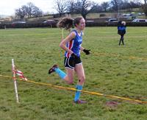
On a course that was surrounded by snowcapped mountains, the final round of the season's Gwent League was held in Brecon yesterday, 5th March, in sunny and thankfully dry conditions although with a bitingly cold wind.
Despite a lower than usual turnout (the senior men and women were particularly disappointing), Cardiff's junior athletes were to the fore in most of the age groups, with Carys Bill, Jessica Heggarty and Ciaran Lewis winning their races with ease. James Vincent and Laura Wright were also age group winners within combined races.
The final team results will show that, amongst other team medals, the under 13 boys won gold and that Cardiff has won the overall junior club trophy; for the third year running.
Jemima Robinson had got the day off to a good start with second place in the under 11 girls race and she was followed by second and third in the under 13 boys for Ben and Jacob Reynolds.
The individual results were:
Under 11 Girls - Jemima Robinson 2nd
Under 11 Boys - Ben Hughes 9th
Under 13 Girls - Lili Jones 22nd
Under 13 Boys - Benjamin Reynolds 2nd
Under 15 Girls - Carys Bill 1st
Under 15 Boys - Seth Kelly 13th
Under 17 Women - Laura Wright 1st
Under 17 Men - James Vincent 1st
Under 20 Women - Jessica Hegarty 1st
Under 20 Men - Ciaran Lewis 1st
Senior Women - Emma Blow 121st
Senior Men - Steven Smith 121st
Athletes of the day are Laura Wright and Matthew Verran for consistently turning out for the Cardiff AAC this season and showing themselves to be valuable assets to the club teams - Well done!
Congratulations to all who have taken part in another successful Gwent League season and a special thank you to team managers Kay Chapman and Tracey Gammon who have worked so hard to encourage and support the athletes.
The official results will be on the Gwent League website which can be found HERE.

Academy goes indoors Friday 4 March 2016

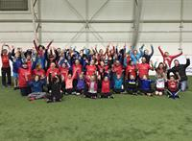
On Monday 15th February, over fifty Cardiff Academy athletes assembled at the House of Sport for an evening of sportshall athletics.
The event was kindly supported by Welsh Athletics and all the academy coaches, who even dusted off their spikes for a ‘coaches against the athletes relay'. Needless to say, the athletes won.
The athletes divided into two teams that participated across six events: speedbounce, an agility course, shot put, long jump, triple jump & sprints.
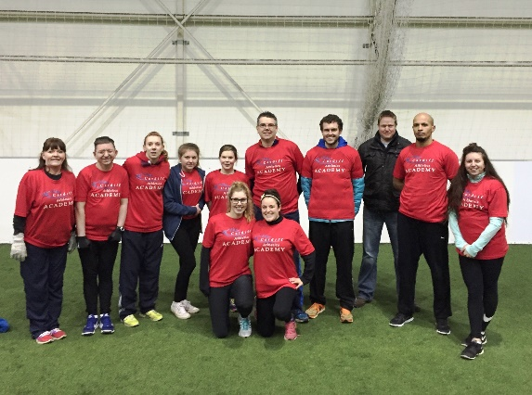
It was great to have so many parents present too, who were able to watch from the viewing gallery. Maybe at the next one we could include a parents relay!
The evening was the first of what we hope will be regular indoor training evenings where athletes get to compete against each other in a friendly environment.
Details of the next indoor training evening will be advertised in due course, and we hope to see even more academy athletes taking part in this fun evening.
Many thanks to everyone that helped out on the day and we look forward to welcoming you at the next indoor athletics spectacular, in the mean time ‘like’ our academy page on Facebook for up to date information; simply search: Cardiff AAC Academy.

Final Gwent League Wednesday 2

March 2016
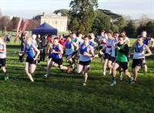
The final round of this season's Gwent Cross Country League takes place at Penlan Leisure Centre, Brecon on Saturday next, 5th March.
With Cardiff AAC well placed for lots of individual and team honours, we need a big turn out in order to end the season in style.
If you have not yet informed your team manager that you will be running, please do so straightaway.
The timetable of races is as follows:
12.00 Novice Boys
12.08 Novice Girls
12.16 Under 13 Boys
12.33 Under 13 Girls
12.50 Senior Ladies and Masters
13.32 Under 15 Boys
13.40 Under 15 Girls
13.49 Under 17/Under 20 Men
14.05 Under 17/Under 20 Women
14.20 Senior Men and Masters
The team managers are:
Senior Men - Alex Donald 07740 471573
Senior Women - Liz Davies 07815 952457
Junior Boys up to under 20 - Kay Chapman 07749 716151
Junior Girls up to under 20 - Tracey Gammon 07795 098053
The course map can be seen here.

Cross Country Heroes Sunday 28 February 2016

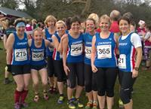
Cardiff athletes were out in force at the Welsh Cross Country Championships, held yesterday, 27th February, at Swansea's Singleton Park. On a bright, sunny day on a course that was undulating and very sticky in places, Cardiff vests were to the fore in every age group and brought home great individual and team performances.
Jake Heyward returned to racing with a bang to win the under 17 men's gold medal and lead his team to silver. Other individual medallists were Elis Finlayson (Yr 5 boys' silver), Carys Bill (under 15 girls' silver), Ciaran Lewis (under 20 mens' silver), Morgan James (under 15 boys' bronze), Bethan Evans (under 17 women's bronze), Jessica Hegarty (under 20 women's bronze) and Lucy Marland (senior women's bronze).
Other leading performances, short of medal winning, were Scarlett Davies (year 5 girls - 16th), Rhys Blow (year 6 boys - 7th), Jemima Robinson (year 6 girls - 4th), Ben Reynolds (under 13 boys - 5th), Lili Jones (under 13 girls - 17th), Ieuan Thomas (senior men - 5th).
Team medals were won in almost every age group:
Under 11/year 5 boys: Bronze (Elis Finlayson, Joseph Joyce, Tommy Bryant)
Under 11/year 6 boys: Gold (Rhys Blow, Ben Hughes, Henry Spencer)
Under 11/year 6 girls: Bronze (Jemima Robinson, Libby Pearson, Poppy Tucker)
Under 13 boys: Gold (Ben Reynolds, Jacob Reynolds, Evan Griffiths, Ryan Edwards)
Under 15 boys: Gold (Morgan James, Daniel John, Louis Spencer, Alfie Davies) and Bronze (Rowan Allin, Seth Kelly, Kian Murphy, Sam Griffin)
Under 15 girls: Gold (Carys Bill, Kiara Frizelle, Abi Fisher, Mali Howell)
Under 17 men: Silver (Jake Heyward, James Vincent, Jac Smith, Antonio Peacock)
Under 17/20 women: Gold (Bethan Evans, Megan Bowen, Jessica Hegarty, Naomi Reid)
Under 20 men: Gold (Ciaran lewis, James Hunt, Daniel Graves, Sam Curwen)
Senior women/U 23: Silver (Lucy Marland, Charlotte Gaughan, Liz Davies, Heddwen Daniel)
Other team performances were :
Under 11/year 5 girls (5th); Under 13 girls (6th); Under 15 boys (C team - 9th); Under 15 girls (B&C teams -4th & 5th).
There were also numerous runners in the masters races and probable team medals. However these need to be confirmed later as there was some confusion with the results of these combined age group races.
All in all it was an excellent day for Cardiff and everyone deserves to be congratulated. Well done.
The official results (subject to confirmation of the senior/masters categories) can be seen here.

National & world records Sunday 28 February 2016

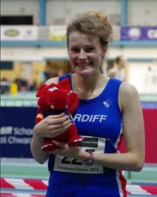
At the UK National indoor championships in Sheffield today, Cardiff's Bethan Davies and Aled Davies set new indoor UK national and world records respectively.
In taking the gold medal, Bethan improved her own UK record for the 3,000m walk by almost two seconds with a time of 12:44.99 whilst Aled (competing in the able bodied championship but with the F42 6kg shot) improved his own indoor F42 shot put world record to 16.14m.
Competing yesterday on the first day of the two day championship, David Omoregie took the bronze medal in the 60m hurdles, have gone close to his personal best with a time of 7.69 to win his heat.
Rowan Axe also set an indoor personal best, for the 3000m, when finishing seventh in 8:15.11. Charlotte was also seventh in the final of the women's 3000m.

University medals and PBs Tuesday 23 February 2016

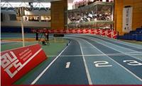
The British Universities indoor championships were held in Sheffield over last weekend and several Cardiff athletes were competing for their universities.
David Omoregie won the gold medal in the 60m hurdles for Loughborough and his time of 7.77 seconds in his heat was faster than his UK rival David King produced in the Glasgow International on the same day. Lucy Griffiths took the silver medal in the women's shot put with a personal best throw of 13.88m, Rebecca Chapman was second in the long jump and Jonathan Hopkins won bronze in the 3000m, also with a personal best time of 8:14.65.
Elsewhere, Paul Bennett ran a season's best time of 49.41 in the semi final of the 400m, Lucy Marland was sixth in the final of the women's 3000m and Gareth Hopkins (60m), John Cove (1500m) and Rebecca Chapman (60m) each made it through to their respective semi finals.
Morgan Jones, a T47/F47 disability athlete, won the Gold Medal in both the 60m and Long Jump events in this category.
The full results can be found here.

Final Reminder Thursday 18 February 2016

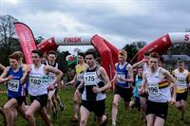
Tthe Welsh Cross Country Championships will be held on a new course at Singleton Park Swansea on Saturday 27th February and the final date to get your entry in is the day after tomorrow, February 20th
The first race (for under 11 boys) is at 10.30; with the last race (for senior men) at 14.55.
Welsh Athletics has, this year, introduced the ‘Participation Cup’ which will be awarded to the club providing the most finishers in the Senior / Masters races (men & women combined).
Entries need to be made through one of the team managers, who are:
Junior Boys (up to 20): Kay Chapman (07749 716151)
Junior Girls (up to 20): Tracey Gammon (07795 098053)
Senior Men (over 20): Alex Donald (07740 471 573)
Senior Women (over 20): Arwyn Davies (07855 952 862)
The course map and timetable can be seen here.
With the championships returning to South Wales, Cardiff will expect to have plenty of participants and to do well.
Don't forget the entry deadline.

World Record for Omoregie Tuesday 16 February 2016

Cardiff's David Omoregie has received the good news that the IAAF has ratified his 2014 time for the 60m hurdles (7.50) as an under 20 world record, equalling the time set by the Greek Konstadinos Douvalidis in 2006.
The delay in ratifying David's time is because Wilhem Belocian had run 7.48 earlier the same day; but it has not been submitted as a record as it did not meet the reqirements and the IAAF had to wait for confirmation.
David's run was achieved during the Welsh Athletics international in Cardiff's NIAC on 9th March 2014.
Congratulations David.

Indoor Silvers and Bronze Monday 15 February 2016

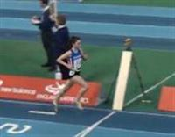
Whilst many were experiencing the mud of the Gwent League, other Cardiff athletes were enjoying the comfort of competing indoors against the best in Britain at the England Athletics indoor championships, held in Sheffield on Saturday and Sunday.
Silver medals were won by Sarah Omoregie in the under 17 women's shot put, Lauren Evans in the under 17 women's high jump and Kiera Frizelle in the under 17 women's 1500m. Sarah's shot put of 13.83m improved her own club and Welsh records and took her to second place on the latest UK rankings. James Vincent, recovering from a throat infection, took the bronze medal in the under 17 men's 1500m in a personal best indoor time of 4:06.80.
Kristian Jones had a busy two days, competing in both the 60m and 200m. He was sixth in the final of the under 20 men's 60m and was looking to improve on that in the 200m. After cruising through to win his 200m heat in 21.85, Kristian appeared to be a comfortable qualifier for the final before being disqualified in his semi final, presumably for running slightly out of his lane.
Naomi Reid was fourth in the under 17 women's 800m, Megan Hodgson and Isabel Breeden were each sixth in the under 17 women's pole vault and 60m hurdles respectively, Catrin Lord was eighth in the under 17 women's long jump and Sarah Omoregie 10th in the under 17 women's high jump. Issie Tustin just missed out on a place in the under 15 girls' 200m, recording a personal best of 26.36 in her semi-final.
The full results from Sheffield can be seen here.

Mud, glorious mud Sunday 14 February 2016

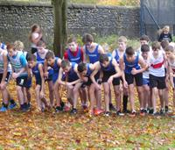
The fourth round of the Gwent Cross Country League was held in Monmouth yesterday. On a cold day with constant drizzle, the course quickly churned up to provide all the runners with generous coverings of mud; none more so than Morgan James who took a tumble and finished completely covered. He still finished fourth.
Cardiff had a good turnout of runners with high finishers although only Carys Bill finished first; in the under 15 girls race.
Five members of the Smith family ran (is this a record?) with dad Steve, mum Emma, Jac (3rd in the under 17 men's race), Ben and Iwan. Well done to them and to all who took part.
Athletes of the day (selected by the team managers) were Jasmine Wallace and James Gold.
Cardiff's finishers in each of the races were:
U11 Girls - Jemima Robinson (3rd)
U11 Boys - Ben Hughes (9th)
U13 Girls - Megan Freidli (28th)
U13 Boys - Benjamin Reynolds (4th)
U15 Girls - Carys Bill (1st)
U15 Boys - Morgan H James (4th)
U17 Women - Laura Wright (6th)
U17 Men - Jac Smith (3rd)
U20 Women - Jessica Hegarty (3rd)
Senior Men - Ciaran Lewis (10th)
Senior Women - Lucy Bob Marland (3rd)
The full results will be available on the Gwent League website.
Lets hope these performances are replicated in the Welsh Cross Country Championships in two weeks time.
Congratulations to everyone who competed today!

Ready for the Half? Friday 12 February 2016

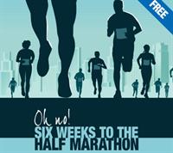
With the Cardiff/World half marathon only weeks away, Cardiff sports shop RunandBecome, which sponsors the club's Athlete of the Month award, is organising a workshop to advise on the final preparations.
The workshop will be held at the store at 100, St Mary Street Cardiff on Tuesday evening, 16th February from 7.00 to 8.30pm and entry is free of charge. The session will be led by performance coach Rory Coleman.
For further information, CLICK HERE.

Running for your money Thursday 11 February 2016

Three of Cardiff's enthusiasts (Alan Wadey, Jen Stone and Huw Phillips) will be raising money for their chosen charities by running in the Virgin London Marathon on 24th April.
All three are also team managers with the junior club teams and will be grateful for any donations to help them reach their fund raising targets.
Alan Wadey will be running for the Ron Pickering Memorial Fund which is the principal charity for helping young athletes with potential. The recently announced grant recipients included six Cardiff AAC athletes.
Donations to the RPMF can be made by going to http://uk.virginmoneygiving.com/alanwadey2016.
Jen Stone is raising money for a colleague whose 18 year old son has osteosarcoma, a bone cancer that affects mainly children and especially teenagers.
Donations to Jen's cause can be made by going to https://crowdfunding.justgiving.com/JenStone2016.
Huw Phillips is raising money for the George Thomas Hospice for the care that they provided to his mother in law.
Donations to Huw's cause can be made by going to http://www.justgiving.com/owner-email/pleasesponsor/Huw-Phillips2.
These are all good causes that deserve support.

Relay glories Tuesday 9 February 2016

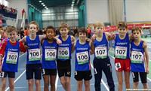
Included in the indoor Welsh International last Sunday at the NIAC in Cardiff were under 13 and under 15 4x200m relays and Cardiff teams won three of the four races and came second in the other. The under 15 boys fielded two teams and came first and third overall.
In the open races, Alex Coomber narrowly beat Carl Hill in the senior men's 800m And Charlotte Arter was an easy winner of the senior women's 3000m.
In the under 20 international match, Kristian Jones ran a storming last leg (timed at 20.8) to clinch victory for WAles over England in the 4x200m relay.
4x200m Relay Results:
Under 13 Boys: Cardiff AAC 1st. Ben Vincent / Jacob Reynolds / Louis Shugar / Luca Logue-Fonseca.
Under 13 Girls: Cardiff AAC 2nd. Maddy Jones / Darcy John-Cook / Olivia Sugarman / Holly Medina.
Under 15 Girls: Cardiff AAC 1st. Issy Tustin / Nia Grundy / Lily Gaskin / Emanualla Kone.
Under 15 Boys: Cardiff AAC 1st. Joseph Coope-Franklin / Luca Contino / Harry Griffiths / Carter Staples.
Under 15 Boys: Cardiff AAC 3rd. Matthew Register / Phillip Grundy / Harry Owen / Ben Hillman.
The full results can be seen here.
A selection of photographs taken by Garry and Gwyn Jones can be seen here.

Back to Cross Country Friday 5 February 2016

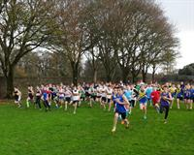
After a gap for Christmas, the Gwent League resumes on Saturday 13th February when the fourth round of the 2015-16 series will be held in Monmouth. This is a new venue for the Gwent League and athletes are advised to arrive early in order to walk the course and familiarise themselves with it.
This has been a successful series for Cardiff so far with individuals and teams in medal winning positions in most of the age categories.
With only two rounds to go, we would like to see as many Cardiff athletes as possible in all age groups so that we can finish the season on a high.
Anyone who is aged nine and over can be in a team and we always like to see new faces. We also need Seniors and Masters athletes to compete too. If you fancy having a run please let your relevant team manager know you are coming by the Friday evening before the races. Please contact them as follows;
Senior Men - Alex Donald 07740 471573
Senior Women - Liz Davies 07815 952457
Junior Boys up to under 20 - Kay Chapman 07749 716151
Junior Girls up to under 20 - Tracey Gammon 07795 098053
The first race is at 12.00 (under 11 boys) and the full timetable can be seen HERE.
A map of the course can be seen HERE and directions can be seen HERE.

Safety First Thursday 4 February 2016

A reminder to all athletes to take care when training at Cardiff International Stadium (and elsewhere).
Rules on the use of the track can be seen on the wall at the entrance to the track and these MUST be followed.
You should NOT cross the grass central area as throwing implements (javelin, hammer and/or discus) are dangerous.
Do not warm up on the inside two lanes.
Be alert and careful.

More Welsh champions Monday 1 February 2016
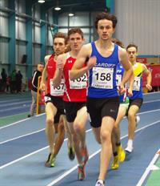
The series of indoor Welsh championships came to an end at Cardiff's NIAC yesterday, 31st January, and Cardiff athletes were once again to the fore in the medal lists.
Two grand slams of medals were achieved, in the senior men's 800m and 1500m. The final of the 800m saw a thrilling drive for the line with hardly the thickness of a vest covering Tom Marshall (first), Alex Coomber (second) and Carl Hill (third).The 1500m was more clear cut, with winner Matthew Edwards easily heading James Thie (second) and Stephen Morris (third). Stephen improved his own T20 British 1500m record with 4:01.05.
An equally exciting and determined finish saw Lana Culliford take the gold medal in the under 17 women's 300m. Daniel John won the under 15 boys' 300m, with Joseph Coope-Franklin second, both recording personal best times.
Personal best performances were coming thick and fast and one of the best was Sarah Omoregie's 13.54m to win the under 17 women's shot put; a new club and Welsh record.
Sarah's older brother David Omeregie, in his first race of the year, was narrowly beaten in the senior men's 60m hurdles by Plymouth's David King but still showed impressive hurdling form.
One of the busiest athletes of the day was Kristian Jones who contested both the senior men's 200m and 60m. After safely negotiating the heats and semi finals of the 60m, Kristian found himself up against two of Britain's fastest sprinters, Adam Gemili and James Dasaolu in the final. Kristian equalled his personal best to add the senior closed Welsh title to the Under 20 title. In the final event of the day, Kristian was an easy winner of the 200m.
Cardiff's individual medallists were:
Senior Men:
Gold: Kristian Jones (60m & 200m); Tom Marshall (800m); Matthew Edwards (1500m); David Omoregie (60m hurdles); Jonathan Bailey (high jump); Ryan Grimwade (pole vault).
Silver: Alex Coomber (800m); James Thie (1500m); Brett Morse (shot put).
Bronze: Carl Hill (800m); Stephen Morris (1500m); Harry Hillman (pole vault); Gage Francis (triple jump); Aled Davies (shot put).
Senior Women:
Gold: Lauren Evans (high jump); Rebecca Chapman (long jump).
Silver: Lucy Griffiths (shot put).
Bronze: Megan Hodgson (pole vault).
Under 17 Men:
Silver: Thomas Hanson (shot put)
Bronze: Jay Morse (shot put).
Under 17 Women:
Gold: Sarah Omoregie (shot put); Lana Culliford (300m).
Silver: Katie Roberts (shot put).
Under 15 Boys:
Gold: Daniel John (300m).
Silver: Joseph Coope-Franklin (300m).
The full results can be seen here.
A selection of photographs can be seen here.

Grants success Thursday 28 January 2016

As a mark of the potential talent of Cardiff's young athletes, six have been awarded development grants by the Ron Pickering Memorial Fund.
Grants are specifically aimed at helping young athletes who have shown above average talent and Cardiff athletes usually feature in the annual lists.
This year's six are Kieran and Ryan Grimwade, Tom Hanson, Sarah Omoregie, Amelia Reynolds and Jac Palmer.
The Memorial Fund was established following the death of Ron Pickering in 1991 and has, since then, raised and distributed in grants well over £1.5million. The latest round of grants attracted 471 applications and 221 grants were awarded, totalling £44,600.
Ron Pickering had been national coach for Wales and had been coach to Olympic Gold medallist Lynn Davies, who is one of the fund's trustees together with John Lister and others.
The fund's main source of income is from runners in the London Marathon for which it has a certain number of guaranteed entries. Anyone interested in one of these entries should contact John Lister; the closing date for entries to the 2016 London Marathon is next week.
Further information can be found at www.rpmf.org.uk.

Outdoors and In Monday 25 January 2016

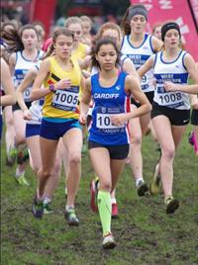
On Saturday 23rd, the third Cardiff Met indoor GP was held at Cardiff's NIAC and yesterday, 24th, cross country took centre stage with the British Athletics Cross Challenge at Blackweir.
With heavy overnight rain, the course at Blackweir was muddy and heavy but, fortunately, the weather stayed dry and the conditions were not too bad (it was cross country!).
Cardiff athletes were to the fore in most of the races with Ciaran Lewis (5th in the under 20 men) and Carys Bill (5th in the under 15 girls) the highest placers.
Naomi Reid had an excellent run to place 6th in the under 17 women's race whilst brothers Ben and Jacob Reynolds were 6th and 10th respectively in the under 13 boys. Abi Fisher was close behind Carys Bill to finish 6th in the under 15 girls.
In the senior men's race, Jonathan Hopkins was 9th overall and first in the universities category.
In the primary Boys and Girls races, Ben Hughes was 7th and Jemima Robinson was also 7th.
The full results can be found here.
A selection of photographs can be seen here.
The conditions indoors on Saturday were rather more comfortable and provided useful competition as athletes start to look forward to the outdoor season.
Wins were chalked up by Daniel Dell (200m heat 2) and Alex Coomber (400m heat 3) and Rachel Matthews was masters gold medallist in both the 400m and the 1500m. Jonathan Bailey cleared 2.00m in the high jump for fourth place.
Steve Morris, who is coached by James Thie, broke the UK T20 indoor 1500m record with a time of 4:01.40, his best time since 2014.
The full results can be found here.

Yesterday, Sunday 24th, saw seven Cardiff pole vaulters take part in the Vault Cardiff competitions at the NIAC. Amongst good performances, Thomas Britt once again took his best to new heights, setting a personal best of 3.56m. Ryan Grimwade showed that he is in good form, clearing 4.36m.
The pole vault results can be found here.

Six Cardiff athletes for Wales Friday 22 January 2016

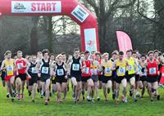
Wales takes on England in the British Cross Country Challenge in Cardiff's Blackweir on Sunday next, 24th January, and Cardiff AAC is represented in every age group team.
Jonathan Hopkins and Lucy Marland are in the senior men's and women's teams respectively while Jack Gooch and Jessica Hegarty are in the under 23 teams and Ciaran Lewis and Megan Bowen are in the under 20 teams.
The first race (under 13 girls) is at 11.00 and the programme finishes at 14.50 with the under 17 men's race.

Charlotte second in Bermuda Tuesday 19 January 2016

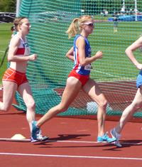
Charlotte Arter's fine form earned her a trip to Bermuda for the annual Bermuda 10k on Sunday last, 17th January, where she finished the mixed race in 8th place and the second woman, in a time of 35:48, just behind England's Faye Fullerton (35:37). Also in the Bermuda 10k was Adam Bitchell who finished in fourth place in 33:22.
The day before, Charlotte and Adam had both taken part in high quality street mile races, Adam winning his in 4:26.5 and Charlotte placing fifth in 4:53.3.
Also avoiding Britain's weather is Katherine Marshall who set a new personal best time of 4:46.71 in winning the Cooks Classic one mile in New Zealand on Saturday last. Katherine comes from New Zealand and was representing her local club Te Awamutu.

More medals on day 2 Sunday 17 January 2016

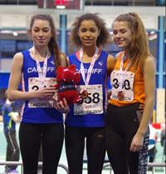
The Cardiff medal rush continued on the second day of the Welsh Athletics junior indoor championships with a number of Cardiff athletes also adding to their medals won on day one.
One of the classiest performances came again from Kristian Jones who not only added the 200m gold to that of the 60m he won yesterday but, with a blistering run from the outside lane, demolished his indoor personal best with a time of 21.76 secs., not far off his outdoor best for the distance. In the field, Tom Trotman set a lifetime best of 2.00m with a first time clearance to win the under 20 men's high jump.
Holly Medina won the under 13 girls' high jump and was second in the 200m, to add to her 60m silver medal from yesterday.
In the under 13 boys' events, Jacob Reynolds added the 1500m championship medal to the 800m yesterday, setting a new personal best in the process. Older brother Ben, who has moved up into the under 15 age group, had to be content with the bronze medal in his 1500m race.
Issie Tustin added the under 15 girls' 200m gold to her 60m triumph and James Vincent had another easy victory, this time in the under 17 men's 1500m. Likewise, Naomi Reid added the 1500m to her 800m gold medal with a well judged race against Kiara Frizelle. All-rounder Lauren Evans was first in the under 17 women's high jump and second in the long jump, to add to her second place in the 60m hurdles; Catrin Lord had pushed Lauren into second in the long jump after placing third in the triple jump yesterday.
Amongst numerous personal bests, Tom Britt increased his high jump best from 1.63m to 1.70m to culminate an, as usual, busy weekend.
Cardiff's medal winners were:
Under 13 Boys:
Gold: Jacob Reynolds (1500m).
Under 13 Girls:
Gold: Holly Medina (high jump).
Silver: Holly Medina (200m).
Under 15 Boys:
Gold: Luca Contino (high jump); Jonathan Gibson (long jump).
Bronze: Carter Staples (200m); Ben Reynolds (1500m).
Under 15 Girls:
Gold: Issie Tustin (200m).
Bronze: Saffie Maurice (pole vault).
Under 17 Men:
Gold: James Vincent (1500m).
Bronze: Iwan Robinson-Booth (200m); Thomas Britt (high jump).
Under 17 Women:
Gold: Naomi Reid (1500m); Lauren Evans (high jump); Catrin Lord (long jump).
Silver: Kiara Frizelle (1500m); Lois Hillman (pole vault); Lauren Evans (long jump).
Bronze: Lana Culliford (200m).
Under 20 Men:
Gold: Kristian Jones (200m); Jac Smith (1500m); Tom Trotman (high jump); Jordan Fender (long jump).
Bronze: Harry Hillman (long jump).
Under 20 Women:
Silver: Ceri Jones (pole vault).
Bronze: Amelia Reynolds (200m).
The combined results for both days can be seen here.
A selection of photographs taken on the second day can be seen here.

Carys tops the bill Saturday 16 January 2016

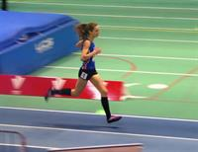
Cardiff's Carys Bill led from the gun to dominate the under 17 women's 3000m at day one of the Welsh junior age groups indoor championships at the NIAC in Cardiff.
But Carys's was just one of numerous excellent Cardiff performances, with medals and personal bests coming thick and fast.
Kristian Jones set a new pb of 6.91 seconds to win the under 20 men's 60m while James Vincent broke the 2 minute barrier again to win the under 17 men's 800m and set a new overall personal best of 1:58.16. Naomi Reid ran smoothly to take the under 17 women's 800m, Harry Hillman won the under 17 men's 60m hurdles, Ben Vincent won the under 13 boys' long jump and Jacob Reynolds the under 13 boys' 800m. Issie Tustin, wearing her go-faster red shorts, won the under 15 girls' 60m
Cardiff's medallists were:
Under 13 Boys:
Gold: Jacob Reynolds (800m); Ben Vincent (long jump).
Bronze: Ryan Edwards (800m).
Under 13 Girls:
Silver: Holly Medina (60m).
Bronze: Maddy Jones (60m); Evie Wong (60m hurdles).
Under 15 Girls:
Gold: Issie Tustin (60m).
Under 17 Men:
Gold: James Vincent (800m);
Silver: Richard Lee (60m); Thomas Britt (pole vault);.
Bronze: Iwan Robinson-Booth (60m); Morgan James (3000m); Seth Kelly (triple jump).
Under 17 Women:
Gold: Naomi Reid (800m); Carys Bill (3000m).
Silver: Jessica Wadey (800m); Lauren Evans (60m hurdles).
Bronze: Lana Culliford (60m); Laura Wright (3000m); Catrin Lord (triple jump).
Under 20 Men:
Gold: Kristian Jones (60m); Harry Hillman (60m hurdles).
Bronze: Arron Owen (60m); Nicholas Jones (800m).
Under 20 Women:
Bronze: Amelia Reynolds (60m).
The official results can be seen here:
A selection of photographs can be viewed here.
Elsewhere, Megan Bowen and Ciaran Lewis travelled to Northern Ireland for the Antrim round of the British Cross Country Challenge series. Megan was an excellent third in the under 17 girls' race and Ciaran was eleventh in the under 20 men's.

Great run by Charlotte Tuesday 12 January 2016

Cardiff's Charlotte Arter produced one of her best performances to date in the Great Edinburgh International Cross Country race last Saturday, 9th January.
Running in the Great Britain vest for the first time, Charlotte was always in touch with the leaders and, with a strong finish, was fifth in the race and the third British athlete to cross the line, contributing valuable points to her winning team.
Athlete of the Month in November, Charlotte has shown excellent form over the winter, and promises further good results to come on the track.

More indoor performances Monday 11 January 2016

Yesterday, the day after the successful indoor regional championships, older Cardiff athletes produced more good performances at the Cardiff Met GP2.
One of the best was Kristian Jones' indoor personal best of 21.90 to clearly win the 200m. This time is not far off his outdoor best and augurs well for the future.
Elsewhere, Rebecca Chapman won both the 60m and Long Jump, Alex Coomber the 800m (with Carl Hill a close second) and Sarah Omoregie the shot put, as well as placing second in the high jump. James Griffiths was second inn the 60m
Ryan Grimwade was near his best with a 4.31m clearance in the pole vault while Jessica Abraham was second in the women's pole vault. Gage Francis was second in the triple jump and fourth in the long jump.
Running indoors after his second placing in the Nos Galan race, Mike Ward was again second, in the 3000m, with Matt Edwards fourth.
Older members of the club may remember Mal Farnham who, yesterday, was second in his heat of the masters 200m, in 41.59 (a bit slower than Kristian's time, but he is over 80).
The full results can be seen here.

Indoor medals haul Sunday 10 January 2016

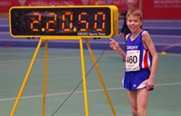
On a day when it was far better to be competing indoors than out, Cardiff athletes turned out in force for part two of the under 13, under 15 and under 17 Welsh regional championships at the NIAC yesterday, 9th January.
The star performance of the day was Jacob Reynold's huge win in the under 13 boys' 800m, setting a new Welsh record of 2:20.52. Jacob is still only 11.
The under 17 boys and girls were particularly successful with clean sweeps of all the medals in the 800m and 1500m (both boys and girls).
Apart from Jacob's excellent run, there were fine individual performances from James Vincent, whose powerful front running saw him to an indoor personal best of 1:59.02 in the under 17 boys' 800; Issie Tustin recovered from a poor start (usually fatal indoors) to show great determination and come through to win the under 15 girls' 60m; and Isabel Breeden showed equally good form to win both the 60m hurdles and 60m. Tom Britt, who qualifies for East Wales, collected three medals, two gold and a silver.
It was also pleasing to see how smart the Cardiff athletes looked. The club has decided that all athletes representing the club should wear the official club competition vest together with plain black or red shorts; so, to those very few that currently wear different coloured shorts, can you please wear black or red in future?
The individual medallists (all South Wales unless otherwise indicated) yesterday were:
Under 17 Boys:
Gold: James Vincent (800m); Morgan James (1500m); Jac Bradshaw (long jump); Tom Britt (E. Wales: 60m Hurdles & Triple Jump).
Silver: Iwan Robinson-Booth (60m); Ieuan Jones (800m & 1500m); Thomas Atkinson (60m Hurdles); Tom Britt (E. Wales - Long Jump).
Bronze: Richard Lee (60m); Thomas Whittaker (800m & 1500m);
Under 17 Girls:
Gold: Jessica Wadey (800m); Kiara Frizelle (1500m); Lauren Evans (60m Hurdles & Long Jump); Ellie May Stonehewer (Triple Jump); Isabel Breeden (E. Wales - 60m & 60m Hurdles).
Silver: Eliza Hill (60m); Carys Bill (800m & 1500m); Clara Nuthall (60m Hurdles).
Bronze: Rhian Jones (800m & 1500m); Ellie May Stonehewer (Long Jump); Eliza Durnall (Triple Jump).
Under 15 Boys:
Gold: Carter Staples (60m).
Silver: Jonathan Gibson (Long Jump); Harry Owen (E. Wales - Long Jump).
Bronze: Harry Griffiths (800m & Long Jump); Ben Smith (1500m); Joseph Coope-Franklin (E. Wales - 60m).
Under 15 Girls:
Gold: Issie Tustin (60m); Sofia Vella (800m).
Silver: Nia Grundy (60m); Emily Chirighin (1500m).
Bronze: Saffron Maurice (60m Hurdles); Cassey Grimwade (Shot Put).
Under 13 Boys:
Gold: Jacob Reynolds (800m); Ryan Edwards (1500m); Ben Vincent (Long Jump).
Silver: Lloyd Jones (1500m).
Bronze: Rhys Blow (800m).
Under 13 Girls:
Gold: Holly Medina (60m).
Silver: Maddy Jones (60m).
Bronze: Evie Wong (60m Hurdles).
The official results can be seen here.
A selection of photographs taken by Garry Gwyn and Ceri Jones can be seen here.

Off to Edinburgh Thursday 7 January 2016

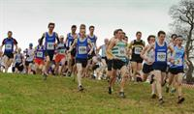
Six Cardiff athletes will be representing Wales in the annual Celtic International to be held in Edinburgh on Saturday (9th) as part of the Great Edinburgh XCountry series.
Taking on teams from Scotland, Ireland and Ulster will be Naomi Reid (under 17 girls), Megan Bowen (under 20 women), Ciaran Lewis and Jack Gooch (under 20 men), Kate Seary and Jessica Hegarty (under 23 women).
Good luck to all of them as well as to the Welsh teams.
These athletes, along with many others, will be competing in Cardiff on 24th January in the British Athletics Cross Challenge, which is always a great occasion in the Welsh cross country calendar.

Great end to 2015 Friday 1 January 2016

The cold and damp conditions did not spoil the enthusiasm of the numerous Cardiff athletes who travelled to Mountain Ash for the popular annual Nos Galan road races.
With former Cardiff star Colin Jackson as the mystery runner, the races saw plenty of Cardiff successes.
The age 10/11 boys saw a clean sweep of medals through Jacob Reynolds (1st), Rhys Blow (2nd) and Ben Vincent (3rd), while Charlotte Arter won the senior women's race in a course record time. Charlotte recently placed 8th in an international cross country race in Belgium where she was representing England.
Other results in Mountain Ash included:
Age 12/13 boys: Ben Reynolds (1st); Ben Smith (2nd).
Age 12/13 girls: Emily Chirighin (1st).
Age 14/15 girls: Naomi Reid (1st); Sofia Vella (2nd).
Age 14/15 boys: Seth Kelly (2nd).
Senior Men: Mike Ward (2nd).

