News Archive 2017

Below is a copy of the news feed for 2017 from Cardiff AACs old website.

Another track season Monday 27 March 2017

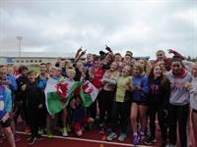
With cross country over and the start of Summer Time, a new track and field season is upon us.
The first rounds of the young athletes leagues are only a few weeks away and the popular annual open meetings in Yeovil this weekend will provide a chance to try out summer form.
The meeting takes place on Saturday 1st and Sunday 2nd April with events for all age groups.
The timetable and entry details for Saturday can be found HERE and for Sunday HERE.
Team managers will be meeting to select teams in a week or so and will be guided by form as well as availability. If you have not yet replied to the availability survey, please go to https://www.surveymonkey.co.uk/r/QT6S7FM and follow the instructions. Thank you - this is important.

Another win for Jake Wednesday 22 March 2017

At the Welsh Schools cross country championships held in Brecon on Saturday last, 18th March, Jake Heyward took his fourth championship title when he won the senior boys' age group in a rare cross country outing for the reigning European under 18 1500m champion.
Plenty of Cardiff AAC athletes were representing their schools and, amongst the best performers, were Jemima Robinson (second in the year 7 girls'race), Naomi Reid (third senior girls), Carys Bill (third middle girls) and Ben Macey (third year 7 boys).
Bethan Evans (fourth) followed Naomi home in the senior girls' race while Jacob Reynolds was also fourth of the junior boys. Kiara Frizelle was fourth in the middle girls age group and Larry Ryan was fifth of the middle boys.
The full results can be found here.

Silver for Ben Hillman Monday 13 March 2017

Several Cardiff athletes travelled to Sheffield to take part in the England Athletics under15/under 17 combined events championships and Ben Hillman established himself as one of the best all-round athletes in Britain by taking the silver medal in the under 15 boys' pentathlon.
With three personal bests (high jump 1.61m, long jump 6.02m and 60m hurdles 8.90), Ben amassed a total points score of 2,911 for a clear second place behind winner Joseph Harding (3,132).
Ben nearly missed out on his medal with two no-throws in the shot put before rescuing the situation with a respectable third and final throw of 10.61m.
Well done Ben.
Other Cardiff athletes in Sheffield were Ben Henson (under 15 boys - 6th), Harri Wheeler-Sexton (under 17 men - 6th), Tom Britt (under 17 men - 7th), Cameron Pamment (under 17 men - 15th) and Sofia Vella (under 17 women - 15th).
Ben Hillman and Harri Wheeler-Sexton are also the Welsh champions as the best performing Welsh athletes in their events.

Final Gwent League results Thursday 9 March 2017

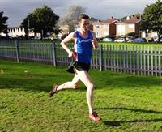
The final round of the 2016-17 Gwent Cross Country League was held in Pembrey Park, West Wales, on Saturday last, 4th March and, for a change, the conditions were much better than of late.
Overall numbers were down and Cardiff AAC produced three individual winners in Carwyn Jones (senior men), Jac Smith (under 20 men) and Georgia Cole (under 20 women).
For the series as a whole, Lucy Marland topped the senior women's rankings and Georgia Cole the under 20s. Morgan James (missing the final race through a minor injury) ended in second place in the under 17 men's rankings, as did Bethan Evans in the under twenty women's. Jessica Wadey was third in the under 17 women's rankings with Laura Wright sixth. Belinda Wallace was the fourth under twenty woman, a position equalled by Jac Smith in the under twenty men, with Matthew Verran in fifth. Other top ten placings were Ben Macey (sixth under thirteen boys), Sam Curwen (eighth under twenty men), Mia Goddard (eighth under 15 girls) and Iestyn Edwards (tenth under 15 boys).
Cardiff AAC teams came first in the under 17 men's age group, under 20 men and under 20 women, with the under 17 women second the under 15 boys third and the under 15 girls fourth.
Cardiff's leading performers on the day were:
Senior women: Carys Hughes (3rd); Lucy Marland (4th).
Senior men: Carwyn Jones (1st); Ciaran Lewis (10th - 2nd under 23).
Under 20 women: Georgia Cole (1st); Ellie Powell (3rd).
Under 20 men: Jac Smith (1st); Matthew Verran (5th).
Under 17 women: Jessica Wadey (4th).
Under 17 men: Owain Edwards (11th).
Under 15 girls: Mia Goddard (12th); Elin Williams (13th).
Under 15 boys: Ben Reynolds (12th); Iestyn Edwards (13th).
Under 13 girls: Elen James (30th).
Under 13 boys: Ben Macey (8th).
Novice girls: Millie Gold (29th).
Novice boys: Joseph Joyce (6th).
The official results can be seen here.

Meeting record and PBs Monday 6 March 2017

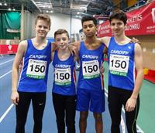
Cardiff AAC arthletes produced some excellent performances at the Welsh Athletics indoor international between Wales and England held at the NIAC yesterday.
Cardiff's under 15 boys' 4x200m relay team were clear winners in a championship record time of 1:42.49 while Sarah Omoregie and Naomi Reid edged closer to selection for the Commonwealth Youth Games to be held in the Bahamas in July.
Sarah already has the qualifying mark for the shot put (15m) and achieved 15.36 yesterday for an indoor personal best. The qualification time for the 800m is 2:09.00 and Naomi was an agonising 0.02 of a second outside, recording 2:09.02 in her race. She will surely get well within the required time soon.
The under 15 boys' 4x200m relay team (Harry Owen, Matthew Register, Philip Gruny and Louis Thorne) scored a resounding victory in the championship record time of 1:42.49 to take the gold medals.
In the under 15 girls' 4x200 relay Cardiff teams were first and third with the A team (Alana Lea, Olivia Sugarman, Saffy Maurice and Emmanuella Kone) taking gold and the B team (Eve Pearson, Holly Medina, Emma Carter and Erin Murray) taking bronze.
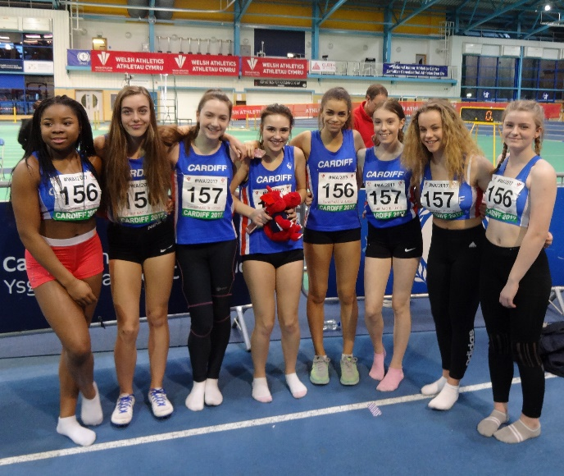
The meeting ended on a high note with Iwan Robinson-Booth anchoring the Welsh 4x200 relay team to a narrow victory over England.
The official results can be seen here.

Final Gwent League Thursday 2 March 2017

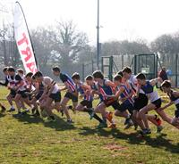
The fifth and final round of the Gwent Cross Country League takes place at Pembrey Park on Saturday next, 4th March and Cardiff is well placed to take team and individual honours.
The under 20 men and women and under 17 women are leading the team rankings while Morgan James (under 17 men), James Hunt (under 23 men) and Georgia Cole (under 20 women) head their individual rankings. Lucy Marland and Bethan Evans are close seconds in the senior women and under 20 women respectively.
Let's hope for a good finish to the cross country season and that the weather will be kinder than recently.
Details of the timetable and course can be found here.
Information on the venue can be found here.

